St Joseph’s Catholic Primary – Geography
Topic: Weather |  |  | Strand: Human and Physical Geography | 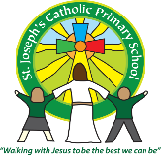  Year 1
What should I already know? |  | Key Knowledge |  |  |  | Vocabulary
-Understand some important processes and changes in the natural world around them, including the seasons.  -Recognise some environments that are different to the one in which they live.  -Draw information from a simple map.  -Recognise some similarities and differences between life in this country and life in other countries. |  | Our Weather  The weather in the UK can change from day to day. The four seasons have weather patterns.  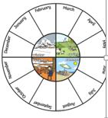  How the weather affects us  The weather affects what we do and wear. If it is rainy we need waterproof clothes and in the sun we need sun cream and hat.  Forecasting  In the weather forecast symbols are used to show what the weather looks like in a certain area. People check the forecast before they make plans to go out. Computers are used to help make accurate forecasts  .  Climates  Countries around the world have different climates. Near equator-hot.  Arctic/Antarctic – cold. Animals and plants are able to adapt to live in extremes.  People need to take special care in extreme weathers such as droughts,flooding,blizzard,heatwave,hurricane. |  |  |  | Seasons 4 seasons in the year are Spring Summer Autumn Winter  Observation What you notice when you look carefully at something  Temperature A measure of how hot or cold something is  Thermometer An instrument used to measure temperature  United Kingdom Made up of England, Northern Ireland, Scotland and Wales  Forecast A prediction of what the weather will be like in the future  Symbols Pictures or signs that help us to understand something  extreme Beyond what is normal  Drought When there is no rainfall for a long time  Flooding When usually dry land is covered with a large amount of water  Heatwave Unusually hot weather over a long period  Climate The usual weather conditions of an area
Geographical skills and fieldwork

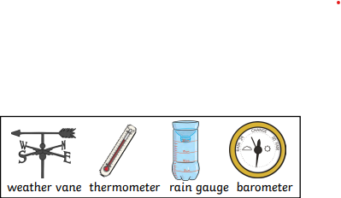
Use different instruments to measure and record the weather.

