St Joseph’s Catholic Primary School Home Learning Pack
Week 2 - beginning 20th April
Class: Cherry
Hello everyone,
I hope everyone is happy and healthy and that last weeks home learning was useful to everyone. If you would like me to see some of your poetry this week please contact me at admin@stjo.uk and in ‘subject’ name it - For Mrs Owens, Cherry Class. I also added a little extra science because I was so excited – see the science section in the overview sheet…… enjoy.
Mrs Owens
Family Home Learning Timetable (example)
This is a guide to help you establish a routine for your children – this is just a suggestion and you will need to adapt it to the needs of your family. Please do not feel you have to complete all activities in the home learning – they are to provide support and direction – feel free to select from them.
Time | Activity
Before 9.00 | Get up, washed, dressed, make beds and eat breakfast
9.00 – 9.30 | Physical Activity – PE with Joe, family walk, yoga, Just Dance (look at Mrs Turner’s suggestions)
9.30 – 9.45 | Drink and get ready for home learning
9.45 – 10.30 | English – writing, spelling or grammar activity from your home learning pack
10.30 – 11.00 | Break time - take a snack and drink outside if you can
11.00 – 11.45 | Maths – choose an activity from your home learning pack
11.45 – 12.30 | Creative time – draw, paint, sew, bake, do a job in the garden, stop-motion animation with lego / plasticine (the list is endless). Have a project that you can do a bit of everyday.
12.30 – 1.15 | Lunch – help to make it AND clear up behind it!
1.15 – 1.30 | Chores – do a job around the house e.g. put laundry away, tidy your room, vacuum or polish
1.30 – 2.00 | Quiet time – shared or independent reading
2.00 – 3.15 | Topic time – science / art / history / geography / music – choose a topic activity from the home learning pack

Top tips for positive home school learning:
- Follow a structure for each day
- Break tasks up into manageable bits
- Turn taking with your child can ‘kick start’ their effort if they are reluctant or need the method modelled
- If your child is stuck make of a note to tell the teacher on return but ‘park the concept’ and move on
- Remember to reward effort and make sure praise is about something specific like “ I liked the way you set out your work” or “You made a good effort” etc
- Remember a child is always learning so be aware everyday activities like making breakfast together can be an educational lesson
- Above all make all learning as much fun as possible

Maths |  | Activities | Resources
Day 1 | Can I use number lines to revise addition and subtraction  (inverse) and the bar method? | Revision | See sheets
Day 2 | Can I  as above revision
Day 3 | Can I use and understand money?
Day 4 | Can I multiply and divide by ten using money?
Day 5 | Can I find fractions of amounts?
 |  | Times table practise for 10 minutes minimum daily please

English |  | Activities | Resources
 | Story:  Diary format |  | See sheets
Day 1 | Can I use and understand adverbs?
Day 2 | Can I write a conversation?
Day 3 | Can I use and punctuate direct speech?
Day 4 | Can I use possessive apostrophes?  Can I perform poetry?
Day 5 | Can I write and perform Poetry?
 |  | - Please practise personal spellings = those generated in your work at home x 3  - Please practise each year 3/4 spelling once daily using your preferred learning method. | spellings this week are –  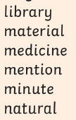

Suggested Reading Activities
Please, keep reading (and quizzing if possible) as this is the very BEST thing you can do to support your progress in learning. Read fiction (story) books, newspapers, magazines, comics, non-fiction texts (about real stuff) – anything will help.
You should all be aiming for at least 20 minutes of reading a day! Mrs Taylor-Bashford has sent links to websites to support you reading at home.
Extra reading practise can be found in the articles on Sustainability on the school website – Home learning from the This Week magazine – you may need to support your child’s comprehension and reading with these.
Reading Skills
Please make sure you are asking children a range of questions you read fiction with them.
- This week’s focus is –
Can your child think and search for the answer?
The answers are found in different parts of the story and they might have to apply prior knowledge or personal experience to an answer.
- How do you make/do……?
- What happened when……… did………?
- What happened to………?
- What do you think might happen next OR what happened before?
- How many times…
- What examples can you find?
- Where did this happen?
- Where was…… when this was happening?
Topic areas

Varied Discrete and Cross Curricular activities: Science, Music, History, Geography, Art, DT, French, Computing and R.E
 |  | Activities | Curriculum Areas
Day 1 – link English plans | Can I? | Use English day 1 extracts to  - Rewrite the incident from The Diary of a Killer Cat from Ellie’s perspective.  How does she feel about Tuffy bringing home the dead mouse?  - What might have happened next in The Diary of a Wimpy Kid? What was the CRAZY thing that happened?  Tell, draw or write about what happened next. | English - writing
Day 2  Geography | Can I? | see Geography below – support with reading articles required - main article is 2 green bags on the school website | Geography
Day 3 - link English plans | Can I? | - Start a diary of your own, use an old notebook or exercise book and note down or draw what has happened and how you feel. Don’t worry if you don’t fill it in every day, just whenever you can. It will be an interesting thing to look back on in the future. | English writing PSHE
Day 4  RE | Can I? | see RE below
Day 5 |  | see science below
GEOGRAPHY  Read the articles on Sustainability on the school website – Home learning from the This Week magazine – you may need to support this reading. | Can I learn and understand current issues related to Earth’s current climate? | Choose one of the following writing warm-ups?  - Write a five-sentence story of a plastic bag from shop to decomposition. Use sequencing conjunctions to make the order in which things happen clear. Read the article and then try the following activities  - How many words can you think of that start with the prefix ‘bio-’? Write a brief definition of each. If you can think of fewer than three, use a dictionary to help.  - The article says that biodegradable bags can still hold 2kg of shopping after three years. But what does 2kg of shopping look like? Ask your parent or carer first, then have a look in your food cupboards at home. Every packet should have the weight marked on it. Find three different ways of making 2kg (to within 100g). Example 1kg of flour + 500g sugar + 500g butter = 2kg | English – writing/grammar  Maths
RE | Can I put the Gospel value of showing kindness into real action? | 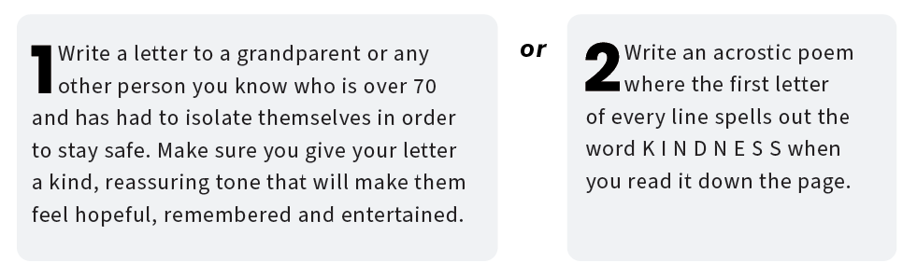
Science | Can I | Make a spinner from recycled card in your home recycling?  Which card/paper worked the best?  EXTRA: I got really excited when I found a ‘sweet’ science experiment – only to be done with adult permission and supervision ( don’t let them eat it all.) I am also going to have a go as well!  Honeycomb toffee.  You will need: 4 desert spoons granulated sugar, 2 desert spoons syrup, 1/4 teaspoon  bicarbonate of soda, and saucepan.  Measure the sugar and syrup into a pan and stir over a medium heat. What happens to the  sugar? When the sugar has completely dissolved, bring the mixture to the boil and let it bubble  until the mixture turns dark brown. Why has the colour changed? Add ¼ teaspoon of  bicarbonate of soda. What happens to the mixture? Allow to froth while stirring out any lumps.  Pour onto a baking tray and allow to cool. What happens to the mixture as it cools down? | You will need  ❋ paper  ❋ paper clips  ❋ Scissors  ❋ different types  of paper or card

