Newsletter #1
Autumn Term 2018

This term has been the busiest and most exciting yet for Primary Music! We are now working in six different schools with over 20 hours per week of specialist whole-class music tuition and more… that’s over 700 children this term who have accessed a high-quality music education with the opportunity to learn a variety of different musical instruments and to perform alongside others.

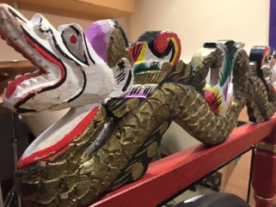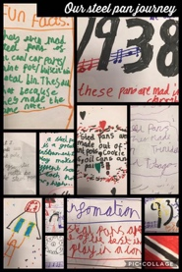
This term was our first at Axminster and has been a great success. We have been working with all year groups from the wonderful Nursery class up to Year 6, who had a whole class set of taiko drums to explore and enjoy! Years 1-5 have been learning the glockenspiel, finding out about notation and getting used to playing together. Nursery has focused on a variety of musical games, listening to each other, exploring percussion instruments and turn taking, whilst children in Reception have been learning early notation with a focus on rhythm. Our extra-curricular activities have included a guitar club, singing group and KS1 music club. | 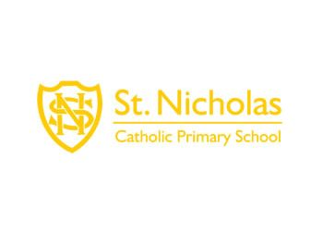  At St Nicholas we are fortunate to be able to work with all year groups from Year 1 to 6. This term we have been lucky enough to be able to borrow a beautiful Indonesian gamelan set and been learning to play different rhythms and beats on gongs, metallophones and finger cymbals. At the end of the term we had a ‘Gamelan Showcase Day’ where parents from all of the classes were invited into school to listen to children perform and to join in with the playing. We have learnt facts about the Indonesian culture and the history and significance of the gamelan. Great fun! |  |  | 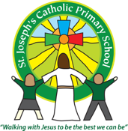  This is our third year at St Joseph’s and the impact that music has had on the children is really beginning to show in their musicality! The children in KS2 have been learning to play the steel pans this term. We have had a lot of fun exploring the instruments and how they have been made, as well as using our knowledge of notation from last year to read and perform music. We have also learnt about the steel pan culture of the Caribbean.
Children at Lympstone have had the opportunity to learn to play Samba this term with both Livvy and Harry, thanks to the loan of a whole-class samba set. We have particularly enjoyed learning a variety of different samba rhythms and learning to play them together, with a focus on listening to each other, understanding how rhythms fit together, and of course, fun! Children in KS1 have also been putting together their own school sea-shanty.  Livvy has also been running a recorder club and a samba club for those children who love music and want to do more and more of it! |  | At Woodbury Salterton this term, our Year 1-6 children have all had the opportunity to learn to play the melodica, to read musical notation and to play along to some simple pieces and perform together. The KS1 children have also been singing and discovering that the human voice is also a musical instrument! | We are doing something a little different and exciting at St Andrew’s… we have started delivering 1:1 sessions with individual children who will benefit from having access to a range of musical instruments and resources to try out in a safe environment, to discover how music can help to calm and focus the mind and to gain confidence in their own abilities.
Coming soon………….
1st February – Bournemouth Symphony Orchestra Schools Concert – we are taking over 400 children this year!
We are now working alongside the Real Ideas Organisation to be able to offer our schools the opportunity to work towards the Arts Mark/Arts Award. Further details will follow in the new term. This is a very exciting opportunity for all of our schools!
We would like to wish you all a very happy and peaceful Christmas and New Year.
Fay and all the Primary Music team

