St Joseph’s Catholic Primary School Home Learning Pack – 20.04.2020
Willow Class

Please find the suggested timetable. This is just a suggestion and you need to find what works for you and your child as we understand that everyone learns differently. Just to be clear, we are not expecting everyone to do all of the activities and these are only suggestions. We understand that our circumstances are all very different at the moment and that lots of you will be trying to juggle ‘home school’ and your own work as well as caring for elderly neighbours and family. Please only do what you feel you can. We do not want to set anything that causes any worry so please do what you feel. There are some references to resources but they do not need to be printed and can be viewed online and the work can be completed or copied onto paper. Please contact us at admin@stjo.uk and in the subject name it… For (Your Child’s teachers name and Class) if you need any further support. For example; For Mrs Spinks, Willow Class. This will help us to ensure your request is dealt with quickly.
Suggested Family Home Learning Timetable
This is a guide to help you establish a routine for your children – this is just a suggestion and you will need to adapt it to the needs of your family.
Time | Activity
Before 9.00 | Get up, washed, dressed, make beds and eat breakfast
9.00 – 9.30 | PE with Joe or family walk
9.30 – 9.45 | Drink and get ready for home learning
9.45 – 10.30 | English – writing, spelling or grammar activity from your home learning pack
10.30 – 11.00 | Break time - take a snack and drink outside if you can
11.00 – 11.45 | Maths – choose an activity from your home learning pack
11.45 – 12.30 | Creative time – draw, paint, sew, bake, do a job in the garden, stop-motion animation with lego / plasticine (the list is endless). Have a project that you can do a bit of everyday.
12.30 – 1.15 | Lunch – help to make it AND clear up after it!
1.15 – 1.30 | Chores – do a job around the house e.g. put laundry away, tidy your room, vacuum or polish
1.30 – 2.00 | Quiet time – shared or independent reading
2.00 – 3.00 | Topic time – science / art / history / geography / music – choose a topic activity from the home learning pack

Maths | Activities | Resources
Times tables | Please continue to practise your times tables everyday this can be done on TTRS or offline through a variety of games and activities. Here are a few ideas to help you:  - Use playing cards – Choose 2 cards at a time and multiply the numbers together and then discuss corresponding division facts.  - Exercise while reciting your times table facts e.g. skipping  - Play times table ping pong – in partners take it in turns to ask each other questions  - Times table bingo – draw a 3x3 grid and choose numbers from the tables – bingo caller to ask multiplication and division question.  - Why not invent your own times table game to play?
Day 1 | Can I order fractions in a sequence?  - Go through the power point or read the learning reminders to refresh understanding of sequencing fractions.  - Complete the practice questions  - If you are finding it tricky complete the ‘A bit stuck sheet’.  - Complete the questions to check your understanding | PDF document ‘Maths day 1’ on the website.  Power point day 1.
Day 2 | Can I find fractions of amounts?  - Read the learning reminders to refresh understanding  - Complete the practice questions  - If you are finding it tricky complete the ‘A bit stuck sheet’  - Have a go at the investigation to check understanding | PDF document ‘Maths day 2’ on the website.
Day 3 | Can I add and subtract fractions?  - Go through the power point or read the learning reminders to refresh understanding of adding and subtracting fractions  - Complete the practice questions  - If you are finding it tricky complete the ‘A bit stuck sheet’.  - Complete the questions to check your understanding | PDF document ‘Maths day 3’ on the website.  Power point day 3.
Day 4 | Can I draw different Polygons and identify their properties?  - Read the learning reminders to refresh understanding of times table facts.  - Complete the practice questions  - If you are finding it tricky complete the ‘A bit stuck sheet’.  - Have a go at completing the investigation to check understanding | PDF document ‘Maths day 4’ on the website.
Day 5 | Can I identify different triangles and describe their properties?  - Read the learning reminders to refresh understanding of the different triangles and their properties  - Complete the practice questions  - If you are finding it tricky complete the ‘A bit stuck sheet’.  - Complete the questions to check your understanding | PDF document ‘Maths day 5’ on the website.

Please continue to keep a written diary recording what you have done each day.
English | Activities | Resources
Day 1 | Can I identify verbs?  - Watch the story ‘ The Great Kapok Tree’  - Use revision cards to revise verbs  - Highlight the verbs on the page | PDF document ‘English day 1’ on the website.
Day 2 | Can I use verbs in the present perfect tense?  - Read talking animals – which animal is the most persuasive and why?  - Look at the power point to refresh understanding of verbs in the present perfect tense. | Power point on the website.  PDF document ‘English day 2’ on the website.
Day 3 | Can I use verbs in the present perfect tense?  - Look at the illustration  - Write sentences using the verbs  - Revise present perfect verbs  - Write a postcard from the man to his family | PDF document ‘English day 3’ on the website.
Day 4 | Can I write a story using descriptive language?  - Read Willow Pattern  - Watch video  - Make notes around the plate to tell the story  - Now use the story plan to plan your story  - Think of descriptive language which you will use in your story  - Use your plan to write your own story  - Edit your story and share it with somebody | PDF document ‘English day 4’ on the website.
Day 5 | Can I write a story with direct speech?  - Read How Tortoise Got His Shell  - Write a conversation between Zeus and Tortoise using speech bubbles  - Read revision cards to revise how to write direct speech  - Plan your story  - Write your story including direct speech | PDF document ‘English day 5’ on the website.

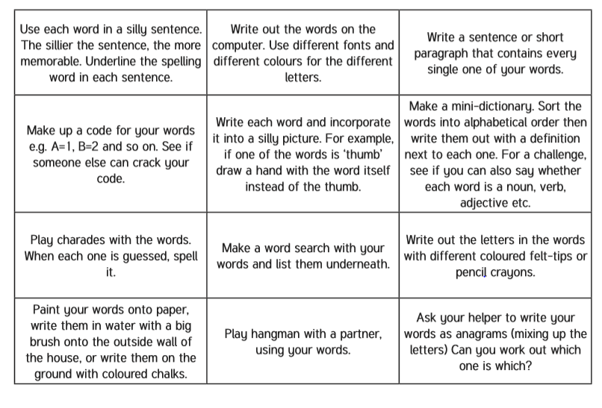
Spelling – Practise the year 4 spellings using a range of strategies. Below are some ideas that you can try.

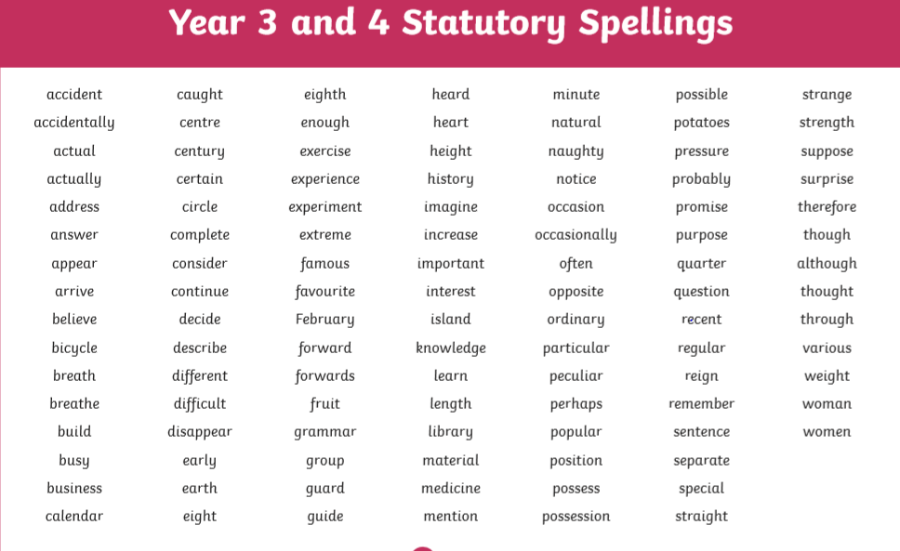
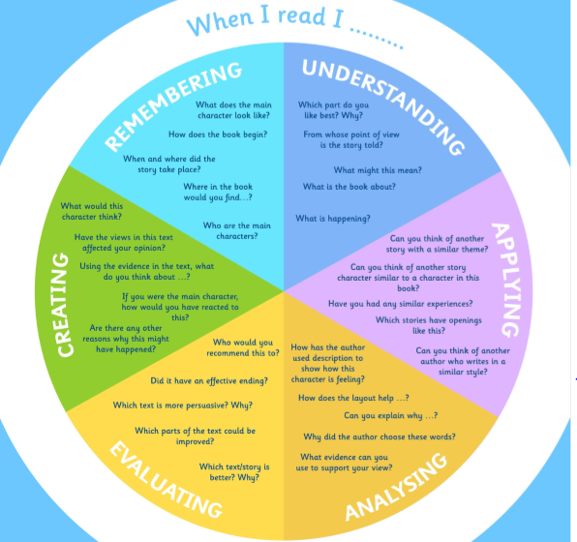
Suggested Reading Activities
This is an essential skill that the children need to continue to practise daily. It is recommended that the children read for at least 20 minutes each day. Continue to record all reading in the reading record books and remember to quiz on accelerated reader. You should have received an email with log in details. Please contact me if there is an issue with this. When listening to your chid read ask questions regularly to check and support understanding. Here is some example questions which would really support the children in their development.

Varied activities of Science, Music, Topic (History, Geography, Art) and R.E
 | Activities | Resources
Activity 1 | Can I find different sounds in my home?  - Consider which areas of your home will be quiet, which will be loud and which will have no sound at all.  - Walk around your home listening for different sounds. Record the different sounds that you hear. Write down how you think the sounds are made.
Activity 2 | Write a poem or a prayer for the people around the world battling the Corona Virus.  Extension – Write a letter to somebody in another country. Tell them what you have been doing whilst at home. What has stayed the same? What has changed? Have you got any handy tips that you could pass on to others?
Activity 3 | Can I read, write and plot coordinates on a map?  Complete the map coordinates sheet on the website – Choose the sheet that will challenge you.  Extension – Create your own treasure map with hidden treasure for your family to find | Map coordinates sheet on the website.
Activity 4 | Can I draw different textures?  Complete the texture worksheet on the website.  Choose an object within your home and have a go at sketching it. Think about texture, pattern, line, shape, form and tone. | Textures worksheet on the website.  Elements of Art on the website to refresh terminology.
Activity 5 | Can I follow directions accurately?  Use the compass sheet on the website and complete the instructions.  Create your own map and directions. This could be a map of your home or a made up place. | Compass sheet on the website.

