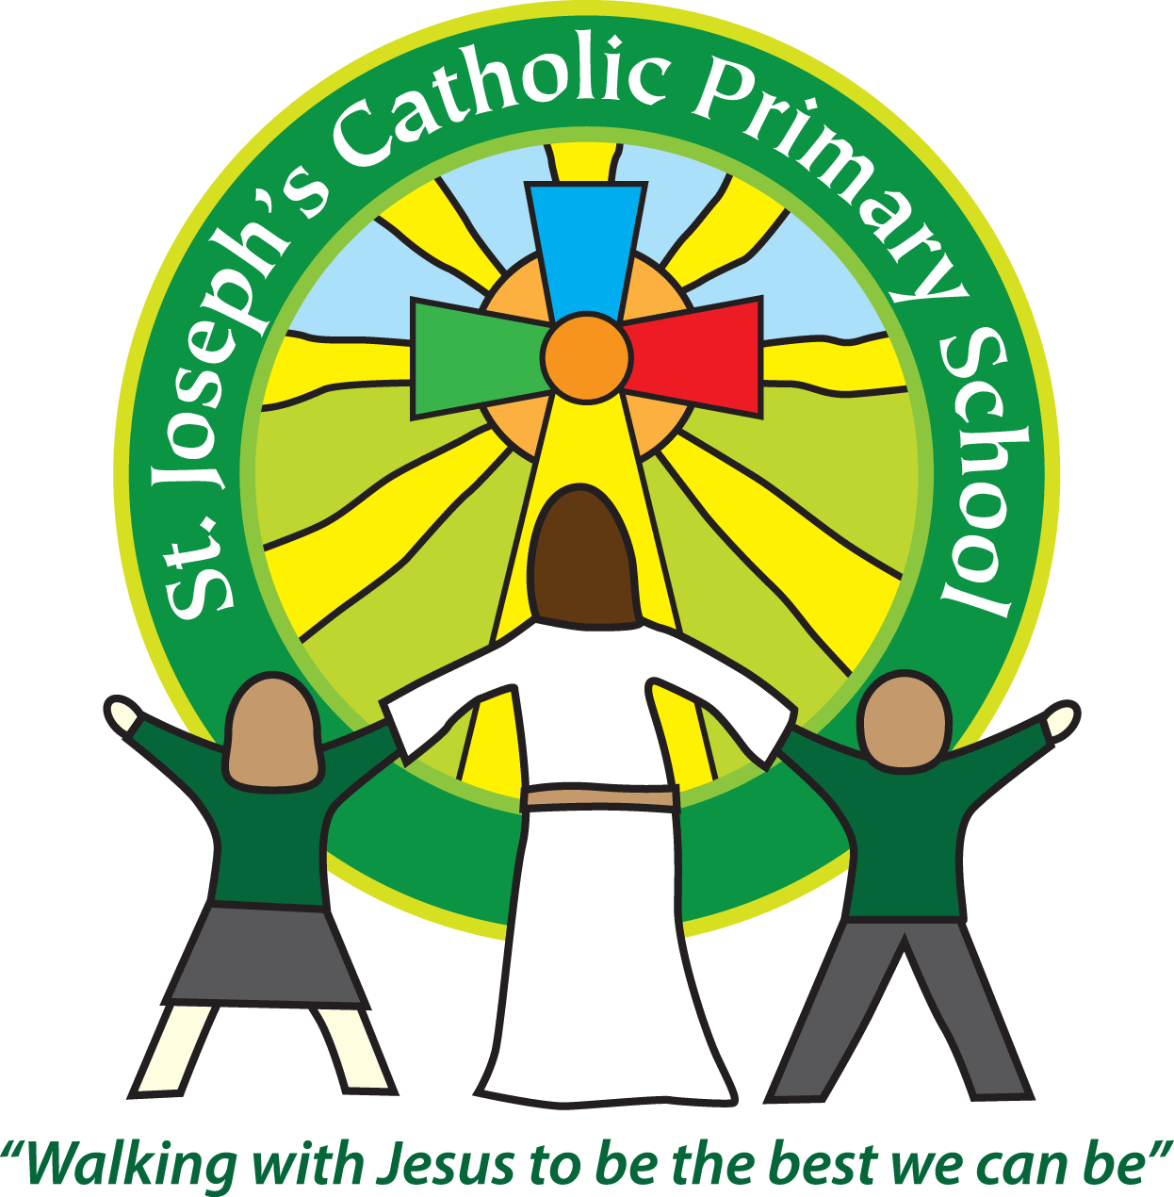
St Joseph’s News
Friday 6 November 2015
stjosephsprimaryschool.com

  Stars of the Week  FS2 Annie  Y1 Irys  Y2 Thomas  Y3 Jeff  Y4 Grace  Y5 Haylin  Y6 Kai |   Head Teacher’s Awards  Congratulations to Isabella, Vince, Samuel and Oliver in Class 1 and Darcie, Louis, Archie, Josh and Jeff in Class 3 who received Head Teachers Awards. |   Courtesy Cup  Well done to the BLUE team, St Andrew’s who are this week’s winners.
Attendance - for the week ending 23 October
Class FS2 | 95.3%
Class 1 | 94%
Class 2 | 96.3%
Class 3 | 97.1% | 2nd
Class 4 | 95.3%
Class 5 | 96.6% | 3rd
Class 6 | 100% | 1st

Marshmallows Around the Fire This week the children in the Foundation Stage have been gathering sticks and lighting a crackling fire to warm their hands and toast marshmallows. They enjoyed the sights, sounds and smells of a real wood fire and patiently toasted their marshmallows over the embers before enjoying a sweet and gooey treat. We plan rich learning experiences like this as we know that these exciting things help to motivate young learners to talk, write, draw, listen, wonder and in this case taste!
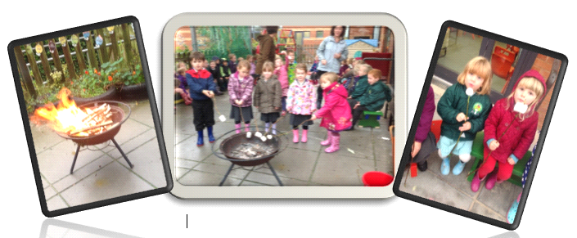

Next Friday is Children in Need Day. This year we are asking the children to make cakes for a bake sale, bring in money (50p) to spend and to dress a teddy as a Super Hero. If there are any cakes left over we will sell them at the end of the day. Happy baking!!

