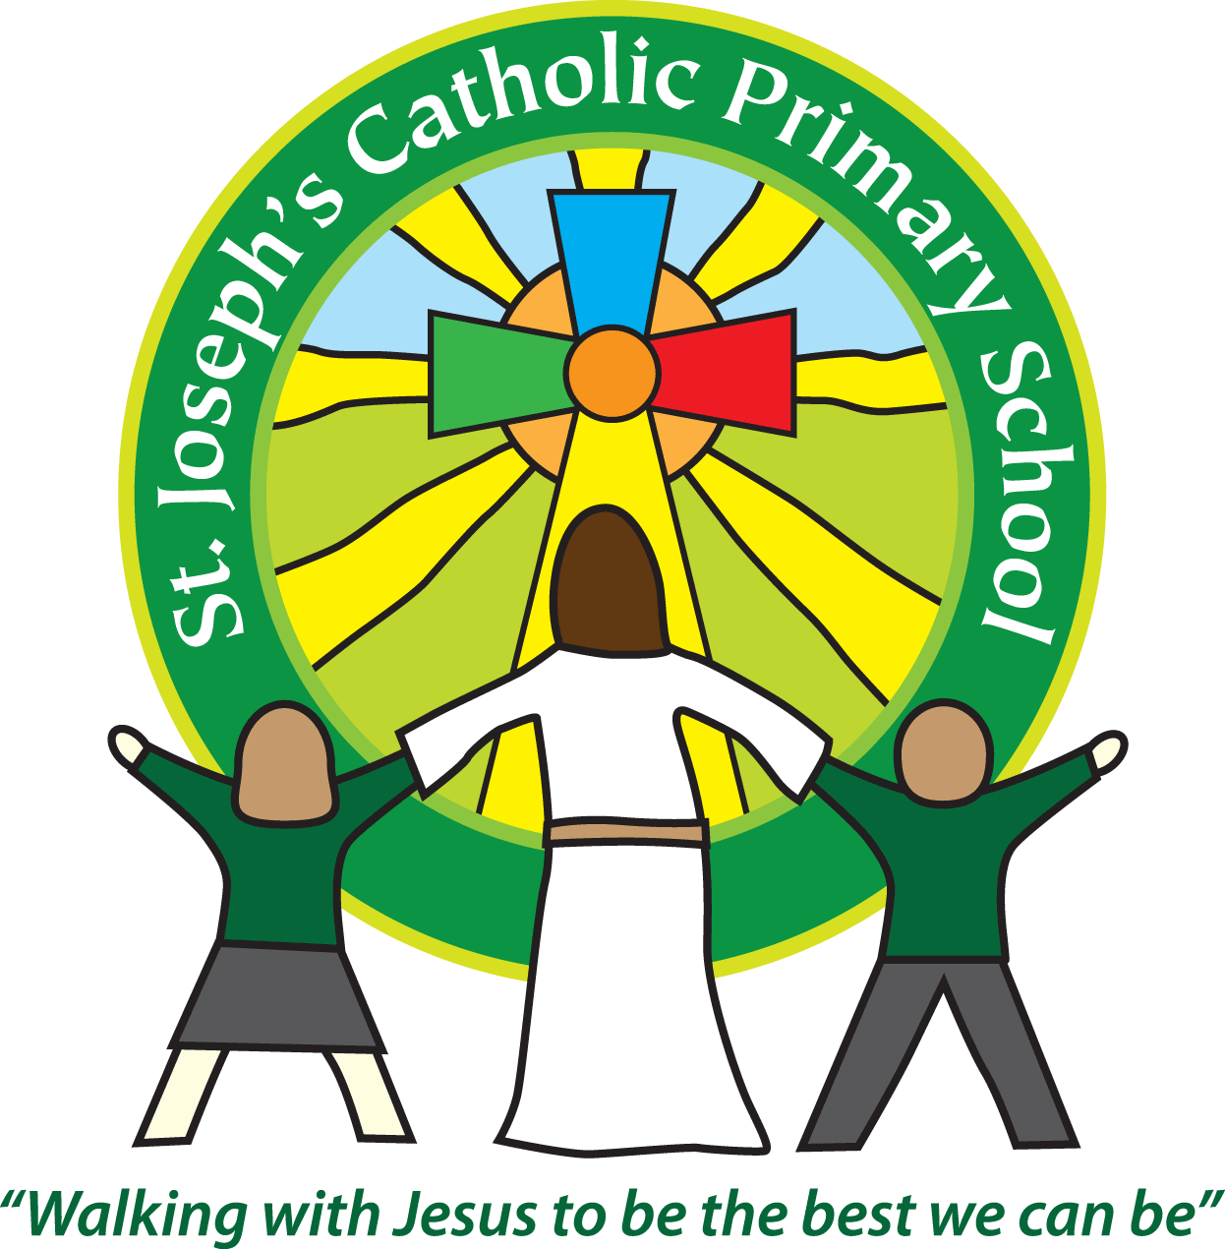St Joseph’s Catholic Primary School
Year 1 – Spring (2nd half)
Welcome back. We hope you had a wonderful half term break as a family.
We completed a spelling assessment at the end of last tem which went home with your child on the last Friday of term. The words NOT highlighted are the words to continue to practise. We will continue to support in school, but it will have a huge impact if you are in turn practising them at home. There are many creative ways to learn spellings and we will keep sharing different games to try on a Friday. The aim is for the children to be confident reading and writing these words by the end of Year 1 as when they progress into Year 2 there will be another set of words to learn. Your support in this is greatly appreciated.
We post homework on Google Classroom every Friday as well as any other updates. It is vital that you check it each week. Please let us know asap if you have any problems.
This half term our topic is ‘Transport in the Past’
Please see attached our topic overview.
Year 1 home learning
Subject
Reading | Friday | We expect the children to read at home daily. Daily practice can really support your child’s progress, even if it is just for five minutes every day. Thank you for your support with this. Books will be changed on a Friday each week. As part of your reading routine, you can support your child by asking questions about the book. E.g How is Lucy feeling when …….? What do you think will happen next? Can you discuss your favourite words and phrases?
English/Maths/Topic/  Spelling | Friday | Parents often ask about how they could further support learning at home, so we put together a  weekly list of ideas. These will be activities that you can choose to use and they will link to what we  have been learning in class throughout the week. Homework will be posted every Friday on Google Classroom. Please share one part of the home learning with us on Google Classroom each week.

Reminders
School lunch and snacks | Year 1 children are entitled to a free school lunch every day. Please see the school website for the menu and now order the meals on Parent Pay. You can send a packed lunch if you prefer.  We promote healthy eating at school and so lunch boxes should not contain more than one chocolate snack and one packet of crisps.  Children are welcome to bring fresh fruit or vegetables for a snack at break time.  We are a nut free school. We have children with potentially fatal nut allergies in school, therefore no food containing nuts may be sent into school.
Drinks | Your child must have a named water bottle in school every day. Please only send in water, no juice or fizzy is allowed.
Uniform | Please ensure all uniform is clearly named.  Grey trousers or shorts, grey skirt or pinafore dress, white or grey socks, grey tights, White polo shirt, Green logo school sweatshirt or cardigan. Warm weather option – green and white gingham dress (dress with shorts instead of skirt is acceptable)  Hair past shoulder length must be tied back – please use plain hairbands in green, black or white, not brightly coloured bows.  Nail varnish is not allowed. School shoes must be black and no heels, trainers or boots.
PE kit | Green t-shirt with school logo, black shorts, black or navy jogging bottoms and trainers.Ear rings must be removed or covered with tape for PE lessons.  Watches must be removed for PE. PE kit must be worn to school on a Tuesday and a Friday.
Bags | Reception, Yr 1 and 2 children must have a book bag in school. This is so books can easily be checked and letters put in.  Children can have a bag or rucksack in school, but please avoid the large bulky ones as 30 rucksacks take up a lot of room in the class.
Mornings | School starts promptly at 8.55am.  Your child will be greeted at the patio gate by an adult. Please only pass on quick messages then, for a longer meeting please make an appointment.  Children and parents arriving after 9.00am will be asked to sign in at the office.
After school | School finishes at 3.30pm. If someone other than yourself is collecting your child please ensure the office has their details. We will not let them leave unless we are sure they are safe.
Contact details | Please ensure you contact details and those of other people who may collect your child are always kept up to date. Please see the office asap if you change your phone number or address.

Teaching assistants: The teaching assistant who will be working with your child this half term is Mrs Kerr. Miss Boylan will be with us for a further 4 weeks. In addition to this we will be joined by a PGCE student from Exeter University later in the term. They will be working in class with us until the end of June.
Key Dates for the Diary:
Monday 27th February – Storyteller in school
Friday 3rd March – World Book Day
Wednesday 15th March – Holy hunt at Holy Ghost Church.
Wednesday 29th March – Forest School
Wednesday 29th March – Reports to go home to parents
Friday 31st March – Easter hunt at Homestead Residential Home
We recognise the importance of passing information between parents and school so we are available at the start and end of the day if you need to pass on any messages. However, if you would like a longer chat please make an appointment with us.
Yours sincerely,
Mrs Robertson and Mrs O’Mahony.

