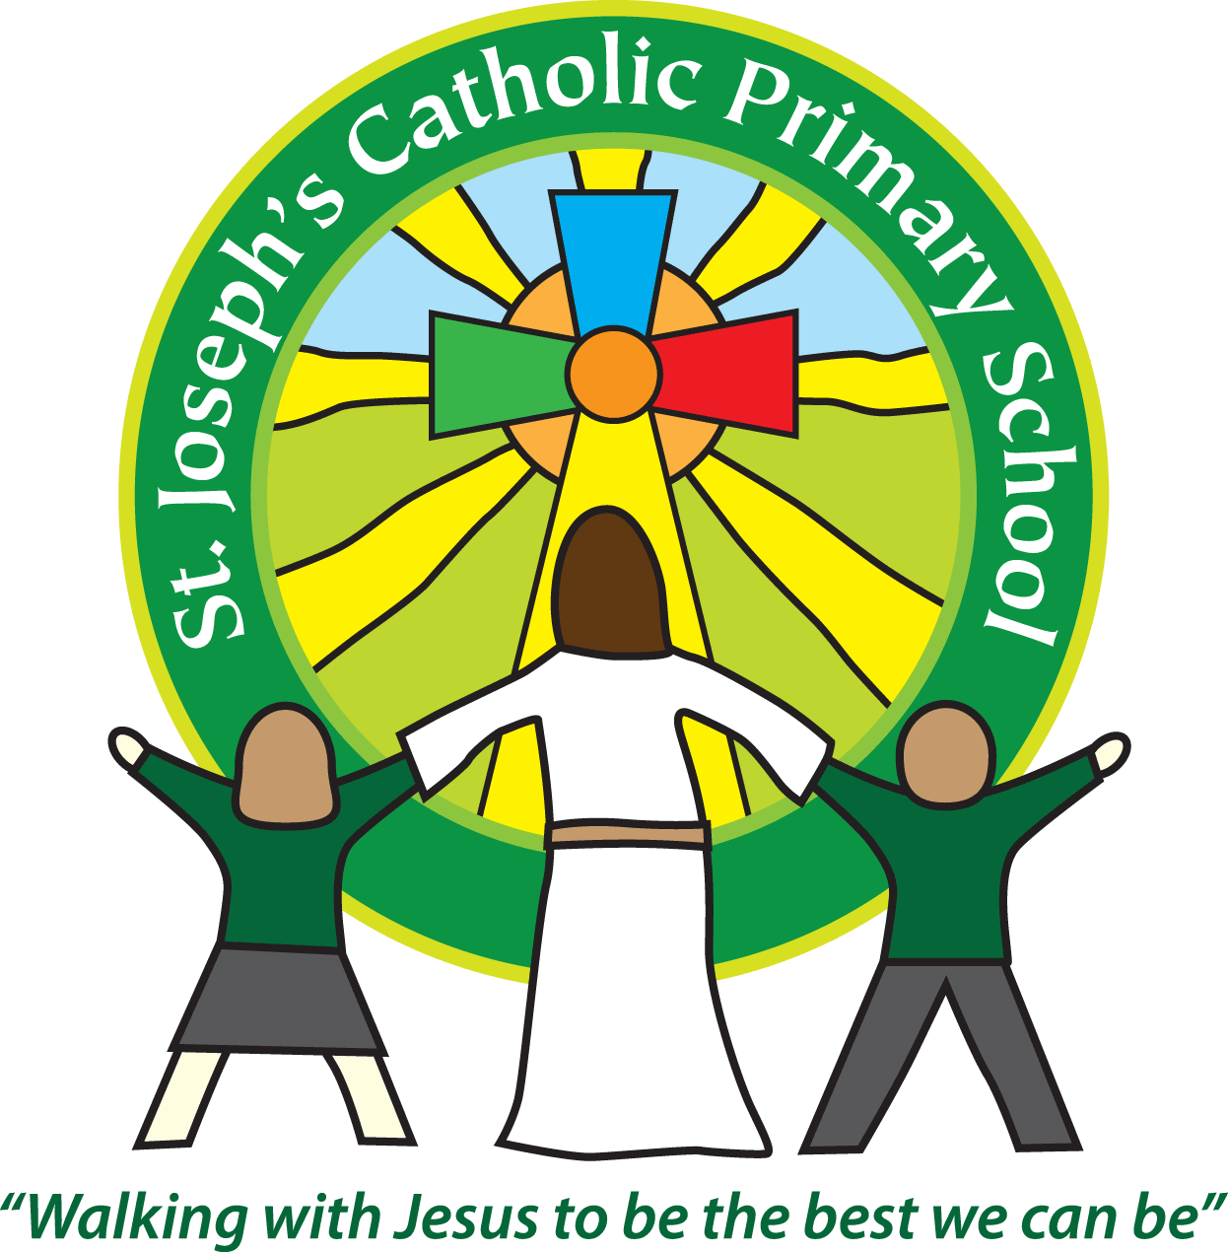
St Joseph’s Catholic Primary School Home Learning Pack
Class: Sycamore Year 2 – 18.05.2020
Please find the suggested timetable. This is just a suggestion and you need to find what works for you and your child as we understand that everyone learns differently. Just to be clear, we are not expecting everyone to do all of the activities and these are only suggestions. We understand that our circumstances are all very different at the moment and that lots of you will be trying to juggle ‘home school’ and your own work as well as caring for elderly neighbours and family. Please only do what you feel you can. We do not want to set anything that causes any worry so please do what you feel. There are some references to resources but they do not need to be printed and can be viewed online and the work can be completed or copied onto paper. Please contact us at admin@stjo.uk and in the subject name it… For (Your Child’s teachers name and Class) if you need any further support. For example; For Miss Rowe, Sycamore Class. This will help us to ensure your request is dealt with quickly.
Suggested Family Home Learning Timetable
This is a guide to help you establish a routine for your children – this is just a suggestion and you will need to adapt it to the needs of your family.
Time | Activity
Before 9.00 | Get up, washed, dressed, make beds and eat breakfast
9.00 – 9.30 | PE with Joe or family walk
9.30 – 9.45 | Drink and get ready for home learning
9.45 – 10.30 | English – writing, spelling or grammar activity from your home learning pack
10.30 – 11.00 | Break time - take a snack and drink outside if you can
11.00 – 11.45 | Maths – choose an activity from your home learning pack
11.45 – 12.30 | Creative time – draw, paint, sew, bake, do a job in the garden, stop-motion animation with lego / plasticine (the list is endless). Have a project that you can do a bit of everyday.
12.30 – 1.15 | Lunch – help to make it AND clear up behind it!
1.15 – 1.30 | Chores – do a job around the house e.g. put laundry away, tidy your room, vacuum or polish
1.30 – 2.00 | Quiet time – shared or independent reading
2.00 – 3.15 | Topic time – science / art / history / geography / music – choose a topic activity from the home learning pack
3.00 – 3.15 | Break time – take a snack and drink outside if you can
3.15 – 3.30 | Reading – enjoy a book together

All the PDF’s and resources will be on the school website under Coronavirus – Home Learning – Sycamore.
Maths |  | Activities | Resources
Day 1 | Can I choose efficient strategies? | Following on from last week, work through these calculations and talk about different ways to work them out. Use your understanding of place value and number facts to help you.  Ask the questions – Could you work this out another way? What is the best way? Why?  52 + 20 = 19 + 21 = 49 – 15 = 24 + 16 =  32 + 18 = 56 + 14 = 39 – 18 = 14 – 9 = | Learning reminders from last week may be helpful.  Paper and pencil
Day 2 | Can I divide? | Look at the Learning Reminders Powerpoint.  If you are unable to access this, don’t worry because the Learning Reminders are the same.  Work through the activities. | Resource Day 2
Day 3 | Can I show multiplication and division facts? | Using the triangle write the numbers of times table facts in each corner of the triangle.  Choose one of the times tables that you are practising.  Write out the multiplication and division facts.  For example –  2 x 5 = 10  5 x 2 = 10  10 ÷ 2 = 5  10 ÷ 5 = 2  5  10  2 | Trio sheet
Day 4 | Can I compare weight? | Work through the Learning Reminders.  If you don’t have the items that are suggested in the Learning Reminders, just choose other suitable items. The idea is to think about heavier and lighter.  Work through the activities. | Day 4 Resource
Day 5 | Can I read scales? | Work through the Learning Reminders.  If you don’t have the items that are suggested in the Learning Reminders, just choose other suitable items.  Work through the activities. | Day 5 Resource

English |  | Activities | Resources
Day 1 | Can I answer questions about what I have read? | Read Dream on.  Answer the questions about the story.  Work through the activities. | Paper and a pencil  Dream on Resource  Day 3 Resource
Day 2 | Can I write a letter? | Can you think of any features of a letter?  This week, I have written you a letter because it really made me smile when I received one this week.  Write a letter. You could write it to me and send it to the school or you could write it to a family member. Use mine as an example to structure yours. | Paper  Pencil
Day 3 | Can I research facts? | Choose a topic. Find out some facts. You could use these to create your own non-fiction book.  Some topics that you might like to choose,  Big Cats (Jaguar, Panther, Lion, Cheetah)  Safari Animals (Elephants, Lions, Rhinos)  Plants (Fushia, Sunflower, Geranium)  Trees (Cherry, Beech, Rowan, Sycamore)  Toys (Cars, Train set, Puzzles)  Animals (Hippo, Kangaroo, Monkey)  Pets (Rabbits, Hamster, Dog, Cat)  You could create a non-fiction book.  Think about what the audience of your book would want to know. Remember we use non-fiction books to research facts.  Here are some examples of questions that you might like to find the answers too.  - What is it?  - Where do they live? Where do you get it from?  - What does it look like?  You can think of some others depending on your topic choice.  Try to take notes and don’t just copy facts out of a book or off the internet.  The idea is that for each animal or toy, you will create a page for a non-fiction book so try to find out as much as you can. | Paper  Pencil  Books/Internet to find facts
Day 4 – Day 5 | Can I write a non-fiction book? | You could get a piece of card and 3 (or more, depending on how much you are going to write) pieces of A4 paper. Make a book by folding it in half with the card as the outer page.  - Make a front page with a heading and drawings.  - Make a contents page  - On each page write about one of your animals or toys  - Include a heading for each page  - You may want to include sub-headings to divide your information up  - Write in full sentences  - Include pictures (You could also label them)  When you are writing your sentences try to include these conjunctions.  (when, if, because, so that, but, or, and)  Remember to use your best handwriting.  If you want to send photos to admin@stjo.uk I would love to see them. | Paper  Pencils  Card

Suggested Reading Activities
Reading Daily
Please enjoy a bedtime story together each night. This week, create a quiz for the adult that you have read the book to. How did they get on?
Spellings
Here are a list of this weekly spellings.
- badge
- edge
- bridge
- dodge
- fudge
- age
- huge
- change
- charge
- village
You could quiz them each week, like we do in class if you would like to.

Varied activities of Science, Music, Topic (History, Geography, Art) and R.E
 |  | Activities | Resources
Day 1 | Can I make observations over time? | This week, the whole school are being set another Science Task. This week it is about observing over time.  Follow the attached resource.  Remember you can always send us in what you have been doing. | Task 4
Day 2 | Can I write a thank you prayer? | From the 16th -24th May we are celebrating the anniversary of ‘Laudato Si’ the letter the Pope wrote to us all advising us what is happening to the Earth and how we can take care of it. The Pope wrote this 5 years ago but it is still very much important today.  You can watch the video here.  https://cafod.org.uk/Education/Primary-teaching-resources/Laudato-Si-animation  You could write a thank you prayer for our world. I have included a template below. You could write it out in neat and decorate it. If you want to, you could send a picture of it in to go in our school prayer book.  Compassionate God,  Thank you for…..  Please help us to……….  Amen | Paper  Pencil
Day 3 | Can I draw some observations? | Last week, you may have explored the different parts of a plant.  This week, when you are outside, look closely at an interesting plant or tree and look at it very closely to focus on small details.  Can you see patterns on the leaf or trunk? Are all the leaves the same?  Take care to draw an observational drawing. Take your time. | Paper and pencil
Day 4 | Can I create actions to a song? | This week, sees the beginning of ‘Laudato Si’ week which runs from the 16th -24th May. This celebrates the anniversary of ‘Laudato Si’ the letter the Pope wrote to us all advising us what is happening to the Earth and how we can take care of it. The Pope wrote this 5 years ago but it is still very much important today.  You can watch the video here to remind you of his message.  https://cafod.org.uk/Education/Primary-teaching-resources/Laudato-Si-animation  The link below will take you some different activities that you may like to try.  https://cafod.org.uk/Education/Primary-teaching-resources/Home-learning-primary  You could listen to the ‘Laudato Si’ song and make up some actions to perform to the song. Look closely at the lyrics.  Can you think of actions for the lyrics?  Perform it.  You could make it into a dance. | Web  links  Lyrics
Day 5 | Can I create a piece of natural art? | Look at the Cafod sheet under Art Project in the Garden.  Can you create your own collage, painting or drawing?  If you would like, you could take a photograph and send it to us at admin@stjo.uk. | Cafod Project ideas

