ONLINE LEARNING LINKS
 | https://www.oxfordowl.co.uk/  Reception-Year 6 |  |  |  | https://ttrockstars.com/ |  |  | https://www.twinkl.co.uk/offer  Offer code - CVDTWINKLHELPS
General (covering a range of subjects)
https://www.bbc.co.uk/bitesize/pr imary  Interactive learning for KS1 (Reception-Year 2) and KS2 (Years 3-6) |  |  | https://classroommagazines.scholastic.com/support/learnathome.html  Daily videos books and activities to do. Covering a range of learning.  (Pre K and Kindergarten = Reception and Year 1 Grade 1 and 2 = Year 2 and 3  Grade 3 and 5 = Year 4 , 5 and 6) |  |  | https://2simple.com/free-access/  Free during school closure for Reception, KS1 and KS2. The site includes a selection of daily activities on different subjects |  |  |  | https://kids.classroomsecrets.co.uk/  Free resources from reception to year 6 during school closure
Phonics and Reading
https://collins.co.uk/pages/b ig-cat-ebooks  Free ebooks and resources linked to letters and sounds |  | https://new.phonicsplay.co.uk  /  Free phonics resources and games |  |  | https://subscribe.firstnews.co.u k/free-downloadable-issue/  Offering free digital download when email address entered.  Suitable for ages 7 to 14 |  | https://www.booktrust.org.uk/boo ks-and-reading/have-some- fun/fun-at-home-with-authors- and-illustrators/  Range of activities, videos and quizzes to enjoy |  |  |  | 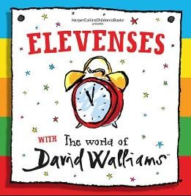  https://www.worldofdavidwalli ams.com/elevenses/  Listen to David Walliams read a story every day at  11
Writing
https://www.literacyshedplus.com/browse/brow se/free-resources  Activities for KS1 and KS2 |  |  |  | https://www.babcockldp.co.uk/improving-schools- settings/english/home-learning  Weekly packages for teaching English at home for KS1 and KS2 |  |  |  |  | https://www.pobble365.com/  A daily image and stimulus for writing.  Suitable for KS2
Maths
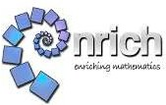  https://nrich.maths.org/covid19  Selection of puzzles, challenges and activities all based around reasoning Ages 3 upwards |  |  | hthttps://www.babcockldp.co.uk/improving- schools-settings/mathematics  Weekly packages of ideas using simple resources that can be found at home. Each week focuses on a different area of Maths and there  are 5 daily lessons per topic |  |  | .  https://www.ncetm.org.uk/resources/54432?utm_source=NCET M%20Newsletters&utm_campaign=09c3bba146-national- newsletter-easter- 2020&utm_medium=email&utm_term=0_13f8d631f4- 09c3bba146-222696841  Videos with tips, learning activities and games to help your child |  |  |  |  | https://mathigon.org/activities  Interactive text book with demonstrations and activities
Science
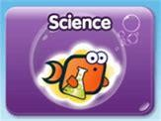  https://www.bbc.co.uk/bitesize/subjects/z7nygk7  Various videos, games and activities linked to the Science  Curriculum for KS1 and KS2 |  |  |  |  |  | https://www.stem.org.uk/home-learning/primary#science  A resource bank, which links to resources on external websites. New home learning resources and games are being developed and updated regularly

