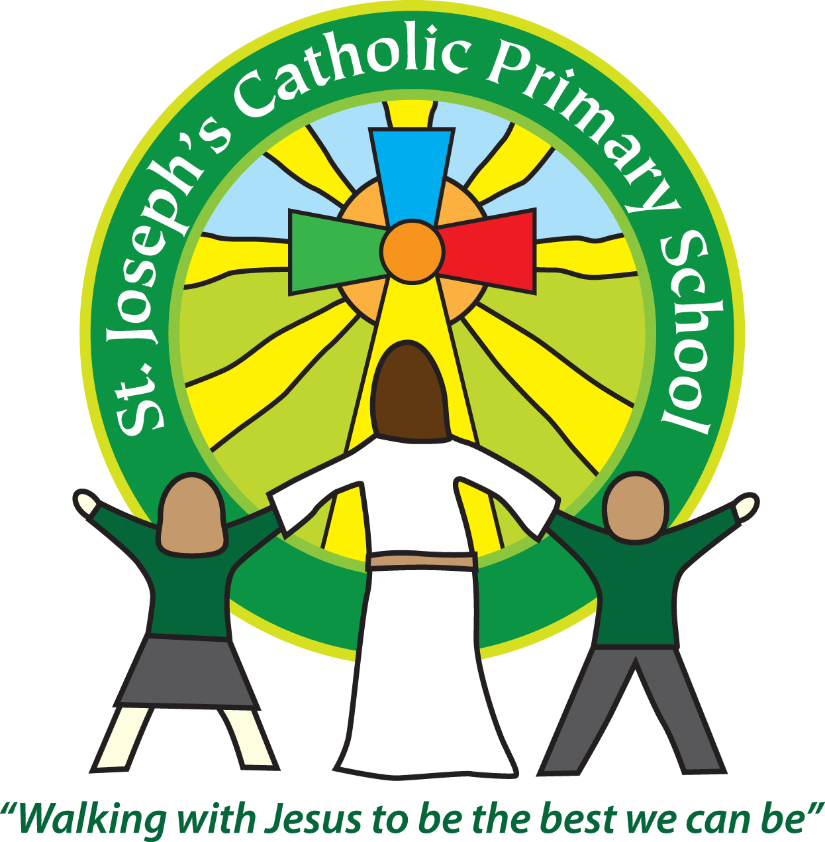
St Joseph’s Catholic Primary School Home Learning Pack
Week 5 - beginning 11th May
Class: Cherry

Hello everyone,
I hope everyone have had the chance to see the home page on the school website where we have made a series of staff videos to make you smile. This week you have a bit of a challenge to guess the adult behind their favourite book – I am there, honestly. We continue to think about you all and miss you. I hope you had fun with the activities last week. One of my favourite activities this week is the Re/art activity – hope you succeed with the challenges.
From Mrs Owens

Home learning attachments (for those receiving this as an email)
For home learning during the partial school closure please go to the tab which says Coronavirus information – Home learning, then select the date and class.
Many thanks

Family Home Learning Timetable (example)
This is a guide to help you establish a routine for your children – this is just a suggestion and you will need to adapt it to the needs of your family. Please do not feel you have to complete all activities in the home learning – they are to provide support and direction – feel free to select from them.
Time | Activity
Before 9.00 | Get up, washed, dressed, make beds and eat breakfast
9.00 – 9.30 | Physical Activity – PE with Joe, family walk, yoga, Just Dance (look at Mrs Turner’s suggestions)
9.30 – 9.45 | Drink and get ready for home learning
9.45 – 10.30 | English – writing, spelling or grammar activity from your home learning pack
10.30 – 11.00 | Break time - take a snack and drink outside if you can
11.00 – 11.45 | Maths – choose an activity from your home learning pack
11.45 – 12.30 | Creative time – draw, paint, sew, bake, do a job in the garden, stop-motion animation with lego / plasticine (the list is endless). Have a project that you can do a bit of everyday.
12.30 – 1.15 | Lunch – help to make it AND clear up behind it!
1.15 – 1.30 | Chores – do a job around the house e.g. put laundry away, tidy your room, vacuum or polish
1.30 – 2.00 | Quiet time – shared or independent reading
2.00 – 3.15 | Topic time – science / art / history / geography / music – choose a topic activity from the home learning pack

Top tips for positive home school learning:
- Follow a structure for each day
- Break tasks up into manageable bits
- Turn taking with your child can ‘kick start’ their effort if they are reluctant or need the method modelled
- If your child is stuck make of a note to tell the teacher on return but ‘park the concept’ and move on
- Remember to reward effort and make sure praise is about something specific like “ I liked the way you set out your work” or “You made a good effort” etc
- Remember a child is always learning so be aware everyday activities like making breakfast together can be an educational lesson
- Above all make all learning as much fun as possible

Maths |  | Activities | Resources
 |  |  | See daily resources for Maths
Day 1 | Practise these mental maths strategies  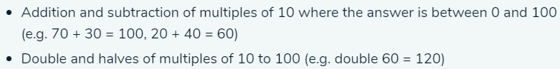  Extend into three digit numbers e.g. 170 + ? = 200 or 170+530 = or 170+134 = etc  practise these methods all week as warm up mental starter before your maths sessions
Day 2 | Round 3-digit numbers to the nearest 10 and 100. |  | Day 2 for full explanation
Day 3 | Find times a specified number of minutes later than a given time. |  | Day 3 for full explanation
Day 4 | Calculate time intervals. |  | Day 4 for full explanation teaching
Day 5 | Record results in a pictogram. (Revision) |  | Day 5 for full explanation
 | BATTLE on TTRS | 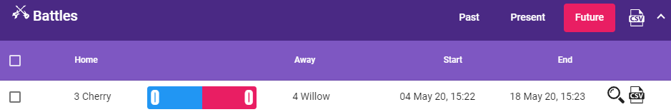  Also see the bingo game format for working on table retention. | TTRS  SEE BINGO GAME
English |  | Activities | Resources
 |  |  | See daily resources for English
Day 1  Comprehension Fiction | Read the story ‘King Midas And The Donkey Ear’s can you order the events and answer questions about the characters? |  | See Day 1 notes
Day 2 | Revise of direct speech – practise using speech from the story. |  | See Day 2 notes
Day 3  Comprehension Fiction | Read another story King Midas And The Golden Touch, make a summary. Write direct speech in the form of a conversation. |  | See Day 3 notes  see revision PowerPoint on direct speech
Day 4  Non Fiction - reports and reviews | Read a report – Warner brother’s studio tour - Harry Potter. Make notes. Explore a website and make further notes on the reports |  | See Day 4 notes
Day 5  Non Fiction -  reports and reviews  writing Focus | Read an opinion and speculate about the writer. Write imaginatively.  (You could do some of the reviews verbally giving more time to the writing as this is quite a long session.) |  | See Day 5 notes
 |  | - Please practise personal spellings = those generated in your work at home x 3  - Please practise each year 3/4 spelling once daily using your preferred learning method. | spellings this week are –  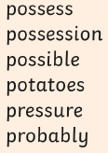

Suggested Reading Activities
A reminder: You should all be aiming for at least 20 minutes of reading a day!
You can find books freely available to access on these sites
https://www.oxfordowl.co.uk/for-home/find-a-book/library-page/

https://readon.myon.co.uk/

Also your parents will have received an email with links to some super sites which will support reading for pleasure – if not I have put the links in home learning ‘Other activities’ folder
Don’t forget to have a go at the school quiz of the week on the Home page of the Website - Who is reading their favourite book?
Topic areas
Varied Discrete and Cross Curricular activities: Science, Music, History, Geography, Art, DT, French, Computing and R.E
 | Curriculum link | Activities | Resources
Science |  | Identifying and classifying is how we can make sense and order of the world around us. This enquiry type requires using observation and reasoning skills.  Examples of classifying include how we classify animals, plants and foods.  Identifying and classifying is used by scientists to help learn about the natural world and therefore assist in conservation projects.  Have a go at the activities in the attached sheet to build your scientific, investigational skills. | See science - classification
RE/Art |  | We have been considering VE day and it seems appropriate that we continue with related topics of hope /Peace and forgiveness  FAITH CONNECTION - According to Japanese legend, anyone who folds a thousand paper cranes is granted a wish. Since the bombing of Hiroshima in 1945, paper cranes have become an international symbol of the wish for peace. Point out that Jesus told his apostles “I leave you peace, my peace I give you” and that, if we want peace in the world, we must share the peace of Christ with others. | See instructions for making Origami cranes  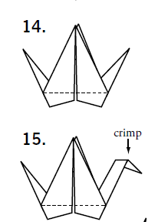
PSHE  On line safety |  | - Everyone has the right to be safe, strong and free. We work with CAP uk to raise children’s awareness of their personal rights – please read through the pamphlet with your child as a reminder of the key messages; you might like to do some of the linked activities. There are also links to related resources about Coronavirus and online safety available at the end of the pamphlet.  - On line safety at home – please see attached sheet for details of activities related to acceptable behaviour on line | 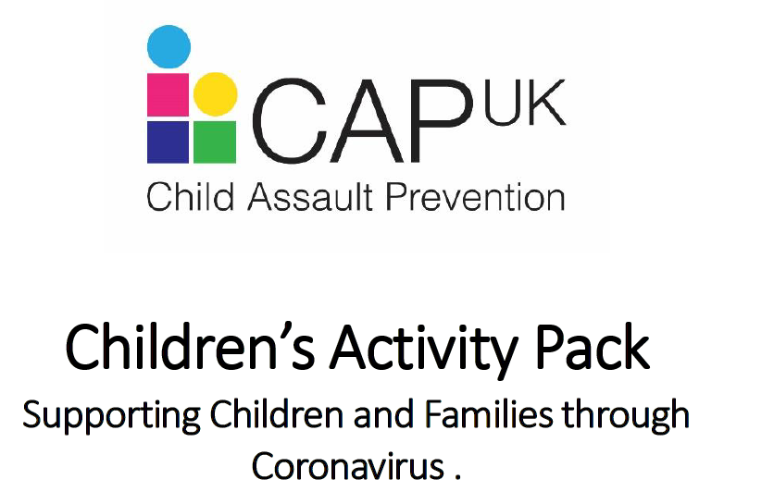
Mini Topic  Geography |  | Lets find out about the different regions in England.  Can we find out and compare the different regions?  What are the names of the different regions?  What counties make up these regions?  What are the areas below like in these regions in England?  - Industry  - Landscape  - Transport  - Important towns and cities | This might be of help  http://primaryhomeworkhelp.co.uk/geography/index.html  then go to Regions in England

