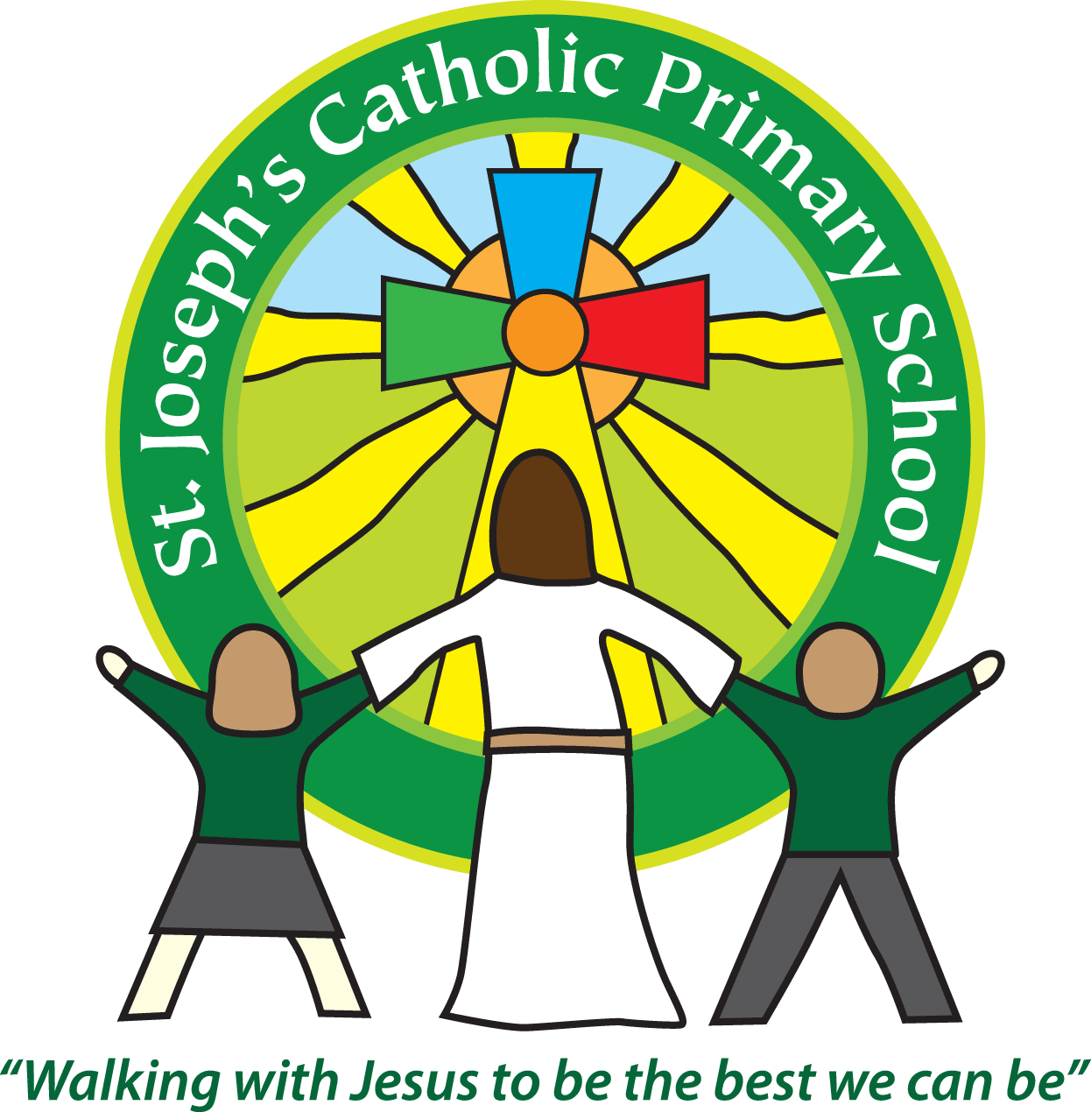
St Joseph’s Catholic Primary School Home Learning Pack
Class: Sycamore Year 2 – 11.05.2020
Please find the suggested timetable. This is just a suggestion and you need to find what works for you and your child as we understand that everyone learns differently. Just to be clear, we are not expecting everyone to do all of the activities and these are only suggestions. We understand that our circumstances are all very different at the moment and that lots of you will be trying to juggle ‘home school’ and your own work as well as caring for elderly neighbours and family. Please only do what you feel you can. We do not want to set anything that causes any worry so please do what you feel. There are some references to resources but they do not need to be printed and can be viewed online and the work can be completed or copied onto paper. Please contact us at admin@stjo.uk and in the subject name it… For (Your Child’s teachers name and Class) if you need any further support. For example; For Miss Rowe, Sycamore Class. This will help us to ensure your request is dealt with quickly.
Suggested Family Home Learning Timetable
This is a guide to help you establish a routine for your children – this is just a suggestion and you will need to adapt it to the needs of your family.
Time | Activity
Before 9.00 | Get up, washed, dressed, make beds and eat breakfast
9.00 – 9.30 | PE with Joe or family walk
9.30 – 9.45 | Drink and get ready for home learning
9.45 – 10.30 | English – writing, spelling or grammar activity from your home learning pack
10.30 – 11.00 | Break time - take a snack and drink outside if you can
11.00 – 11.45 | Maths – choose an activity from your home learning pack
11.45 – 12.30 | Creative time – draw, paint, sew, bake, do a job in the garden, stop-motion animation with lego / plasticine (the list is endless). Have a project that you can do a bit of everyday.
12.30 – 1.15 | Lunch – help to make it AND clear up behind it!
1.15 – 1.30 | Chores – do a job around the house e.g. put laundry away, tidy your room, vacuum or polish
1.30 – 2.00 | Quiet time – shared or independent reading
2.00 – 3.15 | Topic time – science / art / history / geography / music – choose a topic activity from the home learning pack
3.00 – 3.15 | Break time – take a snack and drink outside if you can
3.15 – 3.30 | Reading – enjoy a book together

All the PDF’s and resources will be on the school website under Coronavirus – Home Learning – Sycamore.
Maths |  | Activities | Resources
Day 1 | Can I select addition strategies? | This week, there is a TTRS Battle against the Teachers. Please have a go and contribute to your team score.  Use the Powerpoint from Day 1. If you do not have access to the PowerPoint, don’t worry because the Learning Reminders cover the same aspects.  Today’s learning is about exploring different strategies and looking at the most efficient way.  Use questions such as – Is there another way to work this calculation out? Is that the most efficient strategy? How do you know?  This will challenge their Maths thinking.  Work through reminders and complete activities. | PowerPoint Day 1  Day 1 Resource
Day 2 | Can I select subtraction strategies? | Today follows on with looking for different ways to work calculations out and exploring different strategies to select the most efficient way.  Work through the learning reminders and activities.  Revisit the questions from yesterday.  Use questions such as – Is there another way to work this calculation out? Is that the most efficient strategy? How do you know? | Resource Day 2
Day 3 | Can I add two 2-digit numbers? | Work through the learning reminders.  The focus is on the strategy. Using a numberline will support accuracy.  Complete the activities. | Resource Day 3
Day 4 | Can I recognise 2D shapes? | What is a 2D shape? How is it different from a 3D shape?  Work through learning reminders.  Complete activities. | Day 4 Resource
Day 5 | Can I recognise 2D shapes? | How many 2D shapes can you name?  Which shape has 5 sides?  Which shapes has 6 sides?  Which shape has 8 sides?  Which shapes have 4 sides?  If you can access the Powerpoint, you can use this but if not do not worry as it is the same as the learning reminders.  Work through the learning reminders and complete the activities. | Day 5 Powerpoint  Day 5 Resource

English |  | Activities | Resources
Day 1 | Can I write a recount? | Choose something you have done over the weekend.  It could be a walk or a cycle.  It might just be what you have been doing at home.  Write a recount. A recount is in 1st person.  You can include a title – for example:  My cycle ride to the beach  Then the first sentence includes who, what, where and when.  Yesterday I went for a cycle ride with my family to the beach.  We then sequence our ideas with first, next, then, after that, finally.  Try to include some expanded noun phrases to describe what you saw, how you felt and what you could hear.  Finish off with something that you really enjoyed for your concluding sentence. | Paper and a pencil
Day 2 | Can I write a diary entry? | We are in a time of History which we will look back on in years to come. Many diary entries help historians to find out what it was like in those times.  Create a diary entry. Include the date, what you have been doing, how you have felt, what has changed, what you like and dislike.  Try to include these conjunctions – when, if, because, so that, and, but, or.  Also remember to include adjectives to describe what it is like.  When Historians look back at diary entries, they did not experience the times so it has to include detail and description to describe this. | Paper  Pencil
Day 3 | Can I choose the correct spelling? | Make some flashcards with part of a word on:  midd  cam  bott  padd  tunn  app  squirr  ang  Then make two flash cards with the endings of the words.  le  el  Sort the words into columns underneath the correct ending.  Check if you are correct.  Challenge – Can you write them in sentences? | Blank flashcards to make
Day 4 | Can I compare poems? | Read through the poems.  Complete the activities. | Day 4 Resource
Day 5 | Can I create alliteration? | Alliteration is when two or more words begin with the same letter. For example: the tiny tree tried to tickle the tall tree.  Using these nouns, can you create your own alliteration?  boat  car  cat  dog  giant  dancer  butterfly  tractor | Pencil and paper

Suggested Reading Activities
Reading Daily
Please enjoy a bedtime story together each night. This week, start to make a dictionary of any words that you are unsure of the meaning of. In your reading, you will come across words that you are unsure of. Copy them out and discuss the meaning.
Spellings
Here are a list of this weekly spellings.
- city
- supper
- soon
- custard
- cone
- site
- celery
- fancy

You could quiz them each week, like we do in class if you would like to.

Varied activities of Science, Music, Topic (History, Geography, Art) and R.E
 |  | Activities | Resources
Day 1 | Can I classify? | This week, the whole school are being set another Science Task. This week it is about classifying.  Follow the attached resource.  Remember you can always send us in what you have been doing. | Task 3
Day 2 | Can I create a recycled sculpture? | From the 16th -24th May we are celebrating the anniversary of ‘Laudato Si’ the letter the Pope wrote to us all advising us what is happening to the Earth and how we can keep care of it. The Pope wrote this 5 years ago but it is still very much important today.  You can watch the video here.  https://cafod.org.uk/Education/Primary-teaching-resources/Laudato-Si-animation  Part of caring for our common home is to recycle. Can you make a model out of recycled materials? Create something to celebrate God’s world.  If you would like you could take a picture and send it to us.  admin@stjo.uk | Recycled materials
Day 3 | Can I find out about Capital Cities? | Continuing with our world theme this week…  Pick 10 countries.  Find out what the capital city of each one is. Write them down. Remember to include a capital for place names. | Paper and pencil
Day 4 | Can I identify the parts of a plant? | Watch this video.  https://www.bbc.co.uk/teach/class-clips-video/science-ks1-ks2-ivys-plant-workshop-parts-of-a-plant/zvdkpg8  Draw a plant.  Label these parts – roots, flower, stem, roots.  Identify what each part does. This is their function. Function describes the job that part of the plant is doing. | Website link
Day 5 | Can I create a superhero?  Can I talk about how to keep safe? | Work with a grown-up and read through the Cap booklet.  There are lots of activities in here about the importance of keeping safe and how we can do this.  You could complete some of the activities or design and illustrate your own ‘Safe Superhero’. Remember to give them a name. You could also label your pictures with qualities of their personality, e.g – kind, smart…  If you would like, you could send a picture of your superhero to admin@stjo.uk so that I can see! | Cap Booklet  Pencils and paper

