**Catch up funding – St Joseph’s Exmouth 2020-21**

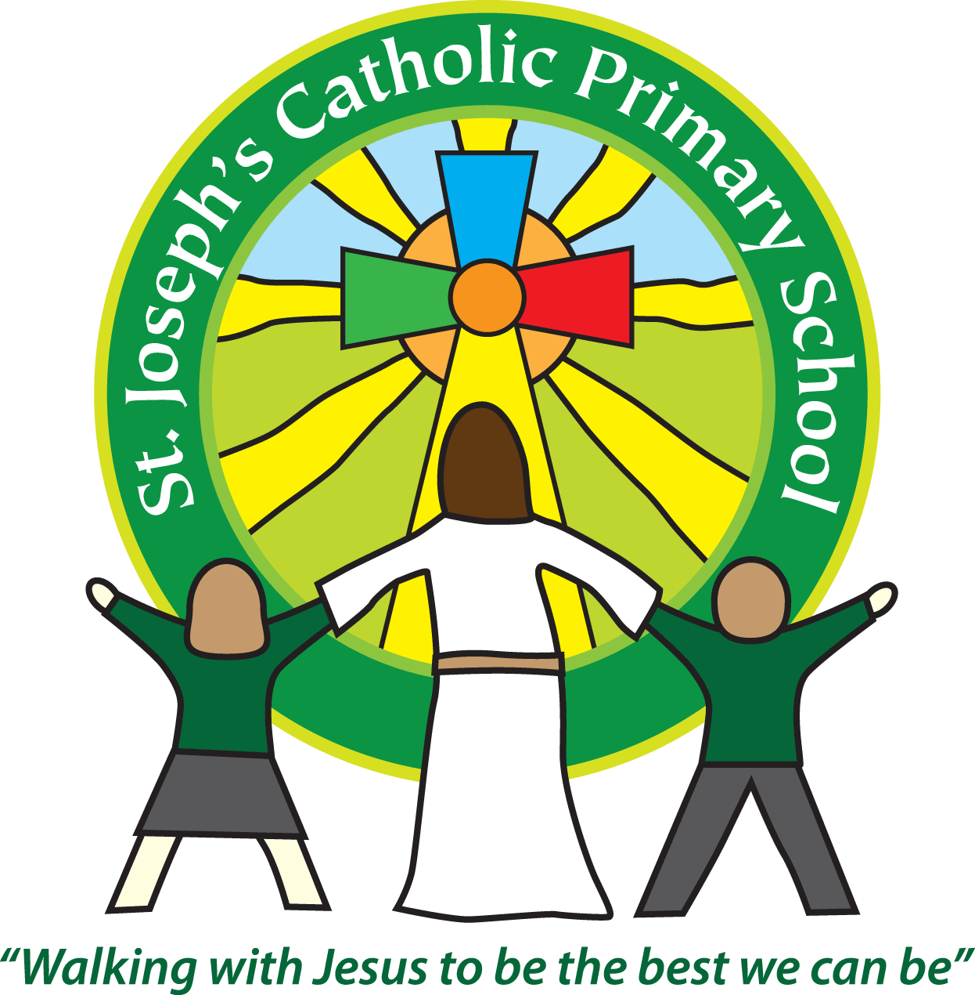

|  |  |  |  |
| --- | --- | --- | --- |
| Total amount - £13,760  Autumn Term £3,440 | | | |
| Focus Area | Action | Impact | Amount |
| Early reading and phonics | To catch up reading gap by providing decodable reading books for EYFS and KS1 | Children to be able to access reading books which match the sounds they are learning in class. This will then support them in catching up their gaps in reading and phonics | £5,300 |
| Early Language development  Nuffield Early Language Intervention | To catch up the vocabulary skills in EYFS | Children to be able to communicate effectively and progress with their peers. | £500 |
| Maths and Writing | To provide small group support by experienced teaching assistant | Children to have small group focussed support to ensure they can catch up and reach ARE. | £2376 |
| RWM | To purchase Chrome books so all children have access to Chrome books in class therefore allowing them to access online school learning programmes - AR, IXL, Nessy | Children to be able to use Chrome books when required to quiz on books, access spelling programme and targeted RWM support on IXL. | £199 x 10 = £1999 |
| Maths | To purchase White Rose Maths to support maths catch up in class and as part of remote learning. Previously used in lockdown successfully. | Children to have access to quality maths online learning to support catch up at school in small groups and at home. | £199 |
| SEMH teacher | To support those children who have fallen behind and are struggling to attend school and access lessons. To work with families and staff to support children as well. | Children to be in school and accessing lessons. | M3  £23.41 per hour including on costs  £3036 |
| Power of Reading | Whole school membership to provide planning for a cohesive curriculum to support those struggling to catch up in reading | For children who have fallen behind in reading to catch up and make at least expected progress. | £350 |
| Total |  |  | £13,760 |