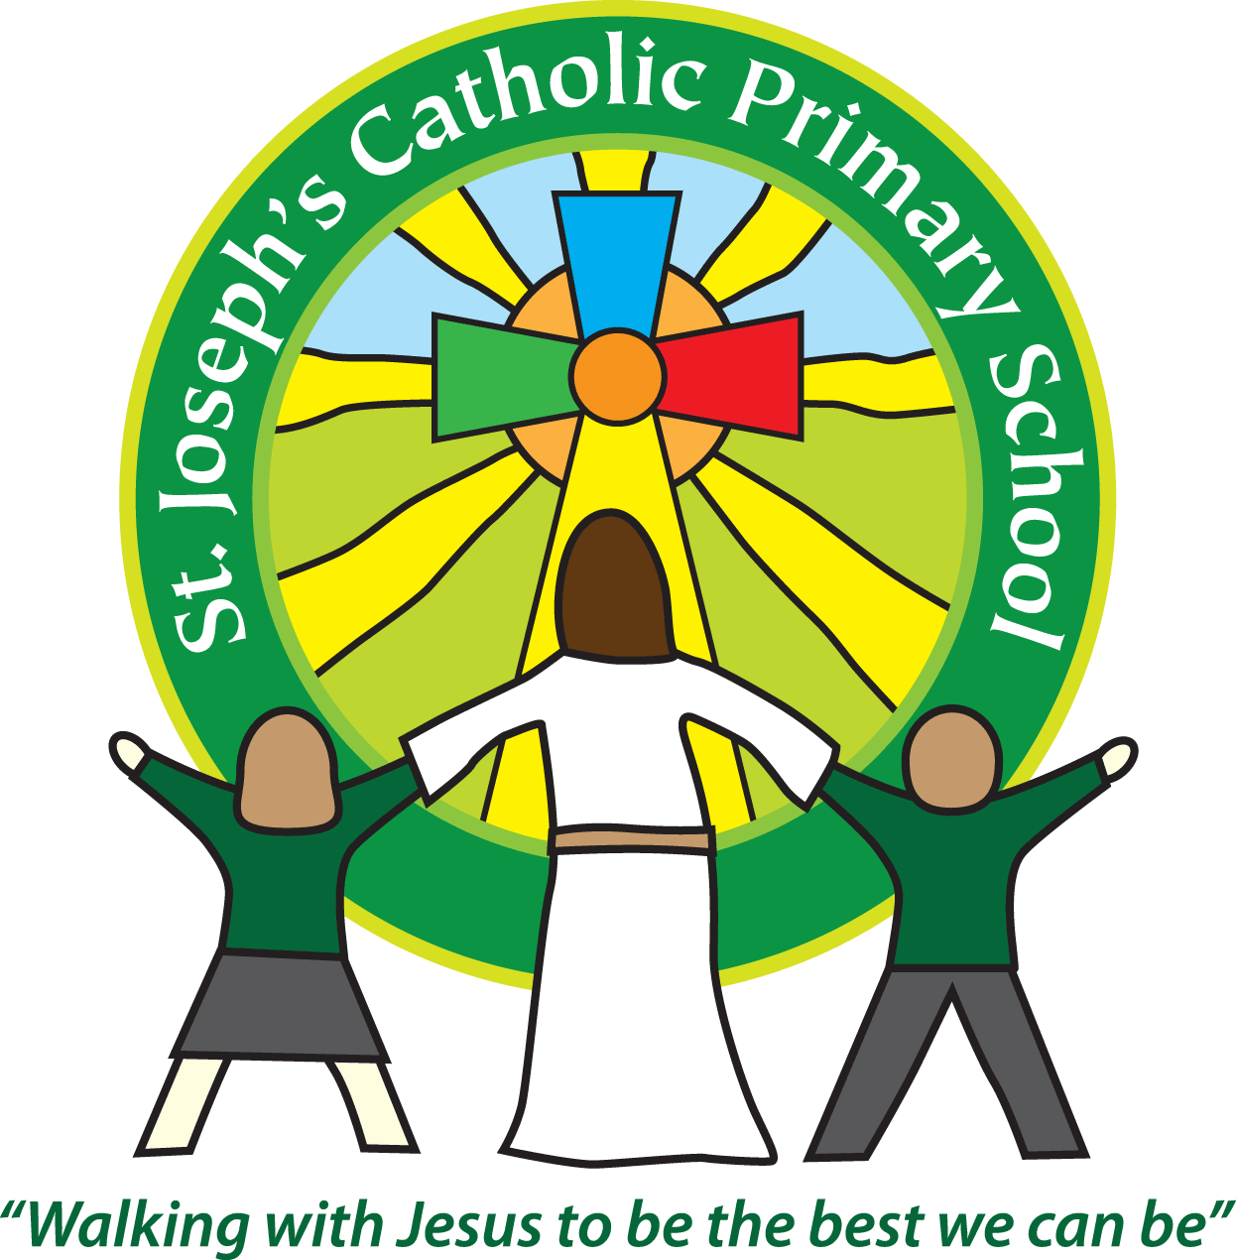

St Joseph’s Catholic Primary School

Newsletter

January 13th 2017

**Dear all,**

It has been a busy week here at St Joseph’s. The children are now in full swing with their topics and there is a lovely buzz of learning around the school.

Thank you to the many children who donated their toys for Syria. They are all being taken up to Exeter tomorrow to be loaded on the lorry and then off to Syria. I’m sure the children in Syria will be delighted when they receive them and hopefully it will bring a bit of fun and laughter into their lives.

**After school club:**

Please send back your completed questionnaires that came home earlier in the week. Your feedback is vital for us to make a decision about out of hour’s provision.

**Free School Meals:**

If you think you may qualify for Free School Meals and are currently not in receipt of it, please do ask at the office or see the form on the school website.

**Primary School Admissions:**

The closing date for school admission for this September 2017 is on Sunday 15th January. Please do not miss the deadline or there is no guarantee you will be able to get a place.

**Attendance:**

As a school we have to monitor the attendance of all our children and have regular meetings with the Local Authority Education Officer. I have become aware that at St Joseph’s our attendance levels are dropping. Whilst I appreciate that some medical absences are unavoidable parents will now receive a graduated series of letters if their child’s attendance starts to fall. Please see the separate letter with more information about attendance.

**Reminders for next week:**

Year 5 need their swimming kit on Monday

The PTA have a meeting on Tuesday in the staff room at 9.10am – everyone welcome.

Year 3 have their cake sale on Tuesday at 3.30pm. Please send in any donated cakes on the Tuesday morning.

Year 4 Class assembly on Wednesday 9.10am in the hall.

**Best wishes and thank you for your continued support**

**Mrs Taylor-Bashford**

**Headteacher’s Awards:**

**Bronze certificates:** FSU – Alfie, Yr 2 – Elliott, Lewis, Sophie, Liam, Vince, George, Patrycja, Yr 5 – Tom, Alex and Yr 6 – Nina

**Stars of the Week:** FSU – Emily, Yr 1 – Freddie, Yr 2 – Callum, Yr 3 – Izzy, Yr 4 – Felix, Yr 5 – Maisie, Yr 6 - Benjamin

