St Joseph’s Catholic Primary School Home Learning Pack – 11.05.2020
Willow Class

Please find the suggested timetable. This is just a suggestion and you need to find what works for you and your child as we understand that everyone learns differently. Just to be clear, we are not expecting everyone to do all of the activities and these are only suggestions. We understand that our circumstances are all very different at the moment and that lots of you will be trying to juggle ‘home school’ and your own work as well as caring for elderly neighbours and family. Please only do what you feel you can. We do not want to set anything that causes any worry so please do what you feel. There are some references to resources but they do not need to be printed and can be viewed online and the work can be completed or copied onto paper. Please contact us at admin@stjo.uk and in the subject name it… For (Your Child’s teachers name and Class) if you need any further support. For example; For Mrs Spinks, Willow Class. This will help us to ensure your request is dealt with quickly.
Suggested Family Home Learning Timetable
This is a guide to help you establish a routine for your children – this is just a suggestion and you will need to adapt it to the needs of your family.
Time | Activity
Before 9.00 | Get up, washed, dressed, make beds and eat breakfast
9.00 – 9.30 | PE with Joe or family walk
9.30 – 9.45 | Drink and get ready for home learning
9.45 – 10.30 | English – writing, spelling or grammar activity from your home learning pack
10.30 – 11.00 | Break time - take a snack and drink outside if you can
11.00 – 11.45 | Maths – choose an activity from your home learning pack
11.45 – 12.30 | Creative time – draw, paint, sew, bake, do a job in the garden, stop-motion animation with lego / plasticine (the list is endless). Have a project that you can do a bit of everyday.
12.30 – 1.15 | Lunch – help to make it AND clear up after it!
1.15 – 1.30 | Chores – do a job around the house e.g. put laundry away, tidy your room, vacuum or polish
1.30 – 2.00 | Quiet time – shared or independent reading
2.00 – 3.00 | Topic time – science / art / history / geography / music – choose a topic activity from the home learning pack

All of the resources for the home learning below can be found at: https://www.stjosephsprimaryschool.com/website/home_learning_04052020/477542 on the Coronavirus information page – Home learning and then select the date and appropriate class.
Maths | Activities | Resources
Times tables | Please continue to practise your times tables everyday this can be done on TTRS or offline through a variety of games and activities. Here are a few ideas to help you:  - Use playing cards – Choose 2 cards at a time and multiply the numbers together and then discuss corresponding division facts.  - Exercise while reciting your times table facts e.g. skipping  - Play times table ping pong – in partners take it in turns to ask each other questions  - Times table bingo – draw a 3x3 grid and choose numbers from the tables – bingo caller to ask multiplication and division question.  - Why not invent your own times table game to play?
Day 1 | Can I multiply by multiples of 10 and 100?  - Go through the power point or read the learning reminders to refresh your understanding.  - Complete the practice questions  - If you are finding it tricky complete the ‘A bit stuck sheet’.  - Have a go at the investigation to check your understanding. | PDF document ‘Maths day 1’ on the website.  Power point Maths day 1
Day 2 | Can I multiply by multiples of 10 and 100?  - Read the learning reminders to refresh your understanding.  - Complete the practice questions  - If you are finding it tricky complete the ‘A bit stuck sheet’  - Have a go at the investigation to check understanding | PDF document ‘Maths day 2’ on the website.
Day 3 | Can I multiply and divide mentally?  - Read the learning reminders to refresh your understanding.  - Complete the practice questions  - If you are finding it tricky complete the ‘A bit stuck sheet’.  - Complete the questions to check your understanding | PDF document ‘Maths day 3’ on the website.
Day 4 | Can I create a symmetrical pattern?  - Read the learning reminders to refresh your understanding.  - Complete the practice questions  - If you are finding it tricky complete the ‘A bit stuck sheet’.  - Complete the questions to check your understanding. | PDF document ‘Maths day 4’ on the website.
Day 5 | Can I draw symmetrical shapes?  - Read the learning reminders to refresh your understanding.  - Complete the practice questions  - If you are finding it tricky complete the ‘A bit stuck sheet’.  - Have a go at the investigation to check understanding. | PDF document ‘Maths day 5’ on the website.

Please continue to keep a written diary recording what you have done each day.
English | Activities | Resources
Day 1 | Can I use evidence from the text to predict the ending of a story?  - Read Ananse, the forgetful guest Part 1.  - Answer the questions on part 1.  - Use Story Summary and Predictions to predict what might happen at the end of the story. | PDF document ‘English day 1’ on the website.
Day 2 | Can I use adverbials in my writing?  - Read Ananse, the forgetful guest – Part 2. Did you predict the ending correctly yesterday?  - Look through the power point to revise adverbials.  - Re-write each of the sentences from Ananse Adverbials with a new adverbial. | Adverbial power point on the website.  PDF document ‘English day 2’ on the website.
Day 3 | Can I write a story with adverbials?  - Look at Ananse. How could you describe this character?  - Write your ideas carefully around the picture of Ananse or onto a plain piece of paper.  - Answer the Story Prompt Questions.  - Plan out a story based on your ideas.  - Write your story about Ananse. Try to include some adverbials in your writing | PDF document ‘English day 3’ on the website.
Day 4 | Can I understand different poetic terms?  - Read Spaghetti Spaghetti. Read it twice: once in your head and once out loud.  - Read ‘What is an ode?’ and ‘Poetry Terms’.  - Read three more poems: Apple Pie, Ode to an Olive and Ode to a Chestnut on the Ground. | PDF document ‘English day 4’ on the website.
Day 5 | Can I write an ode?  - Read Ode to Marbles.  - Think of your favourite food. Write it down and now plan an ode about it.  - Write some of your favourite ideas on the Ode Strips.  - Copy your poem out carefully. Use your best handwriting! | PDF document ‘English day 5’ on the website.

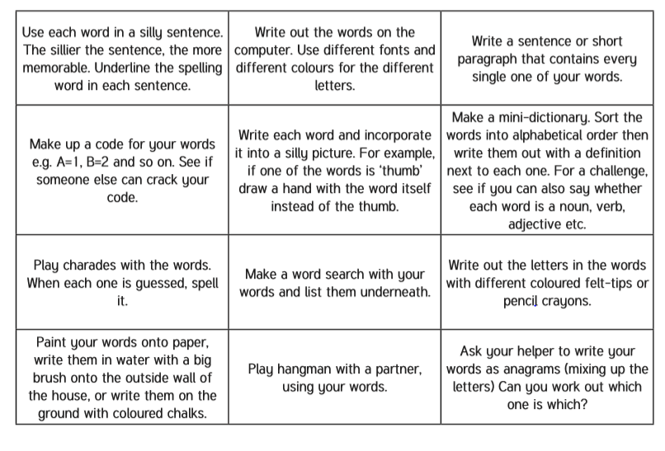
Spelling – Practise the year 4 spellings using a range of strategies. Below are some ideas that you can try.

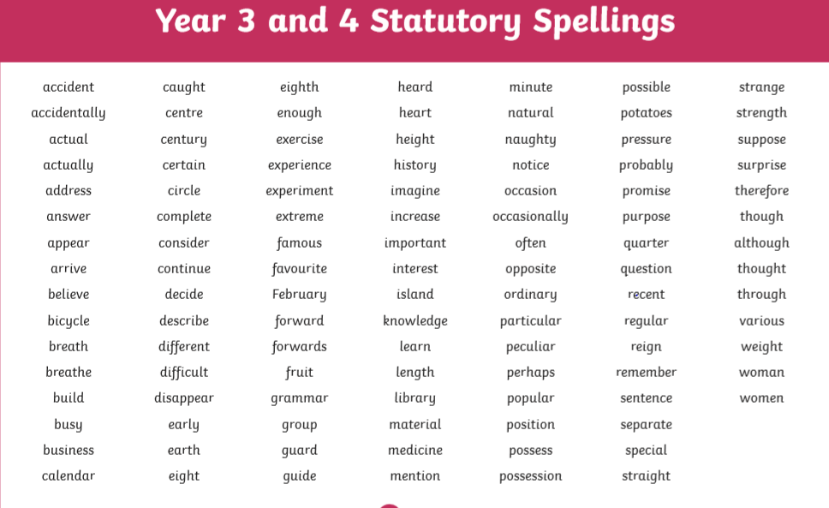
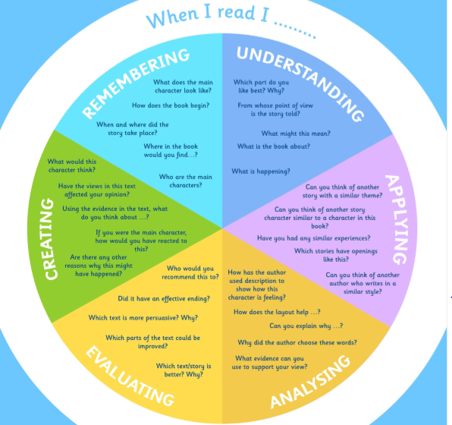
Suggested Reading Activities
This is an essential skill that the children need to continue to practise daily. It is recommended that the children read for at least 20 minutes each day. Continue to record all reading in the reading record books and remember to quiz on accelerated reader. You should have received an email with log in details. Please contact me if there is an issue with this. When listening to your chid read ask questions regularly to check and support understanding. Here is some example questions which would really support the children in their development.

Varied activities of Science, Music, Topic (History, Geography, Art) and R.E
 | Activities | Resources
Activity 1 | In 2015, Pope Francis wrote a letter called Laudato Si’. It was addressed to everyone on the planet, asking everyone to protect our common home… the Earth.  - Watch the clip about Laudato Si’ or research using books or online.  - Reflect on Pope Francis’ message – Do you think things have changed?  - Write a reflective prayer or poem about ‘Our Common Home’ | https://www.youtube.com/watch?v=KOgF2Kgel6k&feature=emb_logo
Activity 2 | This week, why not think deeply about Our Common Home and get creative with a recycled art project?  You could reuse plastic or cardboard from around the house and create something celebrating God’s wonderful world.  - Use materials to create a piece of art to celebrate ‘Our Common Home’ | Recycled materials from your home.
Activity 3 | Follow the instructions to create a lava lamp  - Before you start the experiment write down a prediction as to what you think might happen and why.  - Add three spoons of bicarbonate of soda into the tall glass or bottle  - Fill two thirds of the container with oil – Don’t mix it!  - In the small cup, add some vinegar and a few drops of food colouring.  - Slowly add drops of your coloured vinegar into the oil mixture in the tall glass or bottle  - Watch your lava lamp come to life  - Look back at your prediction were you correct? Is there anything that you would change or add?  - Draw a diagram of your experiment and label it | You will need:  Vegetable/sunflower oil  Vinegar  Food colouring  Bicarbonate of soda  Tall glass or bottle  Spoon  Small cup
Activity 4 | Can I say the months of the year in French?  - Follow the instructions on the attachment  - Play the game to help you to remember the months of the year  - If you don’t have a dice at home you could use one. I have attached a dice net if you need one. | French worksheet on the website.  Dice net
Activity 5 | Can I classify?  - Select at least 10-15 random objects in your house. Consider how they are similar and how they are different to each other.  - Create a classification key to identify your selected objects. | Science task 3 – Classifying on the website.

