Can I write an information text about a volcano situated on the ring of fire?
Activity: Plate boundaries and the Ring of Fire
The tectonic plates that make up the Earth’s crust sit on top of the mantle – a thick layer of molten rock. Currents within the mantle mean that the molten rock flows and so the plates that sit on top of it move. The currents move the plates in different directions and this causes geological activity at their boundaries (where 2 plates meet).
- Plates slide past each other – where this happens, earthquakes are common e.g. San Andreas Fault in California
- Plates move away from each other – volcanoes form along these boundaries releasing magma which cools and eventually creates new crust. An example of these occurs along the mid-Atlantic ridge and is resulting in North America and Europe moving further away from each other.
- Plates move towards each other – two things can happen:
- one plate slides under the other causing friction which results in earthquakes and the melting of the earth’s crust. This results in magma which rises up through cracks and erupts onto the surface (a volcano). These are known as subduction zones.
- plates collide and push each other up – this results in fold mountains forming e.g. the Himalayas
A video clip which shows this can be found here: https://www.bbc.co.uk/bitesize/topics/z849q6f/articles/zj89t39

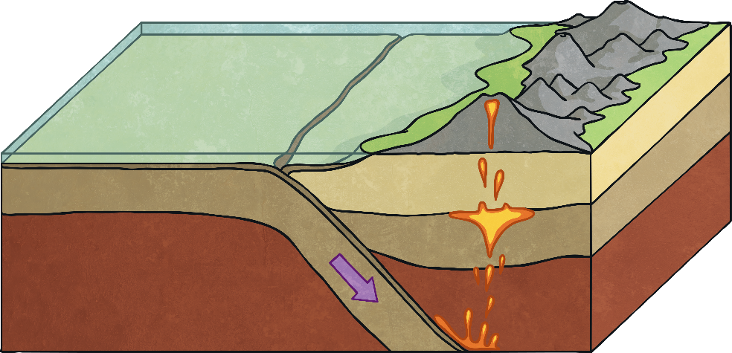
subduction zone
two plates meet – one slides under the other

If you want to know more, read the Plate Tectonic Information Text attached below.

The ring of fire is a boundary between plates where 75% of the world’s volcanoes and 90% of the world’s earthquakes occur. It is shown as a horseshoe-shaped line on a map:

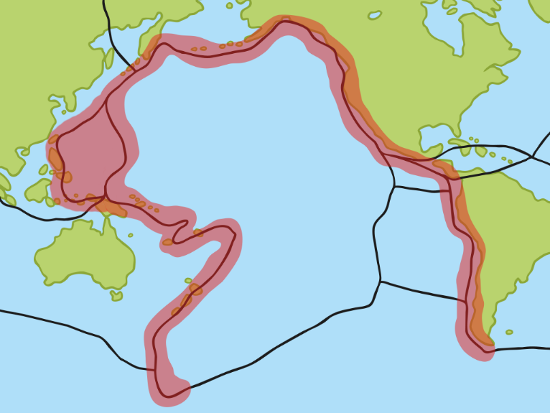
San Andreas Fault
Pacific Plate

The Ring of Fire is mostly subduction zones (where one plate slides under another) and so earthquake and volcanoes are common along this line. There are at least 452 volcanoes along the Ring of Fire – your task is to find out about one of them. Some famous ones include: Mount Fuji (Japan), Mount St Helen’s (America) and Popocatepetl (Mexico). How are the lives of people living near to the volcano affected? What are the advantages and disadvantages? Why do people continue to live so close to a volcano? Write a short information text about your chosen volcano. Remember to set it out like a non-fiction text with headings, sub-headings, diagrams and pictures (with captions).

