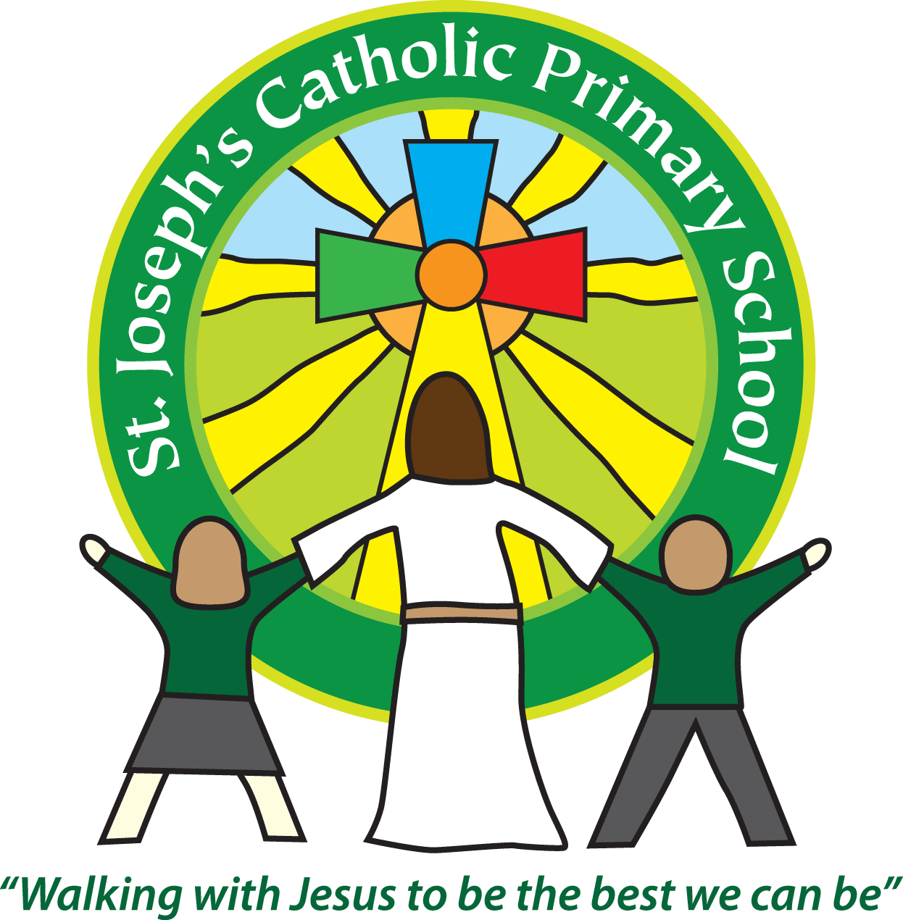St Joseph’s Catholic Primary School
Year 1 – Spring (1st half)
Welcome back. We hope you had a wonderful Christmas and New Year break as a family.
Thank you so much for all the generous cards and gifts we received at the end of last term.
We are thrilled with how the class are blossoming in their learning. Thank you to all of you for continuing to support reading at home. We will be having a big focus on spelling this term. There is a list of spellings for each year group to learn. The list sent out before Christmas is the list for Year 1 that we will be supporting them with this year. If you would like any further advice or support with spelling then please get in touch.
Every Friday we collect in the reading records to update them. Please can you record any reading in these and have them in school ready for Friday morning. Children should be aiming to read 5 x a week.
We post homework on Google Classroom every Friday as well as any other updates. It is vital that you check it each week. Please let us know asap if you have any problems.
This half term our topic is ‘You’re Great Britain’
Please see attached our topic overview.
Year 1 home learning
Subject
Reading | Friday | We expect the children to read at home daily. Daily practice can really support your child’s progress, even if it is just for five minutes every day. Each week we will continue with the three reading practise sessions, they will then share this with you at home. They will also bring home a book to read for pleasure to share with you. Thank you for your support with this. As part of your reading routine, you can support your child by asking questions about the book. E.g How is Lucy feeling when …….? What do you think will happen next? Can you discuss your favourite words and phrases?
English/Maths/Topic/  Spelling | Friday | Every week we will post spellings, a Maths task and an English task linked to our learning in class that week. Homework will be posted every Friday on Google Classroom. Please share with us any home learning on Google Classroom.

Reminders
School lunch and snacks | Year 1 children are entitled to a free school lunch every day. Please see the school website for the menu and now order the meals on Parent Pay. You can send a packed lunch if you prefer.  We promote healthy eating at school and so lunch boxes should not contain more than one chocolate snack and one packet of crisps.  Children are welcome to bring fresh fruit or vegetables for a snack at break time.  We are a nut free school. We have children with potentially fatal nut allergies in school, therefore no food containing nuts may be sent into school.
Drinks | Your child must have a named water bottle in school every day. Please only send in water, no juice or fizzy is allowed.
Uniform | Please ensure all uniform is clearly named.  Grey trousers or shorts, grey skirt or pinafore dress, white or grey socks, grey tights, White polo shirt, Green logo school sweatshirt or cardigan. Warm weather option – green and white gingham dress (dress with shorts instead of skirt is acceptable)  Hair past shoulder length must be tied back – please use plain hairbands in green, black or white, not brightly coloured bows.  Nail varnish is not allowed. School shoes must be black and no heels, trainers or boots.
PE kit | Green t-shirt with school logo, black shorts, black or navy jogging bottoms and trainers. All kit must be named and in a named bag.  Ear rings must be removed or covered with tape for PE lessons.  Watches must be removed for PE.  PE kit must be worn to school on a Thursday.
Bags | Reception, Yr 1 and 2 children must have a book bag in school. This is so books can easily be checked and letters put in.  Children can have a bag or rucksack in school, but please avoid the large bulky ones as 30 rucksacks take up a lot of room in the class.
Mornings | School starts promptly at 8.55am.  Your child will be greeted at the patio gate by an adult. Please only pass on quick messages then, for a longer meeting please make an appointment.  Children and parents arriving after 9.00am will be asked to sign in at the office.
After school | School finishes at 3.30pm. If someone other than yourself is collecting your child please ensure the office has their details. We will not let them leave unless we are sure they are safe.
Contact details | Please ensure you contact details and those of other people who may collect your child are always kept up to date. Please see the office asap if you change your phone number or address.

Teaching assistants: The teaching assistants working in our class this term are Mrs Kerr and Mrs Jones.
Specialist teachers: Mrs Gates will continue to work with the children every Thursday afternoon and alternate Monday afternoons.
Key Dates for the Diary:
Wednesday 1st February – Cultural Awareness day
We recognise the importance of passing information between parents and school so we are available at the start and end of the day if you need to pass on any messages. However, if you would like a longer chat please make an appointment with us.
Yours sincerely,
Mrs Robertson and Mrs O’Mahony.

