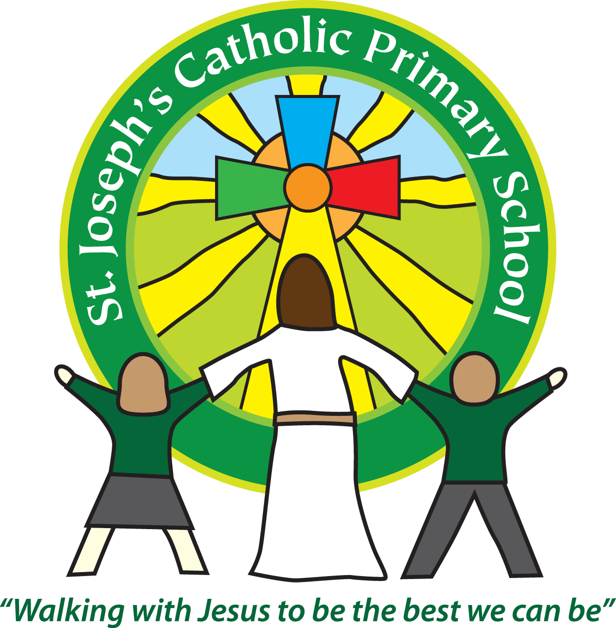

St Joseph’s Catholic Primary School

Newsletter

July 8th 2016

**Dear all,**

It is certainly busy in the run up to the summer holidays! This week has had the new teacher day, which as I was walking around, seemed to involve lots of laughing and fun!

Thank you to those of you who attended the parent talks after school on Wednesday. It was a good opportunity to ask any questions and find out about the expectations for the year ahead and for some to get some homework for the children to do over the holidays!

The Year 6s who went to the Latin taster day at Exmouth Community College yesterday did very well; some have won e-praise points for the college already! Some of the teachers from ECC passed on comments about the excellent behaviour the St Joseph’s children demonstrated at their transition day last week, which was really lovely to hear.

This week also saw the second sleepover in as many weeks. Last week’s being the Yr. 6’s at the Church and this week being the Yr. 3/4’s at school. The children have had a wonderful time – although having attended both I am now feeling a little tired! Many thanks to all the teachers involved.

Exmouth library have been in today talking about their summer reading competition. If any of you have time for your children to do this over the summer holidays it is a great way to encourage their enthusiasm for reading and to keep practising their skills.

Next week is looking equally busy:

**Wednesday 13th July 9.15am -FSU celebration assembly** in the hall – everyone welcome.

**Wednesday 13th 3.30-5.30pm - The Summer Fair.** This is one of the biggest events in the school year for the PTA and it would be really lovely if we could have as many people there as possible. This year there are: children’s performances, a fire engine, bbq, creation station, bouncy castle, games, lucky dips and much more.

**Thursday 14th 3.30pm** – Tanya will be selling **nearly new uniform** on the playground for anyone who wants to be very organised for next term!

**Thursday 14th 6pm** – Andrea from Rainbows is giving a talk to parents about **‘How to talk to your children about bereavement and significant changes’** This is not a talk just for parents whose children have been significantly affected by bereavement but for parents of children who may know another child who has been bereaved and so your child is coming home with questions or worries themselves.

**Friday 15th 3.00pm** – **Violin concert** - The children who have been having Violin lessons will be putting on a short concert to show what they have been learning – everybody welcome.

**Friday 15th 6.00pm** – Our **Public speaking finals**. I have heard the children practising and am really looking forward to the evening.

**Sunday 17th** – **The Church Summer Fair** – lots of stalls and fun for all the family.

**Best wishes & thank you for your continued support**

**Mrs Taylor-Bashford**

**Headteacher’s Awards:** Well done to: Sophie Yr1, Jasmine Yr1, Archie Yr3, Jeff Yr 3, Hermione Yr5

Stars of the Week:

FSU – Edith & Lewis, Yr 2 – Chloe, Yr 3 - Freddy, Yr 4 - Carmela, Yr 5 - Amelia, Yr 6 - Oliver

Gospel Value Bronze certificates:

FSU – Elizabeth, Alicia, Isabella, Alfie, Nicholas, Ella, Annie, Lola, Yr 2 - Lola, Thomas, George, Izzy, Yr3 - Cameron, Freddy, Felix, Jeff, Maddison, Darcie, Yr 4 – Maisie, Brandon, Charlie, Tom, George, Evelyn, Yr5 – Lillie, Yr 6 –Jessie, Kaitlin, Kaela

Gospel Value Silver certificate – Yr 6 - Devon

