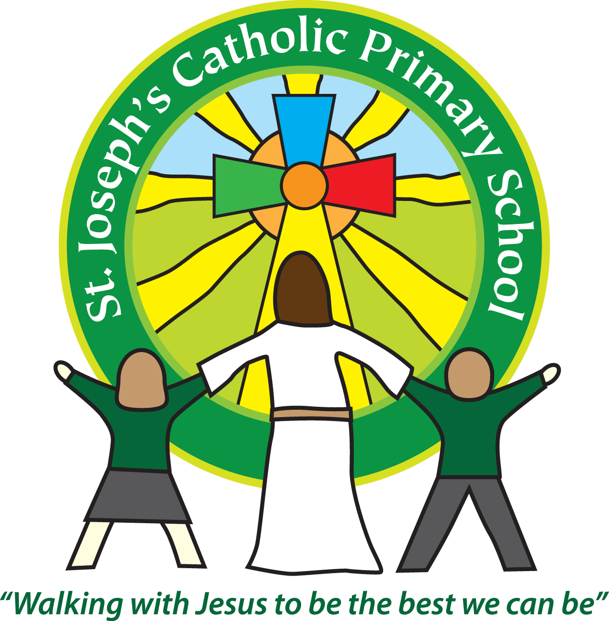

St Joseph’s Catholic Primary School

Newsletter

July 15th 2016

**Dear all,**

**The Penultimate week!**

What a super week it has been! We had an amazing FSU assembly. The children spoke clearly and sang beautifully. I couldn’t believe how many words they had learnt and how confident they were; it was very impressive.

Then we had our Summer fair, what a relief the weather was fine! Thank you so much to everyone who helped out, especially our super PTA for organising it all. Even the fire brigade breaking the gate open couldn’t dampen our enthusiasm! As with all these events it never ceases to amaze me how generous everyone is and therefore how much money is raised.

Thank you to all the people who attend the bereavement talk last night. I hope you all found it useful and that it will support you with how to help your children when they ask difficult questions.

Later today is our Violin concert and then the Public Speaking final, both of which I’m really looking forward to.

**New technology**

I have recently been made aware of a new app that has been released called ‘Pokemon Go!’ As a Head teacher it has immediately flagged up some potential concerns I have for our children if they are using it. (It is an app for using around the local environment not in school). Yr 5 kindly did a super piece in assembly this morning, talking to the school about the app and they have written a letter about it which is on the reverse of this. As with all these apps there are pros and cons and we just want to make sure you are aware of these.

**SATS results**

As we approach the final week for our Yr 6’s we are pleased to report that for all the SATs tests the children scored higher than the National average.

|  |  |  |
| --- | --- | --- |
| Subject | St Joseph’s | National |
| Grammar, Punctuation & Spelling | 90% | 65% |
| Reading | 84% | 66% |
| Maths | 71% | 70% |

Writing is teacher assessed not test based and for that we are looking at 68% against 74%.

I would like to say a big well done to all the children and staff for all their hard work, especially with the uncertainty of the new tests this year.

**Chicken pox**

We have had a case of chicken pox in the school. Please be aware to look out for symptoms particularly if you are pregnant.

**Outstanding fees**

We currently have £831.58 outstanding in dinner money, breakfast club and nursery fees. Please can I ask that if you have fees outstanding you pay them immediately, using either cash, cheque or card at the office or Parentpay online. Due to the amount of fees that we are having to chase, from September if anybody has more than two weeks dinner money outstanding they will have to bring packed lunches until the fees are paid.

**Best wishes & thank you for your continued support**

**Mrs Taylor-Bashford**

**Headteacher’s Awards:** Well done to: Orla Yr 1, Vince Year 1, Joseph Yr 1, Piran Yr 1, Isabella Yr1, George Yr1, Oliver Yr1, Nina Yr 5, Edward Yr 5

Stars of the Week: FSU – Aleksy, Yr 1 – Callum, Yr 2 – Ralph, Yr 3 – Jack, Yr 4 – Damon, Yr 5 – Ellori, Yr 6 - Rosie

