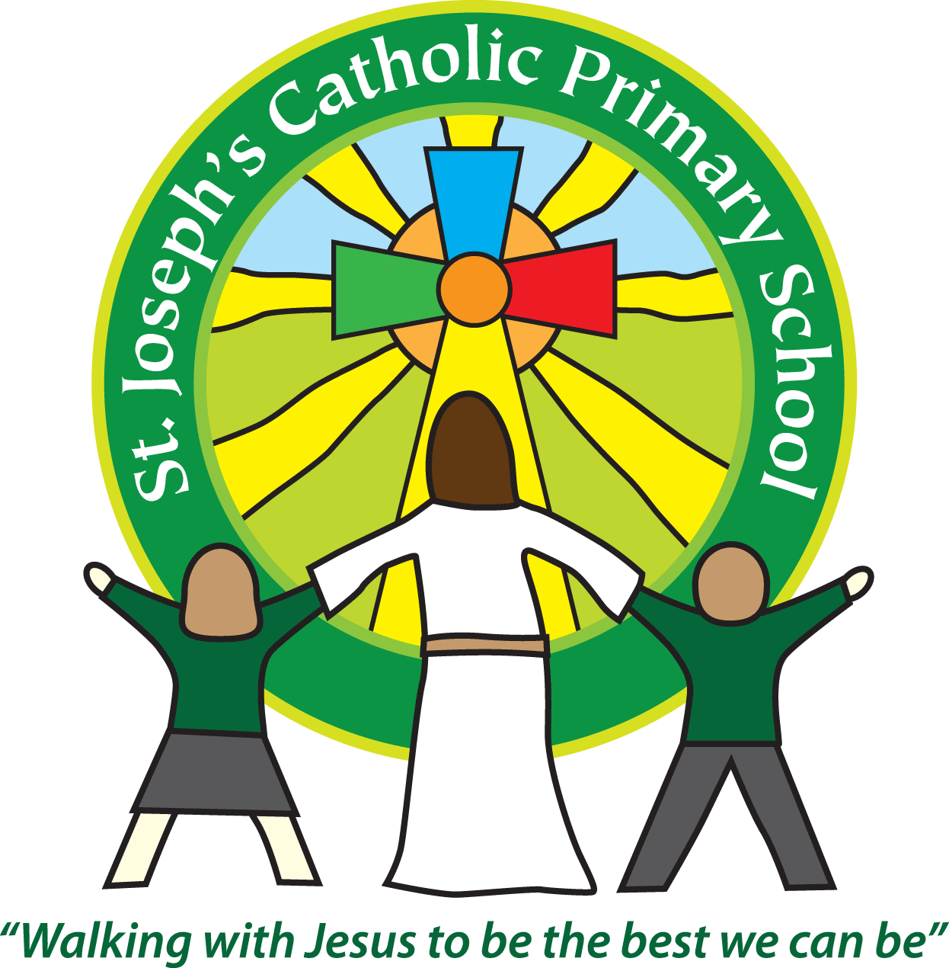Diary dates for parents/carers Autumn 2019

|  |  |  |
| --- | --- | --- |
| Date | Time | Event |
| September |  |  |
| Monday & Tuesday 2nd/3rd Sept | All day | School closed for Non-Pupil days |
| Wednesday 4th September | 8.55am | Children return to school after summer holidays |
| Wednesday 4th September | All day | Home visits for new Oak children |
| Thursday 5th September | 8.55am | Oak children start |
| Thursday 5th September | 3.30pm | Science Club starts |
| Friday 6th September | 9.30am | Mass in School, everyone welcome |
| Monday 9th September | 9.00am | Self-defence presentation for new after school club |
| Monday 9th September | Various times | Violin lessons start |
| Monday 9th September | Various times | Spanish Club starts |
| Wednesday 11th September | 3.30pm | Running Club starts |
| Friday 13th September | 3.30pm | PTA Summer Fayre – please join us to raise much needed funds for the school. |
| Saturday 14th September | 10-12 noon | Forest School working party – volunteers needed! |
| Monday 16th September | Morning | Gymnastics sessions for Oak, Rowan and Sycamore |
| Monday 16th September | 3.30pm | Football Club starts |
| Tuesday 17th September | Morning | Gymnastics sessions for Cherry, Willow, Maple and Beech |
| Wednesday 18th September | TBC | Beech and Oak Classes trip to the Maer. |
| Tuesday 24th September | Morning | School photos |
| Wednesday 25th September | TBC | Maple and Willow Classes, schools’ conference on “Protecting the Environment” at Ocean, LED. |
| Thursday 26th September | 1.45-3.15pm | Patchwork parenting course starts |
| Thursday 26th September | Evening | Exmouth Community College open evening |
| Friday 27th September | 3.30pm | Catch up photos for any children away on Tuesday or for children with siblings that are not in school. |
| Monday 30th September | 4-6pm | Cross Country race at Bicton |
| Monday 30th September – Thursday 3rd October | 3.30 – 5.45pm | Parents evening, including SEND meetings, times to be issued |
| October |  |  |
| Wednesday2nd October | All day | National walk to school day |
| Thursday 3rd October | All day | FSU Forest School day |
| Monday 7th October | 4-5.30pm | Hi 5 competition, group from years 5 and 6. |
| Tuesday 8th October | 9.10-10am | Maple Class parent activity session |
| Tuesday 8th October | 2.15 – 3.15pm | Cherry Class parent activity session |
| Tuesday 8th October | 4 – 6pm | Cycle Cross competition, group from years 3-6 |
| Wednesday 9th October | Morning | Oak Class Eye tests |
| Wednesday 9th October | 9.10 – 10am | Sycamore Class parent activity session |
| Wednesday 9th October | 2.15-3.15pm | FSU parent activity session |
| Monday 14th- Friday 18th October | Residential | Beech Class PGL trip |
| Tuesday 15th October | TBC | Cherry and Willow Class trip to Farmwise, Westpoint |
| Monday 21st – Monday 28th October | All week | HALF TERM |
| Monday 28th October | All day | NON-PUPIL DAY |
| November |  |  |
| Friday 1st November | All day | Dress up as a Saint Day |
| Monday 4th November | 2.15 – 3.15pm | Willow Class parent activity session |
| Tuesday 5th November | Various times | Environmental workshops for Oak, Rowan, Sycamore, Cherry Classes. |
| Wednesday 6th November | 9.10-10am | Rowan Class parent activity session |
| Thursday 7th November | 9.10am | CAP UK assembly for Classes 1-6 |
| Friday 8th November | 9.10-10am | Beech Class parent activity session |
| Monday 11th – Friday 15th November | All week | Anti-bullying week |
| Monday 11th November | 2.15-4.15pm | Hi 5 competition, group from years 5 and 6. |
| Tuesday 12th November | All day | Rowan and Sycamore Class trip to Living Coasts |
| Thursday 14th November | Various times | Environmental workshops for Willow, Maple and Beech Classes. |
| Friday 15th November | All day | Children in Need day. For £1 dress up in something that makes you smile! |
| Sunday 24th November | 10.30-1pm | Church welcome Mass for Reception children and fayre |
| W/beginning 25th November | 3.30pm | SEND parents’ meetings, times to be issued |
| Tuesday 26th November | 10 – 12 noon | Hi 5 festival, group from years 3 and 4. |
| Wednesday 27th November | All day | Governor day |
| December |  |  |
| Friday 6th December | TBC | Years 3- 6 to watch Bournemouth Symphony Orchestra |
| Tuesday 10th December | 10am & 6pm | Rowan and Sycamore Nativity performance |
| Thursday 19th December | 3.30pm | School finishes for Christmas holidays |
| Monday 6th January | 8.55am | Children return for Spring term |