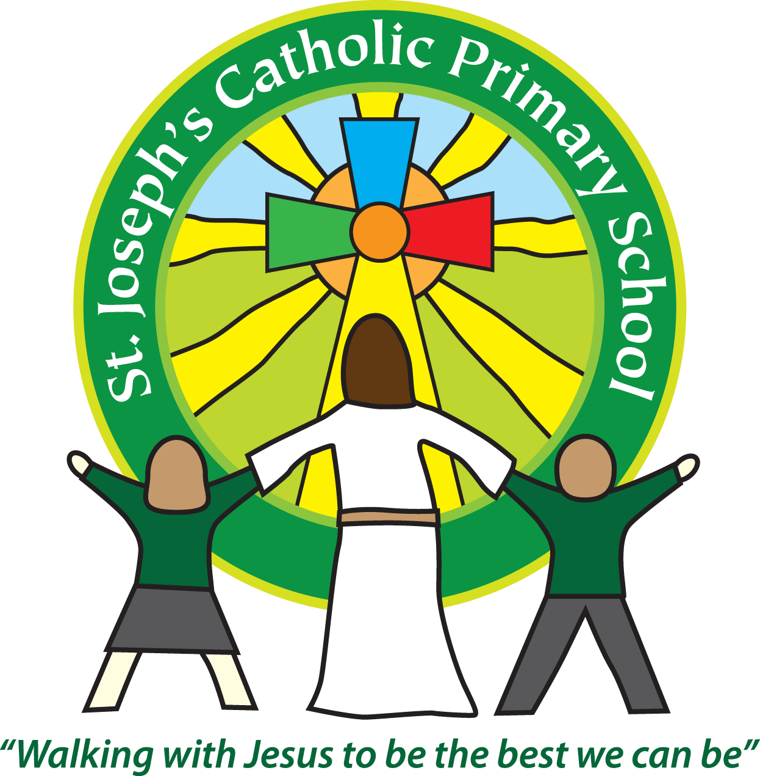

St Joseph’s Catholic Primary School

Newsletter

Friday 1st February 2019

**Headteacher’s awards:** Rowan – James, Finlay, Emily

**Silver Awards:** Beech – Jack, Charlotte

Bronze Awards: Oak – Amelia, Riley

**Star of the Week Awards**: Oak - Jake, Rowan – Ellis, Sycamore - Esmee, Maple – Lola S, Beech - Evan.

**Breakfast club Award:** Emmie

Dear all,

What a blustery week it has been, with lots of looking out the window for snow!

In case of extreme weather, if we had to make the decision to close the school we would put the information on the school webpage and on the local radio. All school closures are also available on https://new.devon.gov.uk/schools/closure/

Occasionally, schools may need to close during the school day to ensure that families and staff can get home safely, in which case we will send out a text. Please ensure that we have your latest contact details.

**Yr 1**

We are really pleased to inform you that Mrs Robertson will be returning to Year 1 after half term. She will be working Wednesday, Thursday and Friday. Mrs Edwards will continue in Yr 1 but move to Monday and Tuesday. We are really sorry that Mrs Handley will be leaving but thank her for everything she has done for St Joseph’s. We will really miss her and wish her the very best.

**Brownie day**

22nd February is ‘WAGGGS Thinking day’ which is an important day for members of Brownie Clubs. To support our Brownies, on Monday 25th February any children who are members of a Brownie unit can wear their Brownie uniform to school that day.

**Dress Down Day**

I met with the Deaf School Academy this week. Building for the new school will start soon on the old Rolle College site. All the local schools are going to hold a mufti day on Friday 5th April to raise money for the Academy. Please make a note of this on your diary dates.

**Safer Internet day**

Next week we have Safer Internet day. All classes are going to have a focus on cyber-bullying -

Thinking about how to conduct yourself online, what to do if you are bullied online, how once you post something online it is there forever etc. It would be really good if parents could follow this up at home with further discussions.

**Family Line – support for parents**

Being a parent or carer to a child or young person is hard and can be even more difficult without emotional support and guidance there to help. Many parents feel confused by what information is available or struggle to access services close to home. FamilyLine Service tackles these issues in a new and innovative way by using a network of [volunteers](https://www.family-action.org.uk/get-involved/volunteer/) from across the country to support parents and carers through telephone calls, email and text message.

The service aims to: Provide both immediate and long term support, Help with practical information and guidance, Provide emotional and listening support, Help with understanding and accessing relevant services and information, Provide regular one-to-one befriending support to parents feeling isolated. Any parent or carer from anywhere in England can get in touch with the service for free via telephone, text message or email, using the below details.

Opening times:

Monday to Friday 6pm-10pm

Saturday and Sunday 10am-1pm

Telephone: 0808 802 6666, Text message: 07537 404 282, Email: familyline@family-action.org.uk

**Upcoming dates:**

Tuesday 5th February – Safer Internet day

Friday 8th February – Aesthetics festival KS1 team – morning

Friday 8th February – Dance festival – KS2 team – afternoon

**Best wishes & many thanks for your continued support**

**Mrs Taylor-Bashford**