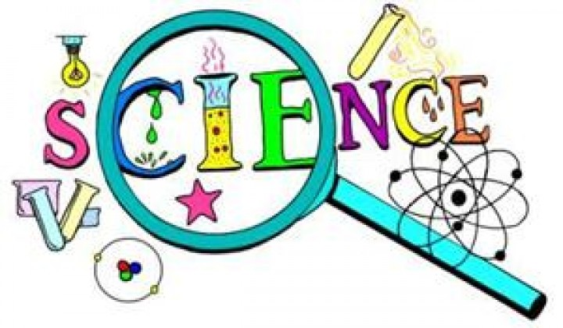
Science Club – Term 1
Science club will continue in September. For more information please email Claire Williamson (Annie’s mum from Class 2) yates.claire@btopenworld.com
Tuesdays 3.30pm-4.15pm (£4.50 per session)
Week 1 (11/9) Slime
Week 2 (18/9) Funny bones
Week 3 (25/9) What is a pangolin?
Week 4 (2/10) Using Electricity
Week 5 (9/10) Leaf litter
Week 6 (16/10) Magic Cabbage
Week 7 (30/10) Chromatography
Week 8 (6/11) Healthy plates
Week 9 (13/11) Making bridges
Week 10 (20/11) Optical illusions
Week 11 (27/12) Explosions
Week 12 (4/ 12) What does the heart do?
Week 13 (11/12) Looking at fossils
Week 14 (18/12) Adaptations of reindeer

