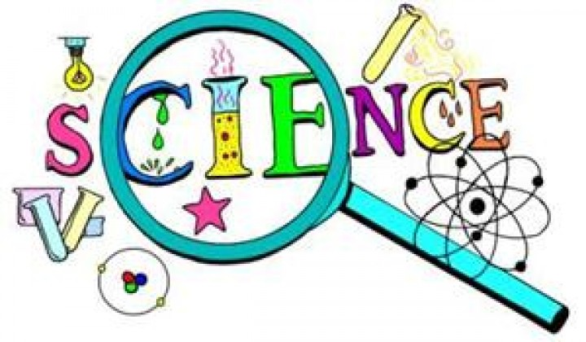
Science Club
Term 2 2019
Mondays 3.30pm-4.15pm

Week 1 (14/1) Light Bulb Chromatography
Week 2 (21/1) Using Microscopes
Week 3 (28/1) Famous Scientists
Week 4 (4/2) Smelly Science
Week 5 (11/2) Adapted Animals
Half Term
Week 6 (25/2) Separating Solutions
Week 7 (4/3) Anglerfish
Week 8 (11/3) Magic Magnets
Week 9 (18/3) Making Bath Bombs
Week 10 (25/3) Busy Bees
Week 11 (1/4) Easter Animals – Making Easter Cards
Easter

