St Joseph’s Catholic Primary School
Exmouth





Behaviour Policy and statement of principles
September 2021
Signed ……………………………………………..Chair of Governors
Signed …………….…………………………………………Headteacher
Date ……………………………….

Contents
1. Aims 2
2. Legislation and statutory requirements 2
3. Definitions 3
4. Bullying 3
5. Roles and responsibilities 4
6. Pupil code of conduct 5
7. Rewards and sanctions 5
8. Behaviour management 7
9. Pupil Support 8
10. Fixed and Permanent exclusions 9
11. Pupil transition 9
12. Training 9
13. Monitoring arrangements 9
14. Links with other policies 9
Appendix 1: written statement of behaviour principles 10
Appendix 2 – St Joseph’s Top Ten Gospel Values 10
Appendix 3 - Rewards and sanctions 12l
…………………………………………………………………………………………………………………………….

1. Aims
This policy aims to:
- Provide a consistent approach to behaviour management
- Define what we consider to be unacceptable behaviour, including bullying
- Outline how pupils are expected to behave
- Summarise the roles and responsibilities of different people in the school community with regards to behaviour management
- Outline our system of rewards and sanctions

2. Legislation and statutory requirements
This policy is based on advice from the Department for Education (DfE) on:
- Behaviour and discipline in schools
- Searching, screening and confiscation at school
- The Equality Act 2010
- Use of reasonable force in schools
- Supporting pupils with medical conditions at school
It is also based on the special educational needs and disability (SEND) code of practice.
In addition, this policy is based on:
- Schedule 1 of the Education (Independent School Standards) Regulations 2014; paragraph 7 outlines a school’s duty to safeguard and promote the welfare of children, paragraph 9 requires the school to have a written behaviour policy and paragraph 10 requires the school to have an anti-bullying strategy
- DfE guidance explaining that academies should publish their behaviour policy and anti-bullying strategy online

3. Definitions

Misbehaviour is defined as (but not exclusive to):
- Disruption in lessons, in corridors between lessons, and at break and lunchtimes
- Non-completion of classwork or homework
- Poor attitude
- Incorrect uniform

Serious misbehaviour is defined as (but not exclusive to):
- Repeated breaches of the school rules
- Any form of bullying
- Sexual assault, which is any unwanted sexual behaviour that causes humiliation, pain, fear or intimidation
- Vandalism
- Theft
- Fighting
- Racist, sexist, homophobic or discriminatory behaviour
- Possession of any prohibited items. These are:
  - Knives or weapons
  - Alcohol
  - Illegal drugs
  - Stolen items
  - Tobacco and cigarette papers
  - Fireworks
  - Pornographic images
  - Any article a staff member reasonably suspects has been, or is likely to be, used to commit an offence, or to cause personal injury to, or damage to the property of, any person (including the pupil)

4. Bullying
Bullying is defined as the repetitive, intentional harming of one person or group by another person or group, where the relationship involves an imbalance of power.
Bullying is, therefore:
- Deliberately hurtful
- Repeated, often over a period of time
- Difficult to defend against
Bullying can include:

Type of bullying | Definition
Emotional | Being deliberately unfriendly, excluding, tormenting
Physical | Hitting, kicking, pushing, taking another’s belongings, any use of violence
Racial | Racial taunts, graffiti, gestures
Sexual | Explicit sexual remarks, display of sexual material, sexual gestures, unwanted physical attention, comments about sexual reputation or performance, or inappropriate touching
Direct or indirect verbal | Name-calling, sarcasm, spreading rumours, teasing
Cyber-bullying | Bullying that takes place online, such as through social networking sites, messaging apps or gaming sites

Details of our school’s approach to preventing and addressing bullying are set out in our anti-bullying strategy.

5. Roles and responsibilities

5.1 The governing board
The governing board is responsible for monitoring this behaviour policy’s effectiveness and holding the headteacher to account for its implementation.

5.2 The headteacher
The headteacher is responsible for reviewing and approving this behaviour policy.
The headteacher will ensure that the school environment encourages positive behaviour and that staff deal effectively with poor behaviour, and will monitor how staff implement this policy to ensure rewards and sanctions are applied consistently.

5.3 Staff
Staff are responsible for:
- Implementing the behaviour policy consistently
- Modelling positive behaviour
- Providing a personalised approach to the specific behavioural needs of particular pupils
- Recording behaviour incidents on cpoms (child protection online management system – secure online system which notifies school safeguarding officers of an incidents)
The senior leadership team will support staff as required in responding to any behavioural incidents.
5.4 Parents
Parents are expected to:
- Support their child in adhering to the pupil code of conduct
- Inform the school of any changes in circumstances that may affect their child’s behaviour
- Discuss any behavioural concerns with the class teacher promptly

6. Pupil code of conduct
At St. Joseph’s Catholic Primary School we recognise that inappropriate behaviour will occasionally arise.
We accept that this is normal when children are learning and testing the boundaries of acceptable behaviour. However, we assert that children have a right to learn and that teachers have a right to teach.
No-one should be prevented from learning by the poor behaviour of others. To support this as a School we have created ten Gospel Values (See Appendix 2) which we all aspire to and the children get rewards for achieving. Copies of these Values are displayed in classrooms as well as in other areas of the school.
6.1 Expectations:
Pupils are expected to:
- Behave in an orderly and self-controlled way
- Show respect to members of staff and each other
- In class, make it possible for all pupils to learn
- Move quietly around the school
- Treat the school buildings and school property with respect
- Wear the correct uniform at all times
- Tell the truth
- Help others to adhere to the positive codes of conduct
- Accept sanctions when given
- Refrain from behaving in a way that brings the school into disrepute, including when outside school

7. Rewards and sanctions
In school we have clear Rewards and Sanctions in place (See Appendix 3). These are consistently displayed and adhered to in every classroom.
In addition to this, children on a specific behaviour programme may be given other reward systems such as stickers on a chart which records improving behaviour and work towards their own individual rewards. This plan will be made known to all appropriate adults in the school.
We recognise the effort a child has made to improve his/her behaviour and do our best to support children and their families. However, in planning to meet the needs of an individual child, we also have to consider the effect on the whole school community of continued and serious misbehaviour. Parents of children with behaviour concerns are expected to support the school fully, and to make clear to their child what sort of behaviour is required at school.

We may use the Bubble room for isolation in response to serious or persistent breaches of this policy. Pupils may be sent to the Bubble room or other classes during lessons if they are disruptive, and they will be expected to complete the same work as they would in class.
When used for isolation after a serious behaviour incident the Bubble room will be supervised by a member of SLT.

7.1 Dealing with unacceptable behaviour

Despite positive responses as a means to encouraging good behaviour, it may be necessary to employ a number of sanctions if unacceptable behaviour escalates. This is in order to enforce the school rules and to ensure a safe and positive learning environment for both pupils and staff. Every member of staff should ensure they seek out and consider the context and precursors to any incident of unacceptable behaviour before imposing any sanction.
We operate a hierarchy of corrective interventions and sanctions, working from the least to most intrusive. The hierarchy is made explicit to the children, as is the link between the behaviour and consequence. A variety of low level intervention strategies are used initially, such as non-verbal signals, reminders and close adult proximity to re-direct and encourage children to stay on track. If the inappropriate behaviour persists, then the consequences are presented to the child as a choice to help teach children that they are responsible for their own behaviour.
Within the classroom, the Sanctions (Appendix 3) will be followed. However, extreme behaviour such as physical assault, will result in immediate removal from the classroom and/or being sent to the Headteacher or member of SLT if the Headteacher is unavailable.
The emphasis at each stage is on the child being re-engaged in the lesson and their learning as soon as appropriate.
Extremely unacceptable behaviour will be reported to the Head teacher or SLT immediately. A letter will be sent home or a phone call made to the parents the same day. For continual unacceptable behaviour or in case of serious verbal or physical aggression the child may be excluded internally from their class and in severe cases externally excluded from school for a fixed period of time. When a child receives an external exclusion Plymouth CAST safeguarding team and Devon County are informed.

7.2 Playtimes and Lunchtimes

At play and lunchtimes we provide a range of activities to engage children in positive play with their peers. This includes the play equipment for each key stage and structured games which are led by staff, with the focus on co-operative play, good communication and teamwork. We also have ‘playtime buddies’ who are year 6 children, who help play games and interact with the younger children.
Where problems between children arise, a solution-based approach is used, helping children to resolve their arguments, empathise with the other person and secure a positive outcome.
Children are recognised for positive behaviour at play and lunchtimes through verbal praise and public recognition and Gospel Value awards.
At play and lunchtimes there is a hierarchy of corrective interventions and consequences.
- Rule/expected behaviour reminder
- Timeout on bench for ….. minutes or standing with a member of staff (as deemed appropriate by staff)
- Moved to lunch club for quiet time
- Timeout with headteacher/senior member of staff. If this stage is reached more than once, or for a serious occurrence then parents to be informed.
All incidents of unacceptable behaviour will be followed by a private conversation focusing on a solution to the issue and on the child taking responsibility for their own actions.
In the event of extremely unacceptable behaviour or persistent disruptive behaviour at play and lunchtimes, a child may be given a lunchtime exclusion.

7.3 Off-site behaviour
The behaviour policy will be followed during off-site visits. Sanctions may be applied where a pupil has misbehaved off-site when representing the school, such as on a school trip or on the bus on the way to or from school.
Children are made aware of behaviour expectations off site when aspects of the risk assessments are shared and developed with the children.
7.4 Malicious allegations
Where a pupil makes an accusation against a member of staff and that accusation is shown to have been malicious, the headteacher will discipline the pupil in accordance with this policy.
Please refer to our safeguarding policy for more information on responding to allegations of abuse.
The headteacher will also consider the pastoral needs of the staff accused of misconduct.

8. Behaviour management
We aim to be positive and proactive in encouraging good behaviour and all members of staff play a role in this. Using Key Skills of the EYFS and SEAL programme, all members of staff work to promote the social and emotional aspects of learning throughout the day and in specific SEAL/PSHE lessons. Key members of staff are also trained in the PIPs (passive intervention and prevention) programme to enable them to deal confidently with pupils and minimise antisocial behaviour.
We believe that pupils feel more secure if they know where the boundaries of acceptable behaviour lie. They also need to know what will happen if they make the wrong choices. All staff use praise and positive reinforcement to promote caring attitudes among the children. By giving children responsibility and a chance to make decisions, we try to build self-esteem and the foundation of good citizenship, following the British Values principles.
Older children are trained as playground buddies and help to sort out minor disputes and encourage play between younger children while modelling positive behaviour. We expect children to be courteous to all members of staff and to each other and to respond promptly to instructions given by adults.
We believe that sanctions are most effective if applied fairly and calmly. Children are given the opportunity to explain the reasons for their actions. Pupils need to know what wrong decision they have made and are given the opportunity to make amends. Staff discuss problem behaviour with all pupils involved. Any sanctions are applied in a way that maintains self-respect, not used to humiliate.
Different methods work for different children and staff will judge carefully the most appropriate approach. It is important to state that the majority of children conform willingly to our code of behaviour and enjoy their life at school to the full. Some children, however, need to be helped to make the right choices. A few children do need a specific behaviour programme planned to meet their needs and help them behave acceptably and gain the most they can from school life.

8.1 Classroom management
Teaching and support staff are responsible for setting the tone and context for positive behaviour within the classroom.
As a minimum they will:
- Create and maintain a stimulating environment that encourages pupils to be engaged
- Display the Rewards and Sanctions in their classroom
- Develop a positive relationship with pupils, which may include:
  - Greeting pupils in the morning/at the start of lessons
  - Establishing clear routines
  - Communicating expectations of behaviour in ways other than verbally
  - Highlighting and promoting good behaviour
  - Concluding the day positively and starting the next day afresh
  - Having a plan for dealing with low-level disruption
  - Using positive reinforcement

8.2 Physical restraint
In rare circumstances, staff may use reasonable force to restrain a pupil to prevent them:
- Causing disorder
- Hurting themselves or others
- Damaging property
Incidents of physical restraint must:
- Always be used as a last resort
- Be applied using the minimum amount of force and for the minimum amount of time possible
- Be used in a way that maintains the safety and dignity of all concerned
- Never be used as a form of punishment
- Be recorded on cpoms and reported to parents
Physical intervention is a small part of a range of broader positive handling strategies used by staff to address the needs of pupils whose behaviour presents a challenge. Any contact with a pupil is based upon providing the maximum amount of care, control and therapeutic support. The key messages given to a pupil are that staff care enough not to let them be out of control and to keep them safe. All actions that are taken are reasonable, proportionate and in the best interests of the pupil. All incidents will be recorded on CPOMS, our online safeguarding system.

8.3 Confiscation
Any prohibited items (listed in section 3) found in pupils’ possession will be confiscated. These items will not be returned to pupils.
We will also confiscate any item which is harmful or detrimental to school discipline. These items will be returned to pupils after discussion with senior leaders and parents, if appropriate.
Searching and screening pupils is conducted in line with the DfE’s latest guidance on searching, screening and confiscation.
Mobile phones are also not allowed in school and must be given to the class teacher or office on arrival. They will be given back at the end of the school day.

9. Pupil Support

The school recognises its legal duty under the Equality Act 2010 to prevent pupils with a protected characteristic from being at a disadvantage. Consequently, our approach to challenging behaviour may be differentiated to cater to the needs of the pupil.

9.1 Individual Pupil Behaviour Needs

At St Joseph’s we believe that everyone is entitled to be treated with respect and encouraged to develop their full potential. Therefore, it is important that we are able to use our professional skills and knowledge of the individual pupil when deciding upon and applying consequences not only towards the correction of inappropriate behaviour in the classroom or on the playground, but also towards acknowledgement of pupil achievement and the intervention strategies introduced when a pupil presents with significant behaviour issues. This belief reflects the Vision Statement of our community and every action is conducted in light of the Gospel Values expressed in every area of our school life.

Teachers and support staff closely monitor pupil needs and work to anticipate the relevant level of support. If a Relational Support Plan is needed the school will work with outside agencies to support best practice.
This will involve:
- The development and maintenance of positive and collaborative relationships with pupils, staff and parents
- Ongoing assessment of the behaviour situation, including gathering of relevant information before taking action
- The application of non-emotive, systematic and logical correction and intervention strategies.

If a pupil requires individualised, explicit behaviour support we have a variety of strategies that teachers can access to support behaviour management and positive behaviour choices including:
- Meeting with parents on a regular basis to review progress and develop shared strategies
- Individual support plan that targets specific behaviours
- Relevant referrals to outside agencies e.g. SEMH Team, Educational Psychologists
- Support for the class teacher and teaching assistant to implement individual support plans which may include time for resource making, one on one time with the pupil involved or explicit teaching of behaviours for small groups of pupils.
9.2 Special Educational Needs
We recognise that for a small number of children, whose behaviour is beyond the whole school rewards and consequences system, a more personalised approach may be necessary in order to support them in developing the ability to regulate their own behaviour. They may have an individual behaviour plan agreed between the pupil, staff and parents. The support of outside agencies will also be sought where appropriate, in particular the SEMH Team or Educational Psychologist.

10. Fixed and Permanent exclusions
Extreme behaviour or persistent disruptive and challenging behaviour may lead to a pupil exclusion. Only the Headteacher has the power to exclude a child from school. They may exclude a pupil for one or more fixed periods, for up to 45 days in any one school year. They may also exclude a pupil permanently. It is also possible for the Headteacher to convert a fixed-term exclusion into a permanent exclusion, if the circumstances warrant this.
If the Headteacher excludes a child, she informs the parents as soon as possible, giving reasons for the exclusion. At the same time, the Headteacher makes it clear to the parents that they can appeal against the decision to the Governing Body and how to do so through the letter of exclusion.
The Headteacher informs the Academy, the Local Authority (LA) and the Governing Body about any permanent exclusion or fixed-term exclusions. The Governing Body itself cannot either exclude a child or extend the exclusion period made by the Headteacher. See our Exclusions policy for more information.

11. Pupil transition
To ensure a smooth transition to the next year, pupils have transition sessions with their new teacher(s). In addition, staff members hold transition meetings.
To ensure behaviour is continually monitored and the right support is in place, information related to pupil behaviour issues may be transferred to relevant staff at the start of the term or year. Information on behaviour issues may also be shared with new settings for those pupils transferring to other schools.

12. Training
Our staff are provided with training on managing behaviour, including proper use of restraint and cpoms as necessary. They are given the behaviour policy and rewards and sanctions as part of the induction process.
Behaviour management will also form part of continuing professional development.

13. Monitoring arrangements
This behaviour policy will be reviewed by the headteacher and full governing body annually.

14. Links with other policies
This behaviour policy is linked to the following policies:
- Exclusions policy
- Child Protection and Safeguarding policy
- Anti-bullying policy
- Plymouth CAST Welfare Policy

Appendix 1: written statement of behaviour principles

Every pupil understands they have the right to feel safe, valued and respected, and learn free from the disruption of others.
All pupils, staff and visitors are free from any form of discrimination.
Staff and volunteers set an excellent example to pupils at all times.
Staff and volunteers follow the behaviour policy consistently.
Rewards, sanctions and reasonable force are used consistently by staff, in line with the behaviour policy.
The behaviour policy is understood by pupils and staff.
The exclusions policy explains that exclusions will only be used as a last resort, and outlines the processes involved in permanent and fixed-term exclusions.
Pupils are helped to take responsibility for their actions.
Families are involved in behaviour incidents to foster good relationships between the school and pupils’ home life.

The governing body also emphasises that violence or threatening behaviour will not be tolerated in any circumstances.

Appendix 2 – St Joseph’s Gospel Values

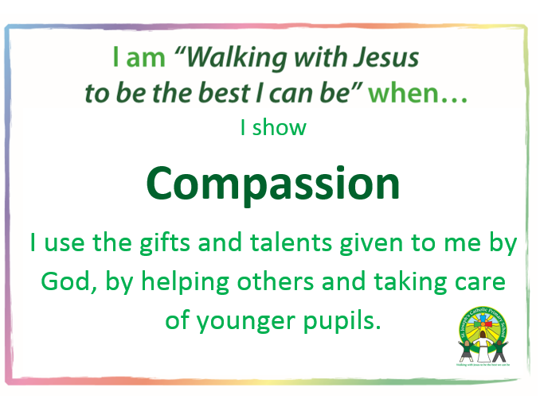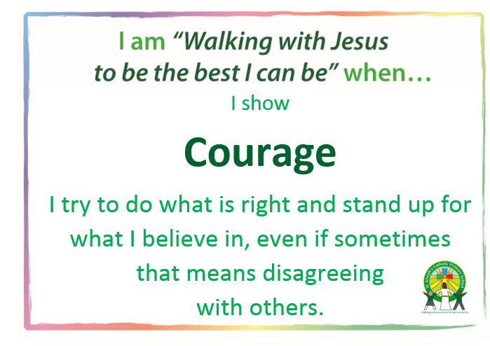
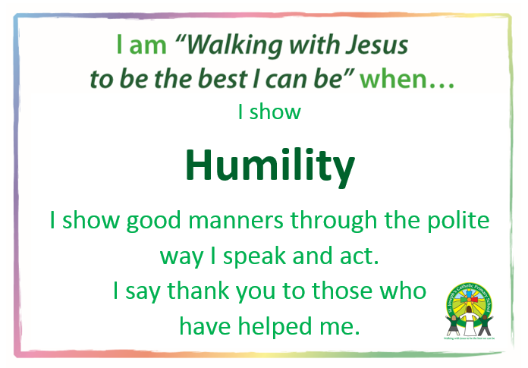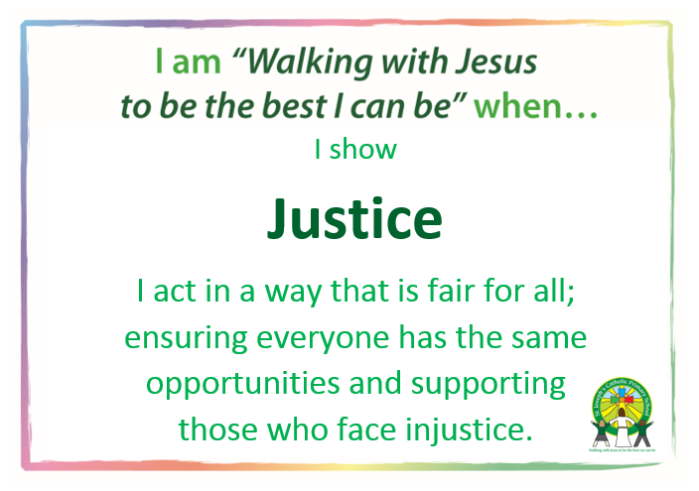
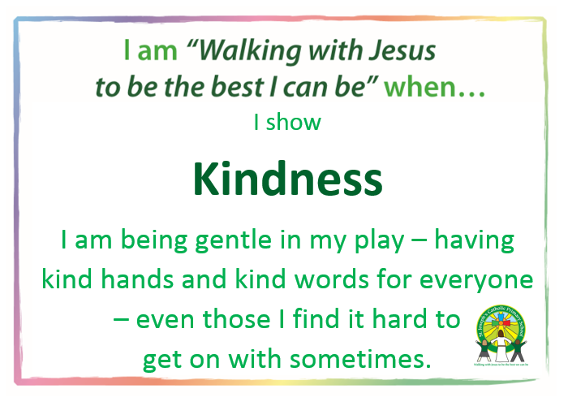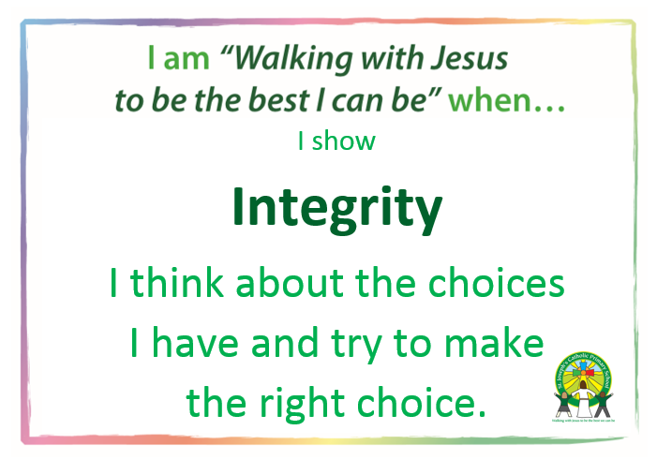
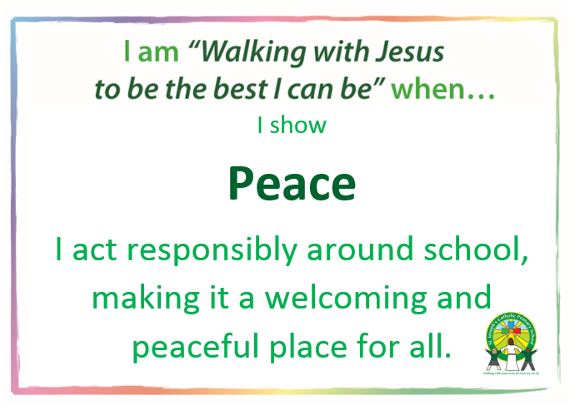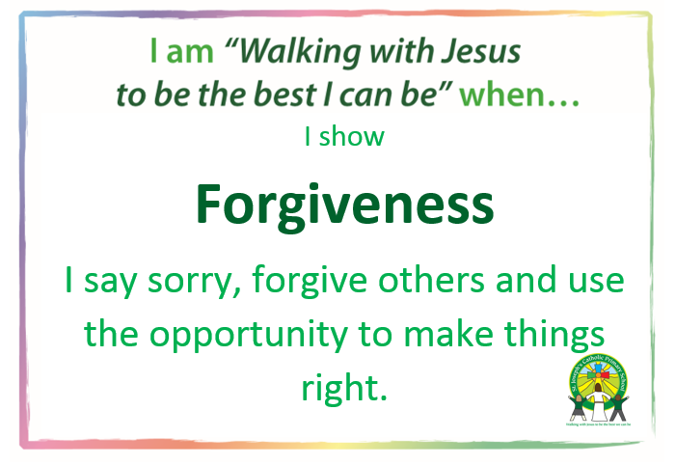

Appendix 3 - Rewards and sanctions
 | Reward type | List/explanation of rewards
1 |  | - Verbal praise  - Gospel values points  - Stickers  - Class reward system e.g. marbles in a pot  - Parents informed
  In class rewards
2 | Regular school and class rewards | - Praise postcard  - Star of the Week  - Sent to another member of staff  - Certificate in Celebration Assembly  - Reward time e.g. 5 minutes extra play  - Parents informed  - Name in the School newsletter or on the website.
3 | Behaviour or work that is ‘above and beyond’ | - Sent to Head teacher  - Parents informed  - As applicable work photocopied and sent home.  - Name in the School newsletter or on the website.  - Work up on display
4 | Whole school rewards | - Star of the term award  - Parents invited in.  - Reading champions  - Curriculum champions
Sanctions

 | When sanctions are to be used | List of appropriate sanctions
1 | In class, for all children who are not demonstrating expected behaviour e.g. calling out, poor manners, low level disruptions, etc. | - Verbal warning  - Moved within classroom  - ‘Time out’ in another classroom  - Missing some break time  - Catching up missed work  - Parents may be informed  - Head teacher may be informed
2 | Behaviour that regularly does not meet expectations or when sanctions from level 1 have already been received. Other behaviours such as stealing or minor damage to property could be within this level. | - Report to teacher after each break  - Missing some break time  - Catching up missed work  - Head teacher informed.  - Parents informed  - Weekly contact with parents to update  - Behaviour chart
3 | Behaviour that is continually not meeting school’s expectations and/or is of a more serious nature e.g. repeatedly hurting or upsetting others, refusing to complete work, bad language, vandalism. | - Missing break times  - Catching up missed work  - Sent to Head Teacher  - Parents informed  - Weekly/daily contact with parents  - Behaviour chart  - Behaviour Care Plan considered
4 | Significantly more serious behaviour e.g. intentionally hurting a child, refusal to remain in class, considerable damage to property. | - Sent to Head Teacher  - Parents informed  - Weekly/daily contact with parents  - Behaviour chart  - Possible Internal exclusion  - Behaviour Care Plan
5 | Extreme levels of behaviour e.g. considerable and deliberate physical assault against pupil or member of staff, deliberate racist abuse, considerable damage to property | - Parents called in for meeting with Head teacher  - Daily meetings with parents  - Outside agency involvement  - Alternative in-school arrangements will be made.  - Internal or external exclusion

For any behaviour that results in another person being treated unacceptably, an apology must always be made either verbally or in writing.

