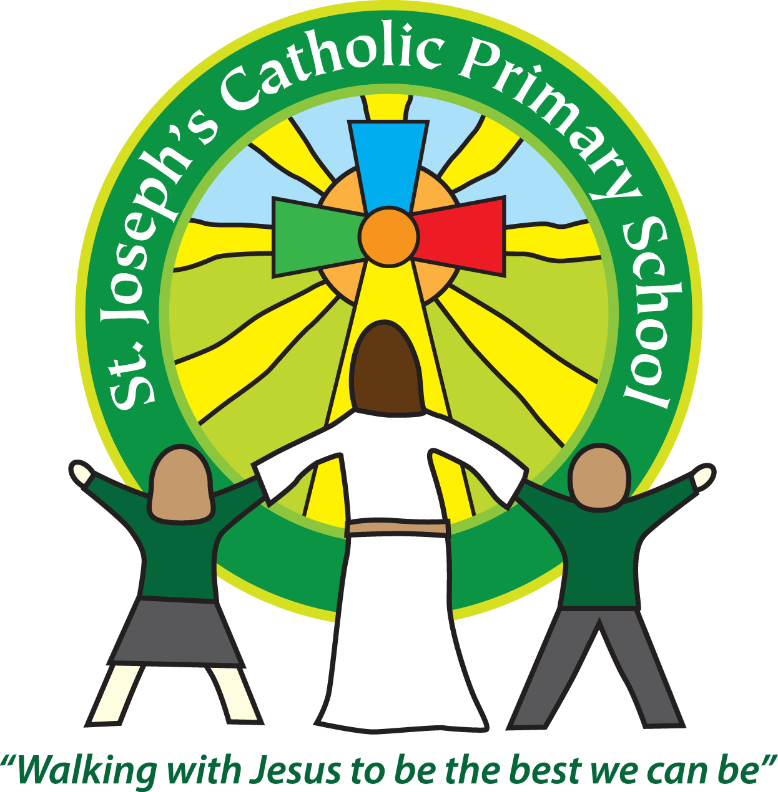
St Joseph’s Catholic Primary School
Regents Gate
Long Causeway
Exmouth
Devon
EX8 1TA

Executive Headteacher: Mrs R Pattison
Acting Head: Mrs N Taylor-Bashford

Tel: 01395 264875

Disruption due to bad weather and other emergencies

In case of emergency school closures, we will follow this procedure:-

If severe weather, or other emergency, forces closure before the start of the school day, as soon as the decision has been made to close the school, we will:-
1. Inform Devon County Council who will put the details on their website
2. Put a notice on the school website (www.stjosephsprimaryschool.com)
3. Contact the local radio stations – BBC Devon, Heart, Bay FM and Radio Exe who will broadcast the information.
4. Start to telephone staff and parents to let everyone know individually. In order to reach everyone we will have to start soon after 7 am. If this will cause you serious inconvenience, please let us know so that we move you further down the list of calls to be made.

If the school has to close during the day due to severe weather or other emergency, we will telephone all parents and put a note on the website.
If the school has to be evacuated due to emergency we will take all the staff and children to our Parish Church, the Holy Ghost and then contact parents.

