Science Task 3: Enquiry Type - Identifying and Classifying

Question
How can you identify objects in your house?
Select at least 10-15 random objects in your house. Consider how they are similar and how they are different to each other.

Younger Children | Older Children
Draw the selected objects into groups based on what they have in common. Eg. Size, colour, shape | Create a classification key to identify your selected objects.eg:  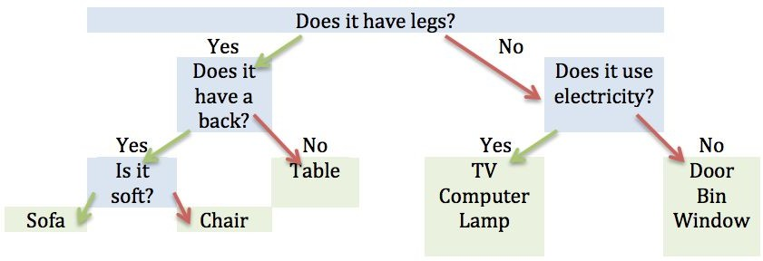

Challenge | About this type of Scientific Enquiry
Research Carl Linneaus who created the system of taxonomy, which is how we classify living things.  h ttps://www.linnean.org/learning/wh o -was-linnaeus  h ttps://www.bbc.co.uk/teach/class-cli p s-video/science-ks2-the-work-of-carl- l innaeus/zhnjf4j | Identifying and classifying is how we can make sense and order of the world around us. This enquiry type requires using observation and reasoning skills.  Examples of classifying include how we classify animals, plants and foods.  Identifying and classifying is used by scientists to help learn about the natural world and therefore assist in conservation projects. You can often help scientists to identify and classify using websites such as Zooniverse.org

