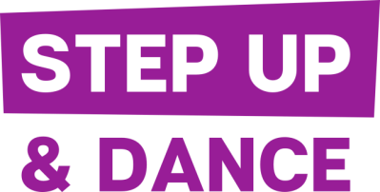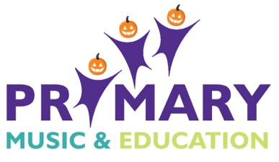
Our next fabulous music/dance collaboration Poptastic will run at Withycombe Raleigh Primary School on Monday 18th February 2019 from 9.30am-5.00pm. Katie Murray (Step Up & Dance) and Fay Nelmes (Primary Music & Education) have a wealth of experience of working as a professional dancer/musician as well as many years of teaching children. Children are guaranteed to have a fabulous experience and learn plenty of great new skills in both dance and music arts whilst enjoying our pop music theme. At the end of the day we will give a performance to parents/carers. The cost of the day is £26, which is payable in advance (non-refundable) via Online Payment in the following way:
All online payment transactions are carried out securely using the PayPal payment gateway. Please note, you do not need a PayPal account. The PayPal payment gateway accepts all mainstream debit / credit cards. Once payment is made you will receive a confirmation email detailing your childs place. To make your payment please go to: https://www.stepupanddance.co.uk/poptastic
Children will need to bring a packed lunch, snacks and drinks (non-fizzy and no glass bottles) and wear comfortable clothing suitable for dancing.
We anticipate the demand for this to be very high so please fill out the form below to secure your child’s place and return it as soon as possible either via email to fay@primary-music.co.uk or by post to Fay Nelmes, 101 Halsdon Avenue, EX8 3DH.
Find out more about what we do at Step Up & Dance at http://www.stepupanddance.co.uk/ and Primary Music & Education at http://www.primary-music.co.uk
----------------------------------------------------------------------------------------------------------------
I would like my child to take part in ‘Poptastic’ and have made a PayPal payment of £26. I understand that their image may appear on our photographs/website/promotional materials (no names will be given).
Name of child: ______________________________________ Age: ________________
Allergies/medical information@ ______________________________________________
Signed (parent/carer): ______________________________________________________
Email address: ____________________________________ Tel.no. _______________________
GDPR regulations have changed so please tick if you are happy to be contacted by email informing you of future events you might be interested in. We never share personal details with any third parties.

