Online Safety Newsletter

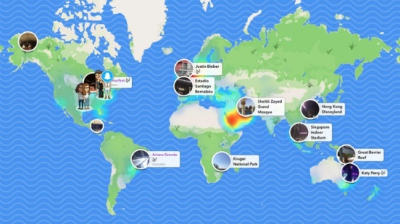
Snapchat Location – Snap Map
Do you know the online safety lingo?

Phishing is the attempt to obtain sensitive information such as usernames, passwords, and credit card details (and, indirectly, money), often for malicious reasons, by disguising as a trustworthy entity in an electronic communication.
Roasting: Girls are ganging up on boys in a new cyberbullying craze called “roasting.” The new bullying takes place via mobile apps such as WhatsApp, Instagram or Facebook where girls pick on a boy and vent the most offensive abuse until the victim “completely cracks”.

Acronyms

POS: Parents over shoulder

IHU: Stands for “I hate you

KOTL: Kiss on the lips

Snapchat have introduced a new feature – Snap Map which allows users to share their location with other Snapchat users. Parents can turn the feature off on children's phones by setting the app to ghost mode. It is important to be careful about who you share your location with, as it can allow people to find out where you live, go to school etc. When first opening the Snap Map users get to make a decision of who they want to be able to view their location. Once these settings are in place they can always be changed in Snapchat’s settings.

Choose who can see your location
We would advise people not to share their location, especially with people they don’t know. There are three settings for sharing your location:
- Ghost Mode: means that you are the only person who can see your location on the map. Within Ghost Mode you can still see the locations of your friends but they will be unable to see you.
- My Friends: means that all of your contacts on Snapchat can see your location. If turning on this setting then it would be important for users to review their Snapchat contacts and also make sure that they never add someone they don’t know in person onto Snapchat.
- Select Friends: this setting allows users to look through their friend list and then decide which of their friends they want to be able to view their location. This setting gives users the opportunity to control who can view their location.

Icebreaker email series
Become an expert in your child's online world

O2 are working with the NSPCC to help all children and their families stay safe online. They’ve produced a series of weekly emails offering useful tools, support and guidance to help parents and carers have conversations with their children about their online lives. Sign up here: https://nspcc.o2.co.uk/

