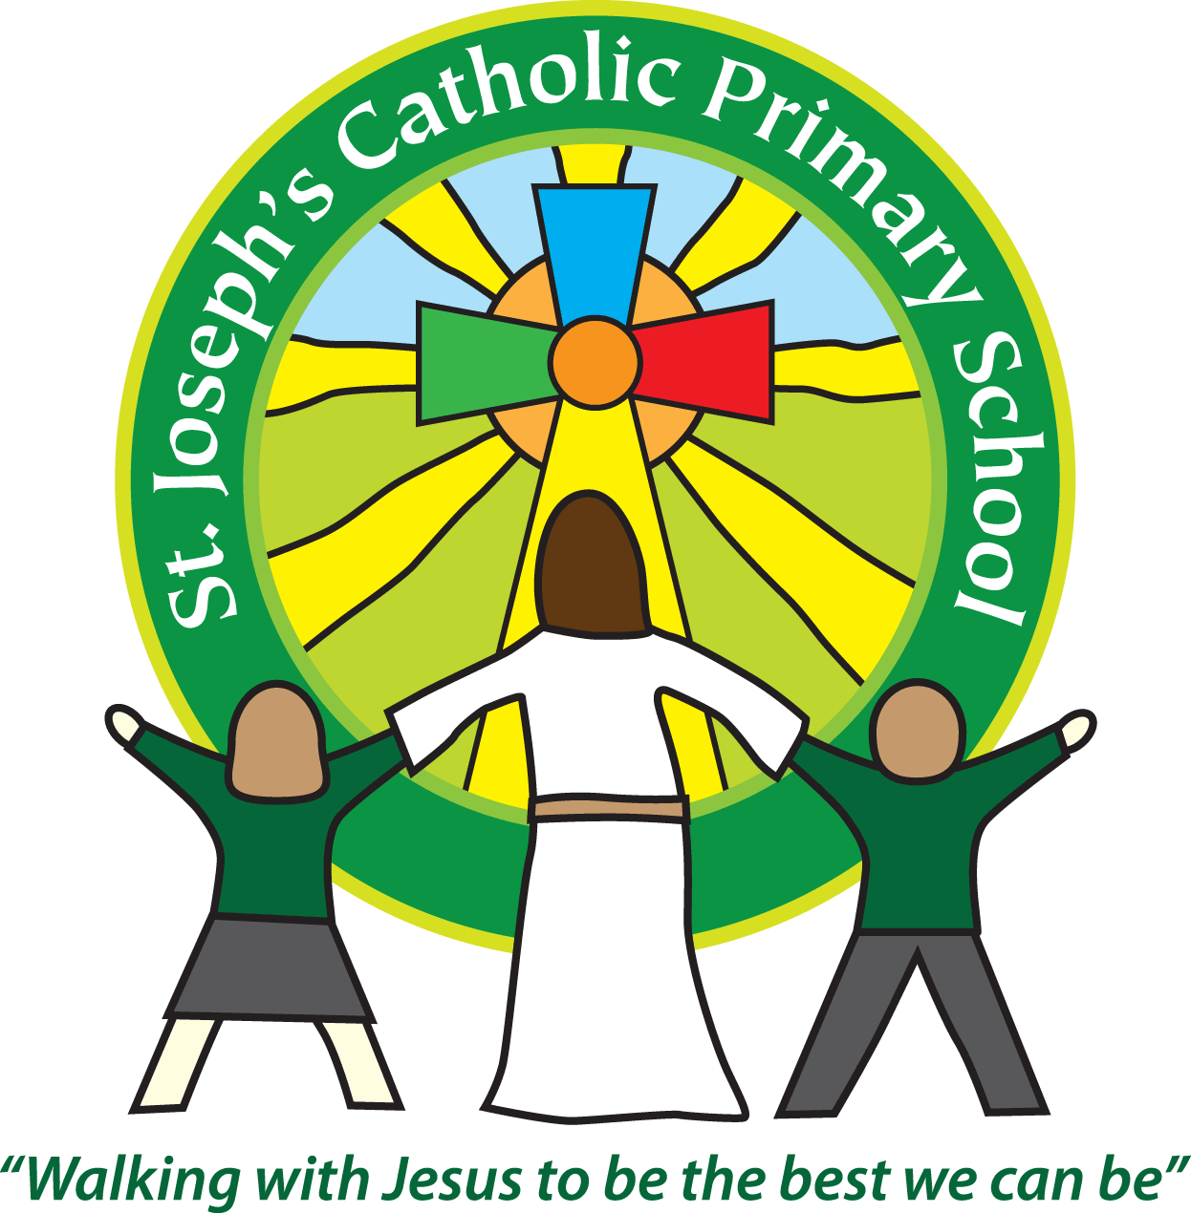
St Joseph’s Catholic Primary School Home Learning Pack – 01.06.2020-12.06.2020
Willow Class
The way we are doing home learning is changing a little. We will be sending tasks home every two weeks and reducing the number of tasks to 3 maths, 3 English and 3 topics per week (so you will receive 6 maths, 6 topic and 6 English every other Monday).
Just to be clear, we are not expecting everyone to do all of the activities and these are only suggestions. We understand that our circumstances are all very different at the moment and that lots of you will be trying to juggle ‘home school’ and your own work as well as caring for elderly neighbours and family. Please only do what you feel you can. We do not want to set anything that causes any worry so please do what you feel. There are some references to resources but they do not need to be printed and can be viewed online and the work can be completed or copied onto paper. Please contact us at admin@stjo.uk and in the subject name it… For (Your Child’s teachers name and Class) if you need any further support. For example; For Mrs Spinks, Willow Class. This will help us to ensure your request is dealt with quickly.
All of the resources for the home learning below can be found at: https://www.stjosephsprimaryschool.com/website/home_learning_04052020/477542 on the Coronavirus information page – Home learning and then select the date and appropriate class.
Maths | Activities | Resources
Times tables | Please continue to practise your times tables everyday this can be done on TTRS or offline through a variety of games and activities. Here are a few ideas to help you:  - Use playing cards – Choose 2 cards at a time and multiply the numbers together and then discuss corresponding division facts.  - Exercise while reciting your times table facts e.g. skipping  - Play times table ping pong – in partners take it in turns to ask each other questions  - Times table bingo – draw a 3x3 grid and choose numbers from the tables – bingo caller to ask multiplication and division question.  - Why not invent your own times table game to play?
Week 1  Activity 1 | Can I add three-digit numbers?  - Read the learning reminders to refresh your understanding.  - Complete the practice questions  - If you are finding it tricky complete the ‘A bit stuck sheet’.  - Have a go at the investigation to check understanding | PDF document ‘Maths activity 1’ on the website
Activity 2 | Can I add together different amounts of money?  - Read the learning reminders to refresh your understanding.  - Complete the practice questions  - If you are finding it tricky complete the ‘A bit stuck sheet’  - Complete the questions to check your understanding. | PDF document ‘Maths activity 2’ on the website
Activity 3 | Can I add four-digit numbers?  - Go through the power point or read the learning reminders to refresh your understanding.  - Complete the practice questions  - If you are finding it tricky complete the ‘A bit stuck sheet’.  - Have a go at the investigation to check understanding | PDF document ‘Maths activity 3’ on the website  PPT Activity 3.
Week 2  Activity 4 | Can I find factors to increase multiplication fluency?  - Read the learning reminders to refresh your understanding.  - Complete the practice questions  - If you are finding it tricky complete the ‘A bit stuck sheet’.  - Have a go at the investigation to check understanding. | PDF document ‘Maths activity 4’ on the website
Activity 5 | Can I multiply 3 numbers?  - Read the learning reminders to refresh your understanding.  - Complete the practice questions  - If you are finding it tricky complete the ‘A bit stuck sheet’.  - Complete the questions to check your understanding. | PDF document ‘Maths activity 5’ on the website.
Activity 6 | Can I subtract three-digit numbers?  - Go through the power point or read the learning reminders to refresh your understanding.  - Complete the practice questions  - If you are finding it tricky complete the ‘A bit stuck sheet’.  - Have a go at the investigation to check understanding. | PDF document ‘Maths activity 6’ on the website.  Activity 6 PPT

Please continue to keep a written diary recording what you have done each day.
English | Activities | Resources
Week 1  Activity 1 | Can I sequence the events of a story?  - Look at the front cover of ‘Henry’s Freedom Box’ and predict what you think the story is about?  - Listen to the reading of the story https://www.youtube.com/watch?v=-41aaH6Vv6c  - Order the events of the story  - Read the author’s notes and answer the questions. | PDF document ‘English activity 1’ on the website.
Activity 2 | Can I draw three captions to show the key parts in the story?  - Listen to the author read Henry’s Freedom Box. https://www.scholastic.com/teachers/videos/teachingcontent/henrys-freedom-box-read-aloud-ellen-levine/  - Read Extract 1 for yourself. Challenge yourself to read Extracts 2 and 3.  - Read Henry’s Freedom Box Questions and write your answers.  - Choose the three events from the story that you think are most important.  - Make an illustration for each one and write a caption that explains it. | PDF document ‘English activity 2’ on the website.
Activity 3 | Can I write a letter explaining Henry’s story in 1st person?  - Read Extract 1. Write what the missing words could be.  - Read Background to Henry’s Freedom Box.  - Read and answer the Comprehension Questions.  - Imagine you are Henry. Write a letter to a friend from when you were a child, explaining your story. | PDF document ‘English activity 3’ on the website.
Week 2  Activity 4 | Can I use possessive apostrophes accurately?  - Read Sea Fever. Read it twice: once in your head and once out loud.  - Read the Poetry Questions. Think about your answers and then write them as sentences.  - Look at the power point or read the learning reminders  - Complete Sea Fever Sentences.  - Read the copy of Sea Fever without apostrophes for possession. Work out where the missing apostrophes go.  - Practise reading the poem aloud. | PDF document ‘English activity 4’ on the website.  PPT on possessive apostrophes
Activity 5 | Can I use possessive apostrophes accurately?  - Look carefully at the Jewellery. They’re all types of amulet. Write a descriptive sentence for each.  - Read the poem Amulet.  - Use the Revision Card to remind yourself about possessive apostrophes.  - Complete Plural Possession Sentences.  - Write your own poem. | PDF document ‘English activity 5’ on the website.
Activity 6 | Can I use suffixes –ous and –sion?  Follow the instructions on BBC Bitesize to revise spelling rules and practice suffixes –ous and –sion. | https://www.bbc.co.uk/bitesize/articles/zr8kwty

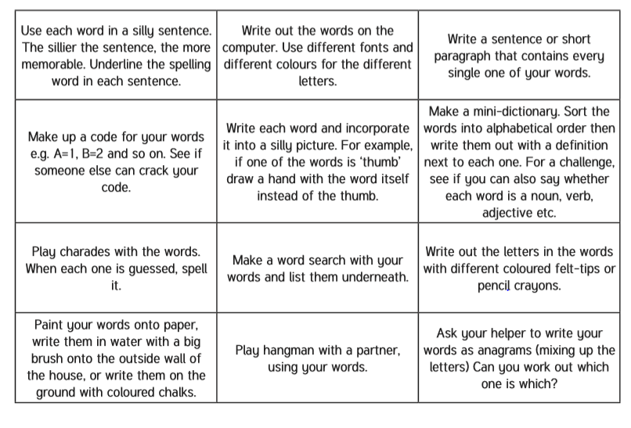
Spelling – Practise the year 4 spellings using a range of strategies. Below are some ideas that you can try.

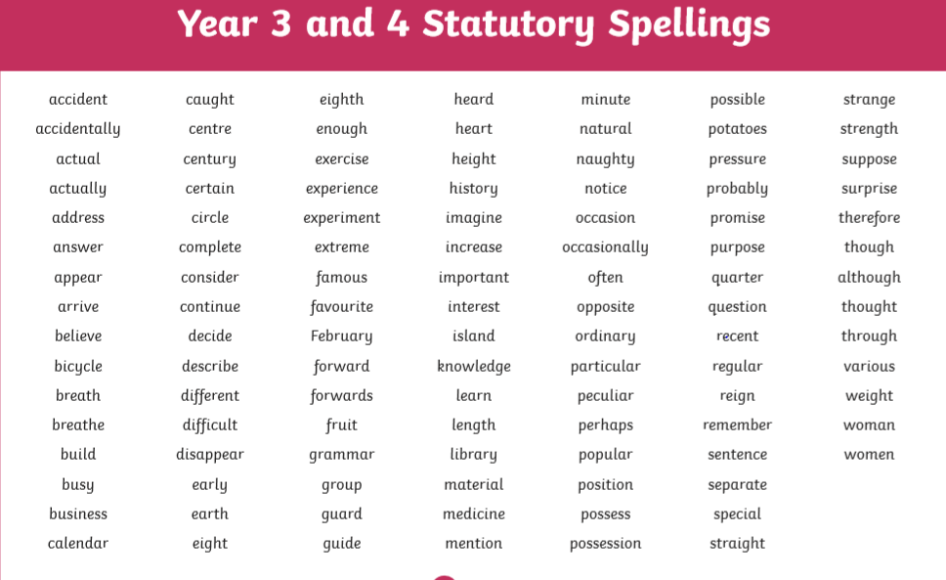
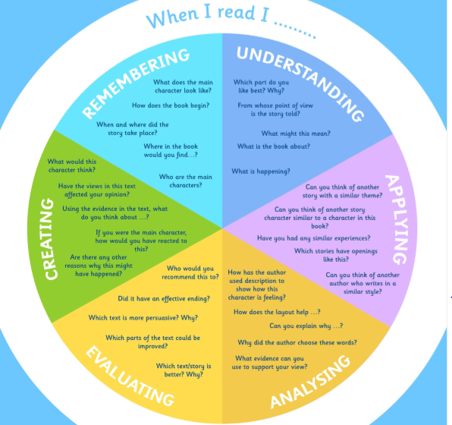
Suggested Reading Activities
This is an essential skill that the children need to continue to practise daily. It is recommended that the children read for at least 20 minutes each day. Continue to record all reading in the reading record books and remember to quiz on accelerated reader. You should have received an email with log in details. Please contact me if there is an issue with this. When listening to your chid read ask questions regularly to check and support understanding. Here is some example questions which would really support the children in their development.

Varied activities of Science, Music, Topic (History, Geography, Art) and R.E
 | Activities | Resources
Week 1  Activity 1 | Pentecost kites  - Design a kite to symbolise Pentecost.  - If you would like to have a go at making a kite I have attached some instructions to help you | Making a kite instructions on the website.
Activity 2 and 3 | 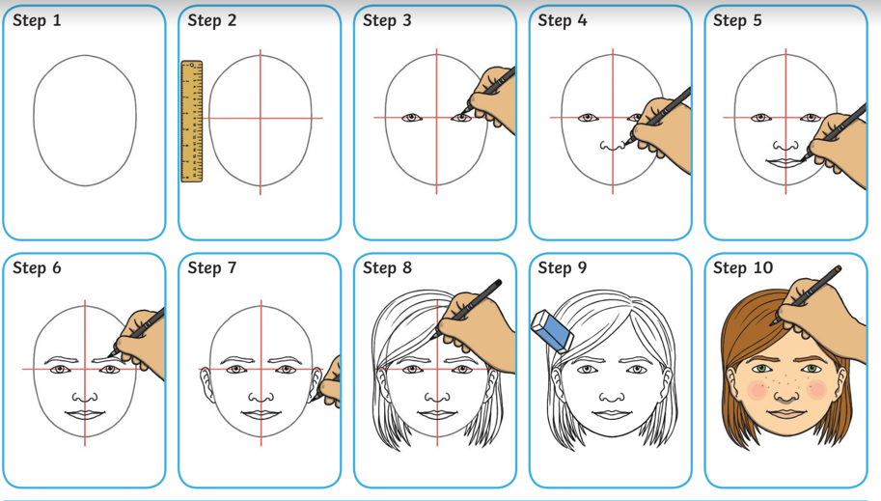Follow the steps on the website to draw a self-portrait in pencil. Think about line, shape, tone and texture. You could use pencils, chalk, pens or paint to colour your portraits.  Research artist Andy Warhol. Have a look at some of the portraits that he has created. Have a go at making your own!  Divide a piece of paper into four equal sections and draw a self-portrait or a portrait of a family member in each section. Then colour each portrait in different colours.  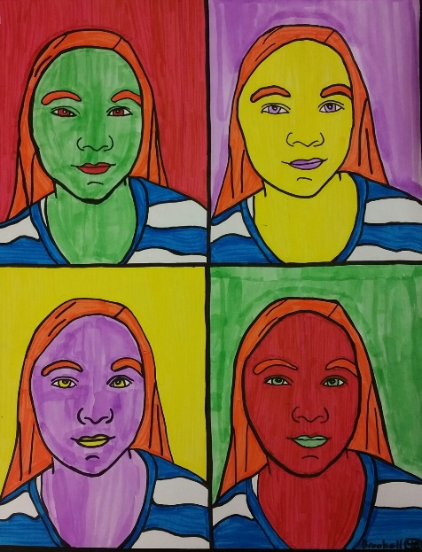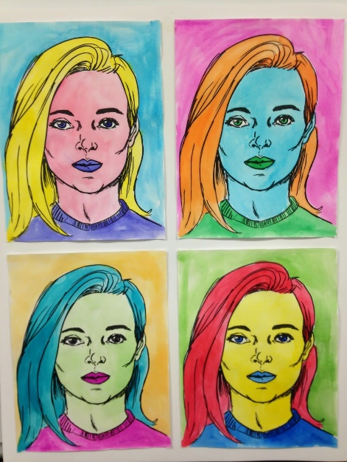 | Self-portrait steps on website.
Week 2  Activity 4 | Re read the Pentecost story or re watch the video.  Write a newspaper article about what happened during Pentecost. | RE document on the website.  https://www.youtube.com/watch?v=MtTjgmlUtps
Activity 5 | Science task  Look in your kitchen to find out what different types of food you can find.  Look at the labels of the food that you find.  Which foods have the highest  fat/sugar/carbohydrate/fibre content?  Which foods have the lowest  fat/sugar/carbohydrate/fibre content?  Do the portion sizes match the packet size? | Science task 5 on the website.
Activity 6 | Label the cities on the map of the United Kingdom.  There are three different sheets to choose from. You can choose which challenge you would like to take. If you do not have a printer you can look up the cities and then research a chosen city. | Map worksheet on the website.

