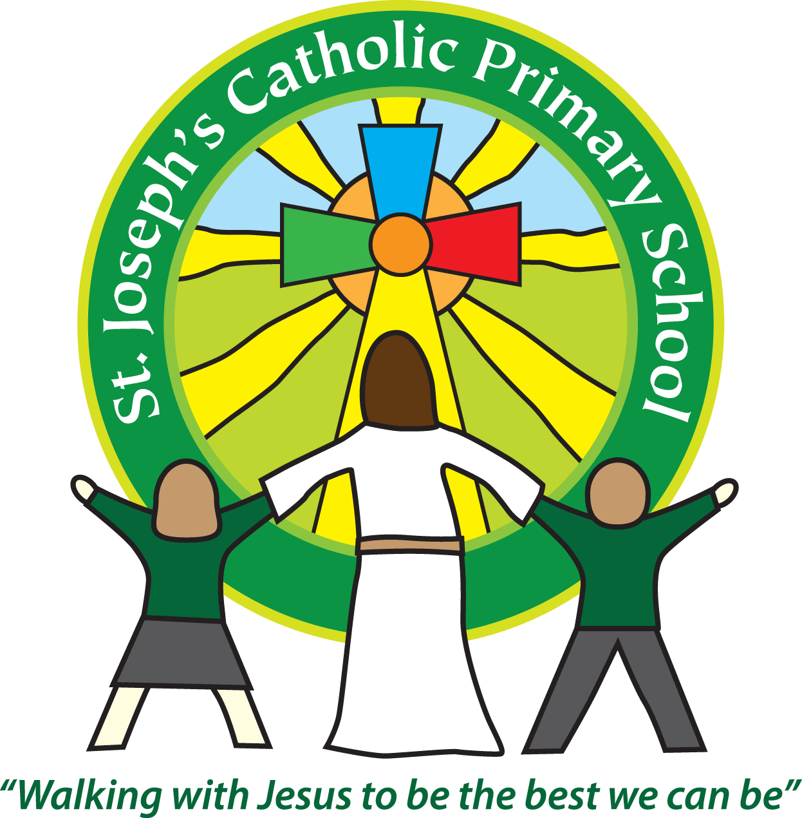

St Joseph’s Catholic Primary School

Newsletter

Friday 7th September

Dear all,

Welcome back! I hope you have all had an enjoyable summer. It has been great having the children back in school – school is a very odd place to be without any children! They have come back well rested and ready to start the adventure of a new term in a new class.

I would like to take this opportunity to welcome all our new families that have started this week as well as our new staff – Miss Christopher, Mrs Kidd, Mrs Burge and Mr Dearsly. I hope you all enjoy your time at St Joseph’s.

**Newsletters by email**

This week you should have received the letter about After School Clubs, your child’s class letter and topic web. Currently we email and send out a paper copy of the newsletter each week. As you can imagine photocopying the newsletter is time consuming and uses up a lot of paper every week! In an effort to help with this we would like to just email the newsletter. As we will send it using ParentPay please ensure your ParentPay account is activated. All new parents will receive a letter asking for the account to be activated within the next couple of days. Any questions please ask at the office. I appreciate that for some people they do not have an email so if you would still like to receive a paper copy please complete and return the slip below to the class teacher or the Office by next Wednesday. If you have more than one child in school the paper copy will go the oldest child.

**School Uniform**

The children have come back looking very smart. We want the children to be proud of their uniform and the way it shows they are part of the school community. Please ensure that all items are clearly labelled with your child’s name. School shoes should be plain black (not boots or trainers).

Long hair should be tied back, just using small white, black or green bands. Second hand uniform is available through the PTA, please ask at the office. ShipShape, the shop on Albion Hill, stocks our uniform and it can also be ordered through their website.

**Budleigh Literary festival**

The festival is on Saturday 22nd September 10.30am - 4.00pm and Sunday 23rd September 10.30am - 2.00pm. This yearly festival always provides lots of fun activities for the children and this year there is a wide range of free activities and events that will be offered throughout the day such as: Craft activities, Drawing competitions, Story reading, a Treasure Hunt and cake decorating.

**Breakfast Club Superstar of the Week:** Shiloh

**Upcoming dates:**

Monday 10th September: Spanish Club starts.

Monday 10th September: Soccer Club starts.

Tuesday 11th September: Science Club starts.

Wednesday 12th September: Guitar Club, Girls Football Club and Running Club starts.

As always if you have any queries or concerns please see either the class teacher or myself – our doors are always open.

**Best wishes & many thanks for your continued support**

**Mrs Taylor-Bashford**

------------------------------------------------------------------------------------------------------------------------------

Child’s name ………………………………….. Class …………………………………………………

Yes, I would like to continue to receive paper copies of the newsletter.

Parent’s name ………………………………Parent’s signature ………………………………….