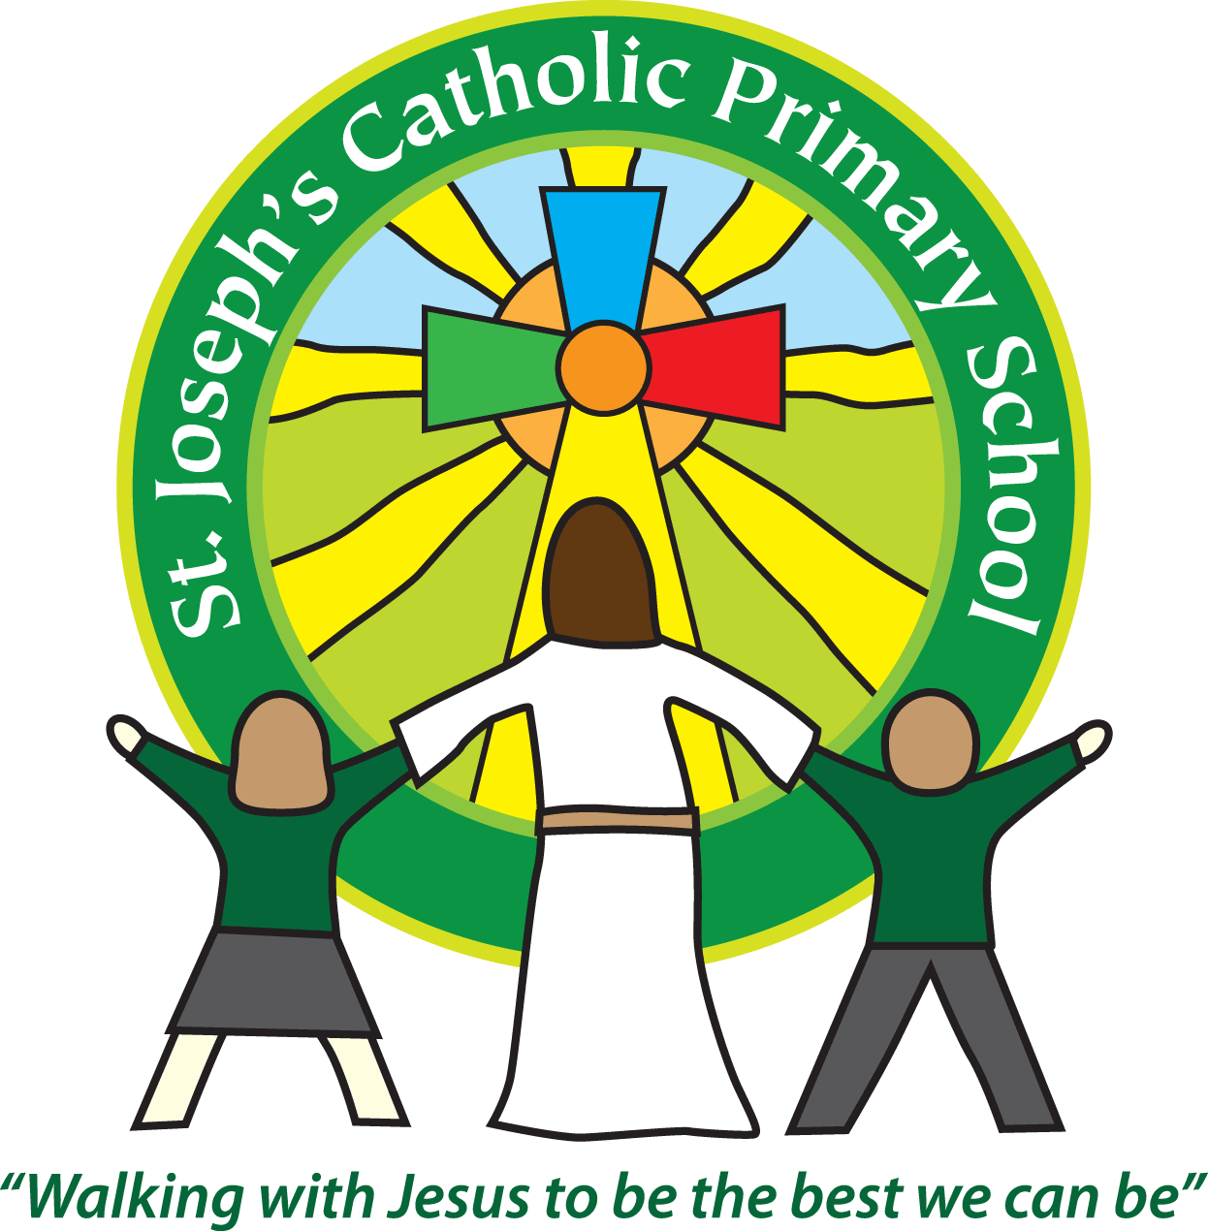

St Joseph’s Catholic Primary School

Newsletter

February 24th 2017

**Dear all,**

It has been lovely to have so many parents in this week for the activity sessions. Classes 5 and 6 learnt all about war time rationing cooking carrot rock cakes and fruit crumbles. Class 4 were having a great time investigating different sounds and speaking to some of the children afterwards I know that trying to beatbox was a real hit! Then FSU were busy learning all about the 3 Little Pigs, making straw houses and acting out the story with puppets. Many thanks to all the parents who were able to attend these activities.

**PTA:**

Thank you to everyone who supports the PTA events. The October disco raised £450.81, the Christmas events made £1358.40 and the February film night made £249.

Many thanks to our PTA for all the things they are doing for St Joseph’s. Last term the PTA paid for all the transport for every class’ school trip totalling £1441.60. They also bought new lunch play equipment and gave every class Christmas presents totalling £604.30. The money makes a real difference to the opportunities and provision we can offer to the children.

Future events are: Friday 26th May Sponsored bounce and Mufti day, June 9th Summer Fayre, July 8th Sponsored Walk and July 15th Summer Ball.

**Funding cuts:**

On a less cheerful note you may well have heard in the news about the funding cuts in education or as it is being termed ‘fairer funding’. Whilst the funding formula in essence would make it fairer across the country the government is also proposing to put 3 billion less into the education budget. This means Devon will be one of the poorest funded counties. We are already funded at £290 less per pupil than the national average. In real terms for our school if the proposed cuts go ahead we will lose at least £43,000. It means £24 million less coming into Devon Schools than if they were funded at the national average. I have written to our local MP, Hugo Swire and he is now coming to meet with me next week but I urge you as parents to also look at the [www.schoolcuts.org.uk](http://www.schoolcuts.org.uk/) website. This shows the cuts to schools across the area and if you feel strongly to email your views to him. There is an email link on the school cuts website or you can email: hugo.swire.mp@parliament.uk. Your support with this is much appreciated as increased budget cuts will have a very real effect on all children in Devon.

**Holy Communion**

Tomorrow (Saturday) it is the First Reconciliation for the First Communion children. This is at the Holy Ghost Church at 9.30am. We hope they enjoy this special occasion.

**Next week:**

Monday: Swimming lessons for Class 5

Tuesday: Class 1 assembly 9.10am in the hall

Tuesday: Class 4 mass in school 2.45-3.15pm

Wednesday: Group of 5/6 children attending Fair Trade conference

Wednesday: Ash Wednesday assembly 2.30-3.30pm

Thursday: World Book Day – Children to come dressed as their favourite character. £1 voluntary donation towards new books for classes.

Thursday: Class 6 visiting ECC

Friday: Hugo Swire visiting

**Best wishes and thank you for your continued support**

**Mrs Taylor-Bashford**

**Headteacher’s Awards:**

**Well done to:** FSU – Elliott,Yr 2 – Max, Lewis, Patrycja, Isabella, Emmie, Alfie, Yr 4 – Laura, Cameron Yr 5 – Oliver, Harry, Henry, Poppy, Evelyn

**Bronze certificates:** FSU – Olivia, Emily, Max, Owen, Rian, Yr6 – Harri, Haylin

**Stars of the Week:** FSU – Rose, Yr 1 – Willow, Yr 2 – Patrycja, Yr 3 – Bart, Yr 4 – Cameron, Yr 5 – Louis, Yr 6 - Adam



If you know anyone looking for school places, please let them know as we still have spaces available in some classes. They can contact the Office for more information or to book a tour.

Tel: 01395 264875 email: admin@stjo.uk