St Joseph’s Primary School
15.05.2020
Dear Sycamore Class,
How are you? I have been really missing you all but it has been wonderful to see all the amazing learning that you have been doing at home. I thought I would write to you and tell you about some of the things that I have been doing.
I have been reading lots of books. What books have you read? What has been your favourite and why?
Also, I am really lucky to have a garden so I have been doing some planting and some much needed weeding! What have you enjoyed doing outside?
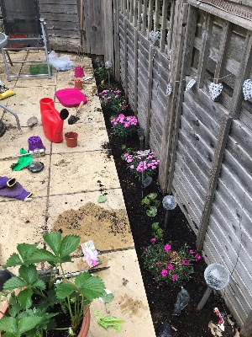
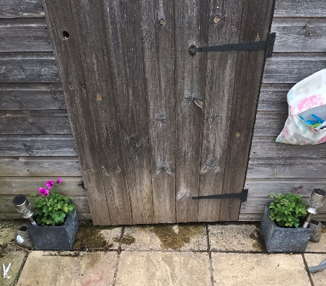
I have also been doing some baking and cooking, although it has been difficult to get some flour. I made some yummy brownies, a very delicious quiche and some homemade coleslaw.
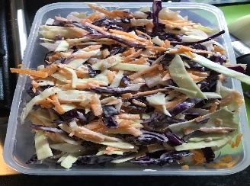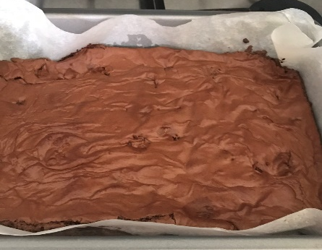
If you would like to write back, please send it to school. I would love to hear what you have been doing.

Smiles and waves,
Miss Rowe

