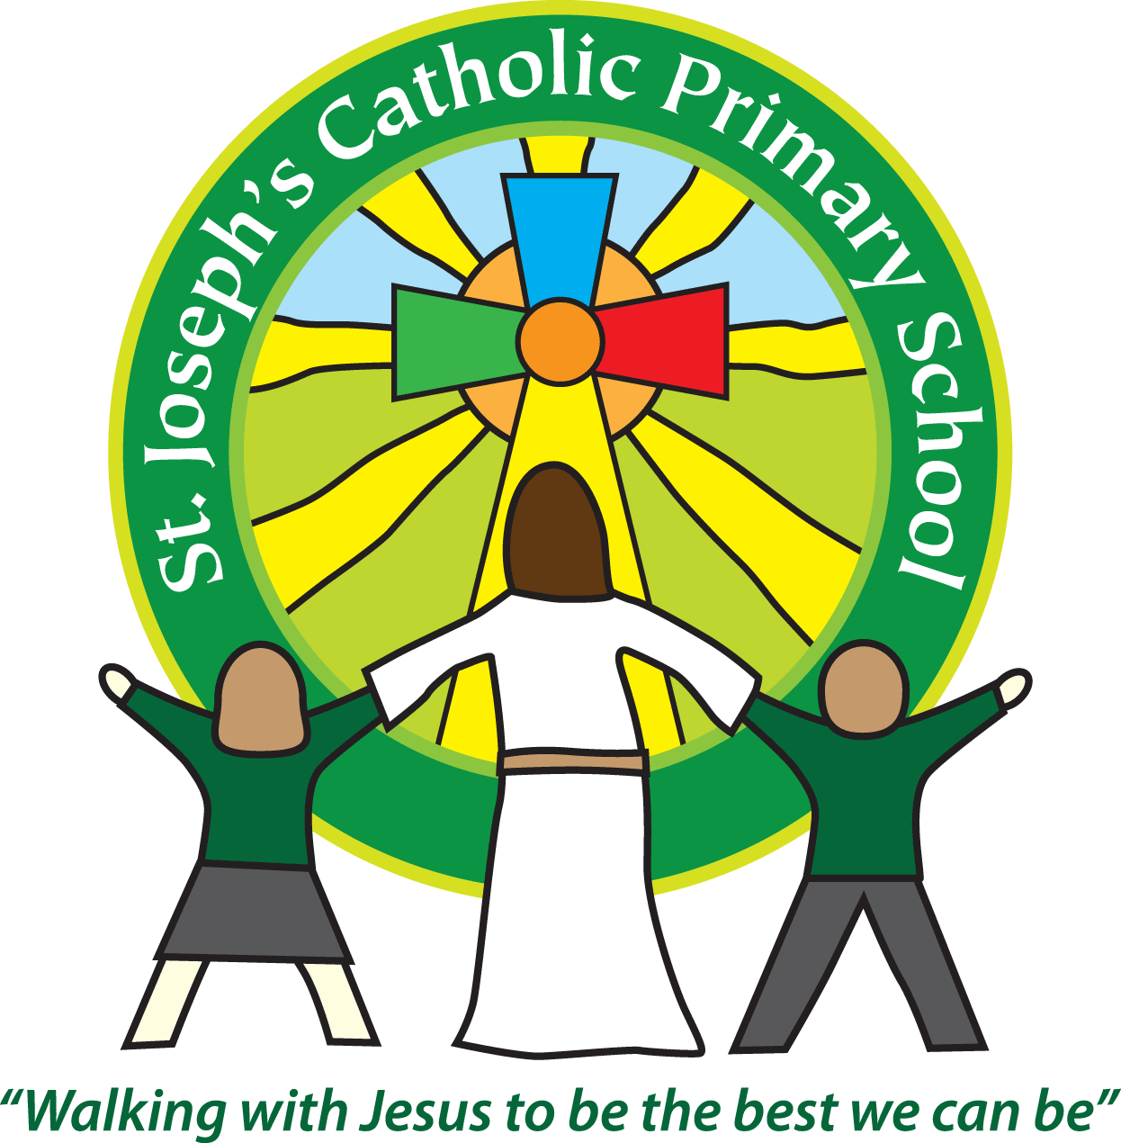
St Joseph’s Catholic Primary School Home Learning Pack
Class Rowan Year 1 Week Beginning 14.4.20

Please find the suggested timetable. This is just a suggestion and you need to find what works for you and your child as we understand that everyone learns differently. Please contact us at admin@stjo.uk and in the subject name it… For (Your Child’s teachers name and Class) if you need any further support or would like to share some of your learning with us! For example; For Mrs Robertson/Mrs Boatman, Rowan Class. This will help us to ensure your request is dealt with quickly.
Suggested Family Home Learning Timetable
This is a guide to help you establish a routine for your children – this is just a suggestion and you will need to adapt it to the needs of your family.
Time | Activity
9.00 – 9.30 | PE with Joe or family walk
9.30 – 9.45 | Drink and get ready for home learning
9.45 – 10.30 | English – writing, spelling or grammar activity from your home learning pack
10.30 – 11.00 | Break time - take a snack and drink outside if you can
11.00 – 11.45 | Maths – choose an activity from your home learning pack
11.45 – 12.30 | Creative time – draw, paint, sew, bake, do a job in the garden, stop-motion animation with lego / plasticine (the list is endless). Have a project that you can do a bit of everyday.
12.30 – 1.15 | Lunch – help to make it AND clear up behind it!
1.15 – 1.30 | Chores – do a job around the house e.g. put laundry away, tidy your room, vacuum or polish
1.30 – 2.00 | Quiet time – shared or independent reading
2.00 – 3.00 | Topic time – science / art / history / geography / music – choose a topic activity from the home learning pack
3.00 – 3.15 | Break time – take a snack and drink outside if you can

Maths |  | Activities | Resources
Day 1 | Can I create a repeating pattern? | Can you draw a pattern that repeats? Eg: red, blue, yellow, red, blue, yellow… Could you use shapes in your pattern? Eg: Square, Triangle, Square, Triangle… Try drawing a pattern and asking if they can spot what comes next. Watch Numberblocks episode called ‘Pattern Palace’ which will help explain this further!  **Check they understand what the word ‘repeat’ means ** | Paper and coloured pencils/pens
Day 2 | Can I recognise my left and right? | Work on which is your left and which is your right through a game of Simon Says, Twister or sing the Hokey Cokey. Demonstrate with your hands – the left hand makes the shape of an L with your finger and thumb.
Day 3 | Can I recognise 2D shapes? | Draw out some simple shapes – circle, triangle, rectangle, square, pentagon, and hexagon. Talk about the properties of the shapes. Encourage them to use the words ‘sides, corners, straight, curved.’ Cut out the shapes and hide one. Which shape is hidden? It has 4 sides that are all the same length. I have hidden a Square! Numberblocks episode Flatland will support work on naming 2D shapes. | Paper, pencils, ruler, scissors
Day 4 | Can I identify 3D shapes? | Go on a shape hunt! Look around your home, what shapes can you find? Look for 3D shapes, eg: cube=dice, cuboid=cereal box, sphere=ball, cone=ice cream, cylinder=tin can. You could take photos on a phone or tablet as you walk around, then review them after. | Objects around the home
Day 5 | Can I solve a problem? | Choose some objects from your shape hunt and build a structure. Which shapes won’t work on the bottom of your structure? Why is that? Talk with them about the properties of the shapes, EG: why won’t they all balance on a ball? You can only use shapes you can name! Take a photo and email it in to share what you have created. | Objects around the home
English |  | Activities | Resources
Day 1 | Handwriting Practise | Sit with them and ask them to write each letter of the alphabet. Watch closely HOW they write each letter. Are they starting and finishing the letter in the right way? Put a dot under the ones that need more practise. If you’re not sure please don’t worry – just lots of encouragement! | Pencil and paper
Day 2 | Can I give my opinion? | Share poems of your choice! I have uploaded some onto the website if you can’t find any at home. Discuss what they like about the poem. What don’t they like about the poem? Have they got any questions about the poem? Can they spot any patterns in the poem? | Poems
Day 3 | Can I use an adjective? | Look out the window and what can you see? A tree, a car, a house. Can you tell me more? An adjective is a describing word. What adjectives can you think of to describe these objects? Eg: The bumpy, tall, brown tree. | Pencil and paper or whiteboard and pens
Day 4 | Can I write a riddle? | Say I am thinking of an animal. It has green scaly skin. Sometimes it likes to hop across ponds. It starts off as a tiny tadpole. What am I? Ask them to generate their own riddle about an animal of their choice. | Pencil and paper or whiteboard and pens
Day 5 | Can I write neatly? | Ask them to look at their poem from yesterday, but this time to write it up in their best handwriting. Add some pictures to decorate it. Take a photo and email it to admin for us to see! | Pencil, paper, colouring pencils or pens.

Suggested Reading Activities
Reading Daily
Please enjoy a bedtime story together each night! Try to get them to make a prediction about what might happen next in the story.
We'll add a list of words each week to simply practise reading. These are from a resource called Early Reading. Encourage the children to sound out the word and then blend it back together. (Eg: th -i -ng = thing) If they get it wrong, model how it should sound. If you're not sure, then simply move on. Any reading practise, little and often, will make a huge difference. This week it's words with the digraphs: wh, qu, ar, ea, oo. Choose a sound a day to focus on. If you are not sure about how to pronounce each phoneme have a look on our class webpage under Home Learning for a link to follow!

Varied activities of Science, Music, Topic (History, Geography, Art) and R.E
 |  | Activities | Resources
Day 1 | Can I create a symbol of Easter?  (RE) | Explore the signs and symbols of Easter. For example, new life – plant a bulb. Make an Easter card together or perhaps plant an Easter garden? | Paper, card, pens and pencils.
Day 2 | Can I do small things with great love?  (RE) | See what you can find out about Mother Teresa. She encouraged people to do small things with great love. We are doing that at the moment by staying home! Can you think of some small things you could do at home? Write them down. See if you can try to do one each day! | Books, internet, paper, pencils
Day 3 | Can I sing a nursery rhyme?  (MUSIC) | ** Link to English**  As we are looking at poems this week, try seeing what nursery rhymes you know. Can you sing some together? Can they spot the rhyming words?
Day 4 | Can I create a 3D model?  (ART) | **Link to English learning**  Use boxes from your home recycling box to make the animal that you wrote your riddle about. | Junk modelling materials
Day 5 | Can I identify the habitat of an animal?  (SCIENCE) | ** Link to English**  Go back to the animal from your riddle. Where does that animal live? That is called its habitat. Can you think of why it likes to live there? Try Andy’s Wild Workouts on BBC iplayer. See which animals live in which habitats whilst working out! | Internet

