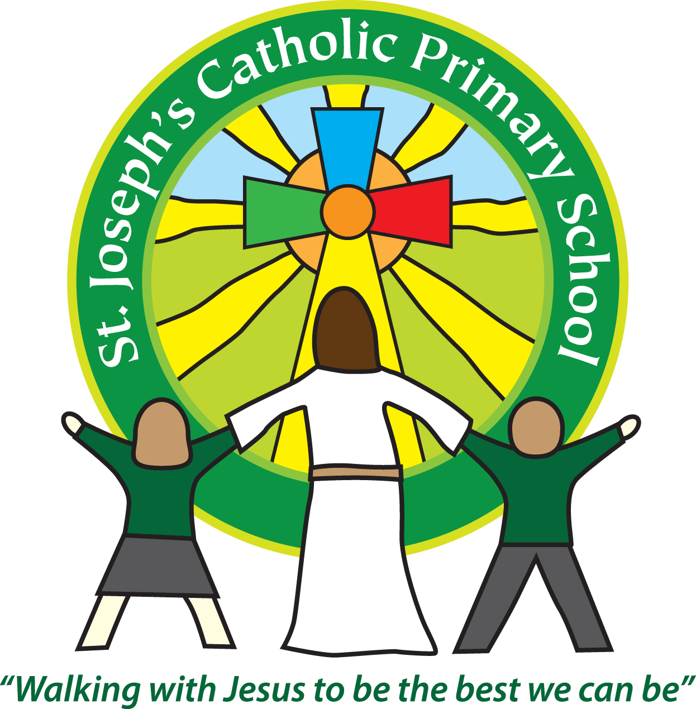Diary dates for parents/carers Spring 2019

|  |  |  |
| --- | --- | --- |
| Date | Time | Event |
| January |  |  |
| Monday 7th January | All day | School closed for Non-Pupil days |
| Tuesday 8th January | 8.55am | Children return to school after Christmas holidays |
| Tuesday 22nd January | Morning | Fire Service workshop for FSU, Yr 2 and 5. |
| Tues, Wed, Thurs 22nd, 23rd, 24th Jan | 3.40 – 5.50pm | Parents’ evenings, appointments will be issued. Times are limited so please only rearrange if absolutely necessary. |
| Wednesday 23rd January | 9.30am | Mass in school |
| Thursday 24th January | 10-3pm | Kids Exeter City Sports at Exeter University – Team from Beech Class |
| Friday 25th January | 9.30-12.30 | Athletics event at ECC – Team from Maple Class |
| Saturday 26th January | 7.15pm | Holy Ghost Church After Burn’s party. See Church website for more information. |
| Thursday 31st January | 9am | Bags 2 school being collected from school office. |
| February |  |  |
| Friday 1st February | Afternoon | Cherry and Willow Classes to watch Bournemouth Symphony Orchestra |
| Monday 4th February | 4-5.30pm | Quiksticks hockey at ECC - Team from Beech & Maple |
| Tuesday 5th February | All day | Safer Internet day |
| Thursday 7th February | 6pm | Yr 6 SATs talk for parents in Class 6. |
| Friday 8th February | 10-12 | Aesthetics festival at ECC – Team from Rowan & Sycamore |
| Friday 8th February | 1-3pm | Dance Festival at ECC – Team from KS2 |
| Monday 11th February | 1.30 – 4.30pm | Quiksticks hockey at ECC - Team from Beech & Maple |
| Tuesday 12th February | 9.10am | Maple Class assembly |
| Wednesday 13th February | TBC | FSU visit to the lifeboat station |
| Friday 15th February | 9.30-12 | Hi-Five Netball at ECC - Team Beech & Maple Class |
| Friday 15th February | Morning | Beech class Maths session with teacher from ECC |
| HALF TERM – Monday 18th – Friday 22nd February | | |
| W/beginning 25th February | 3.40pm | SEND parents’ evenings – appointments will be issued |
| March |  |  |
| Monday 4th March | 4-5.30pm | Quiksticks hockey at ECC - Team from Willow & Cherry |
| Wednesday 6th March | 2.15–3.15pm | FSU parent activity session |
| Thursday 7th March | All day | World Book Day. Children to come in dressed up as a book character of their choice with the corresponding book to share in class. £1 donation to go towards reading books for classes. |
| Friday 8th March | Morning | Beech class to ECC for English session |
| Tuesday 12th March | 9-10am | Beech Class parent activity session |
| Tuesday 12th March | 2.15-3.15pm | Maple Class parent activity session |
| Wednesday 13th March | 9-10am | Sycamore Class parent activity session |
| Wednesday 13th March | 2.15-3.15pm | Cherry Class parent activity session |
| Thursday 14th March | 2.15-3.15pm | Willow Class parent activity session |
| Friday 15th March | 2.15-3.15pm | Rowan Class parent activity session |
| Tuesday 19th March | 9.30am | St Joseph’s day Mass in school |
| Tuesday 19th March | All day | Governor day – Governors in classes all day |
| Wednesday 27th March | TBC | Rowan and Sycamore trip to Powderham Castle |
| Thursday 28th March | 2pm & 6pm | Cherry and Willow Class performance |
| Friday 29th March | All day | Cherry and Willow Class Egyptian dress up day |
| Friday 29th March | 3.30pm | Yr 1 -6 Reports go home |
| April |  |  |
| Thursday 4th April | 2.40pm | Yr 2 SATs talk for parents |
| Thursday 4th April | 3.30pm | Cherry and Willow Class ‘Egyptian Museum’ display. |
| Friday 5th April | 10-11.30am | SEND festival at ECC - group from yrs 2-6 |
| Friday 5th April | 3.30pm | Children finish for Easter holidays |
| EASTER HOLIDAYS 8th – 22nd April | | |
| Tuesday 23rd April | 8.55am | Children return to school after holidays |
| Tuesday 30th April | 9.10am | Cherry Class assembly |
| May |  |  |
| Monday 6th May | All day | Bank holiday |
| Thursday 9th May | 9.10am | Sycamore class assembly |
| Monday 13th – Wed 15th May | Residential | Maple Class to Magdalen |
| Monday 13th – Thursday 16th May | Mornings | Yr 6 SATs |
| Tuesday 21st May | 9.10am | Willow Class assembly |
| HALF TERM 27th – 31st May | | |
| June | | |
| Tuesday 11th June | 9.10am | EYFS Class assembly |
| Wednesday 26th June | 9.10am | Rowan Class assembly |
| Friday 28th June | FSU:  9.15-10am  KS1:  10.15-12.00  KS2:  1.30-3.15pm | Sports Day |