Adding an observation to Tapestry.
We would love you to add your own observations from home. Please upload any ‘WOW’ moments. This may be when your child does something for the very first time or learns a new skill like riding a bike or gets a certificate or attends a club outside of school.
We don’t expect regular observations just those special moments that we may not know about.
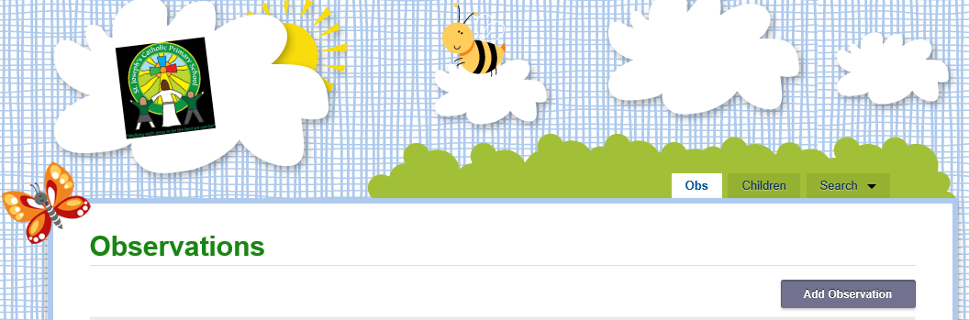
- Log into your tapestry account.
- Click on add observation

- Select your child and fill in the title box.
- In the notes section please explain you ‘Wow’ moment.
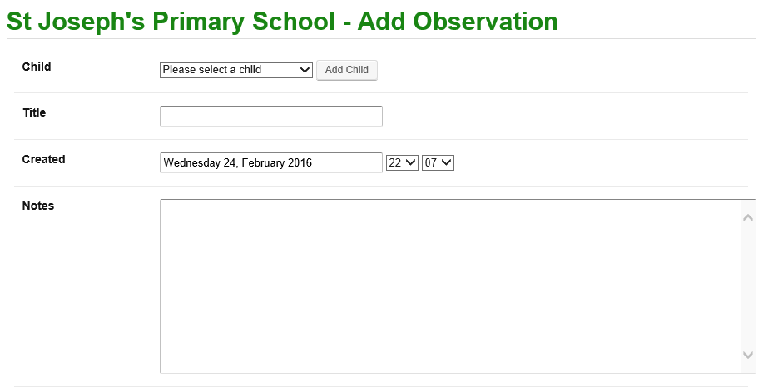
- To add a photo click on Add file
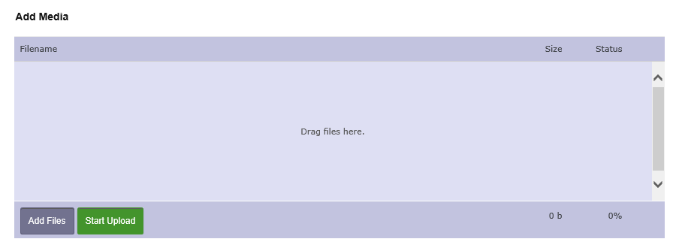
Once photos appear in a list then click Start Upload
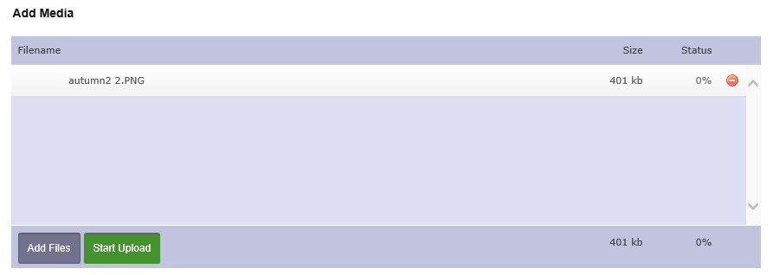
- Finally click save at the bottom of the page 