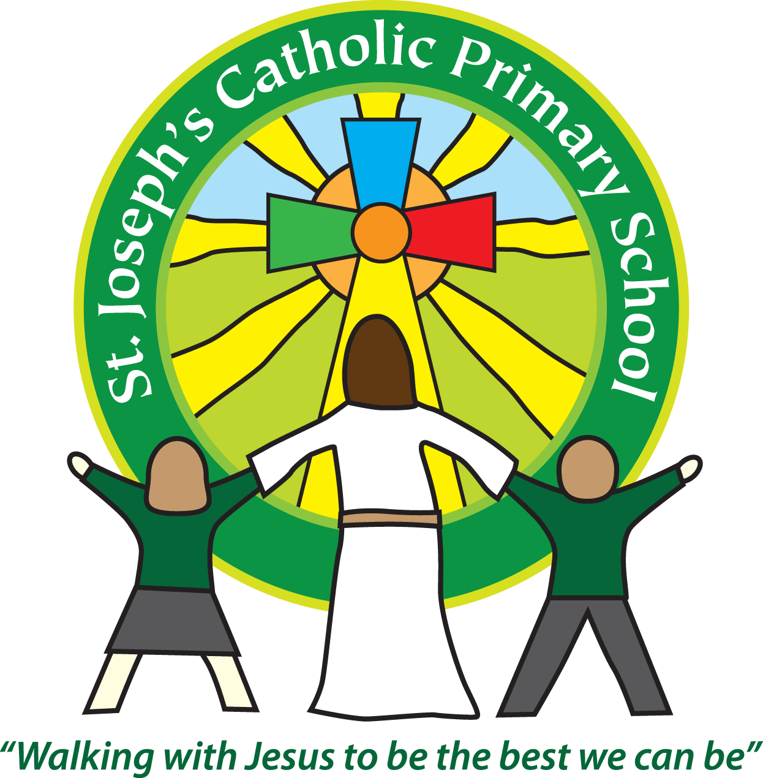

St Joseph’s Catholic Primary School

Newsletter

January 6th 2017

**Dear all,**

Happy New Year!

I hope you have all had a happy and peaceful Christmas.

The term has started off well with Mrs Jukes and Class 6 searching everywhere for the baby Jesus on Thursday and then a surprise visit in assembly from Angel Gabriel!

Father Philip came over and blessed the school doors after the Epiphany Mass today which you can see next to the main entrance. It symbolizes Jesus blessing everyone who walks through the door.

**Welcome**

We would like to welcome two new children who have started in Nursery this week. We hope they enjoy many happy years at St Joseph’s with us.

**Toys for children in Syria**

If you are anything like me you are now finding the house overrun with toys from Christmas and finding the need to have a clear out! On Saturday 15th January Mrs Richardson is hoping to take lots of toys to donate to Exeter Quickstore, Grace Road West – EX2 8PU. This is where ‘Open Hearts, Open Borders’ are collecting toys and taking them to the children in Syria. If you have any unwanted toys we would be very grateful if you could bring them to school next Friday so we can transport them to Exeter on Saturday. (Please no toy guns, toys that need batteries or computer games)

**Music**

I am really pleased to say that we have Mrs Nelmes from The Primary Music Company coming in every Wednesday afternoon this term to teach Classes 1 & 3. We hope that after Easter they will then work with Classes 2 & 5.

**Diary dates**

For your information we have sent out today the term dates by email for 2017-2018 and also the diary dates that we know so far for the rest of this year. You can view both of these items on the website. I’m sure more will be added and some need to be confirmed but this is the information I have so far.

**Class 5** reminder-please ensure swimming kits are brought to school on Monday mornings.

**Best wishes and thank you for your continued support**

**Mrs Taylor-Bashford**

**Headteacher’s Awards:**

Well done to: Year 2 – Callum & Patrycja, Year 3 – Evie, Yr 6 – Scarlett & Alex

