

*St Joseph’s Nursery*

*Come and see our newly created Foundation Stage Unit*

*and meet our experienced Early Years teachers.*

[](http://www.google.co.uk/url?sa=i&rct=j&q=&esrc=s&frm=1&source=images&cd=&cad=rja&uact=8&ved=0CAcQjRw&url=http://www.howtodothings.com/hobbies/a2512-how-to-draw-trees.html&ei=Z_uHVYTkMoaa7gaJioLQCA&psig=AFQjCNEu0IECJ7AMoIsssHiXsuSeg_B3gg&ust=1435060212961608) Open daily during term time for

 3 and 4 year olds.

*We provide a safe, stimulating learning environment.*

.

*We enable choice*

*and decision making, fostering independence*

*and self-confidence*.

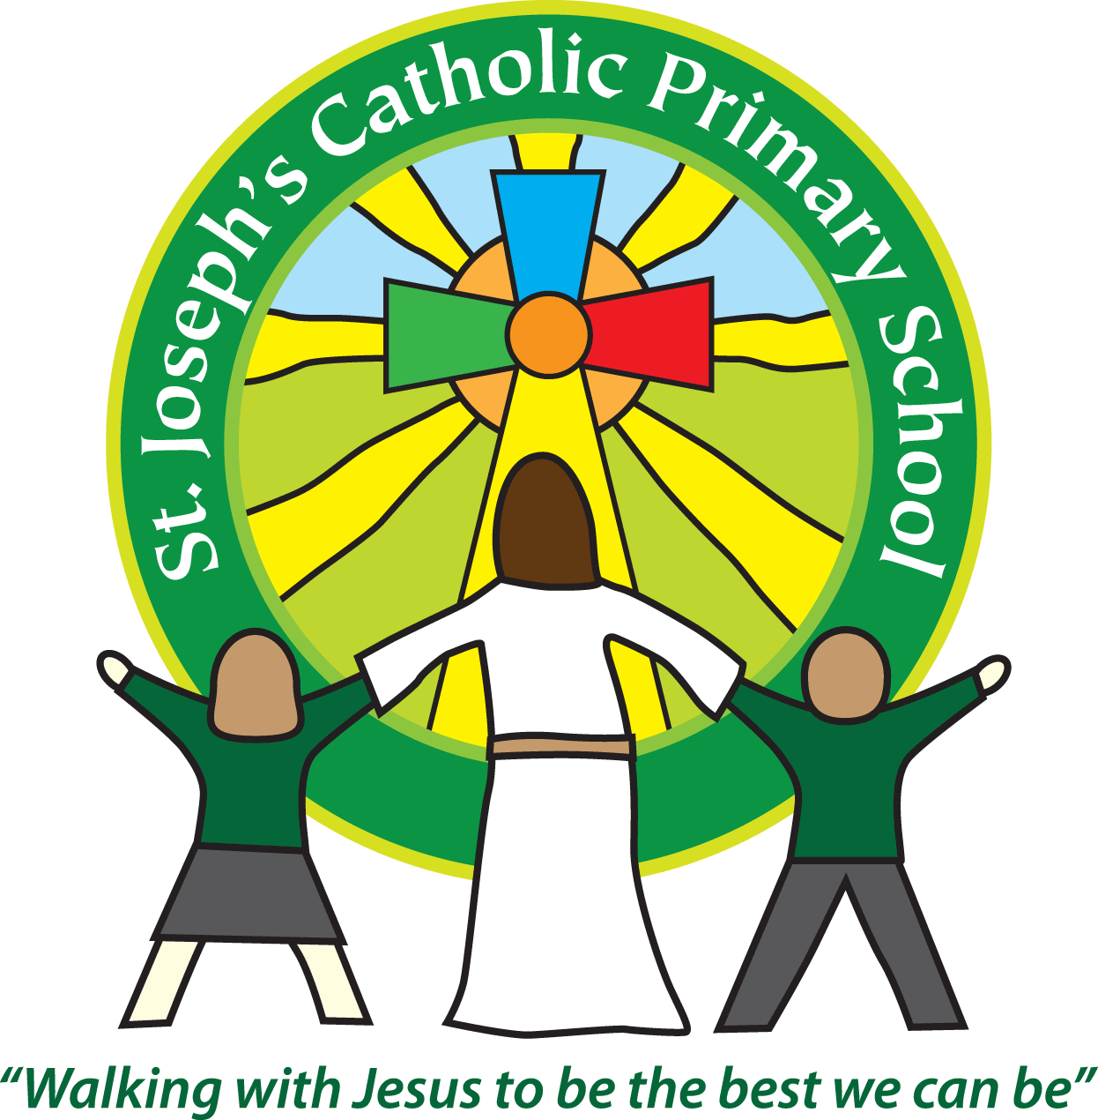

**For more information please contact:**

St Joseph’s Catholic Primary School,

Long Causeway, Exmouth EX8 1TA

Email - [admin@stjo.uk](mailto:admin@stjo.uk)

Tel - 01395 264875