send parents and families?
Next, establish how much time and money you can spend on your newsletter. These factors will help determine how frequently
St Joseph’s Catholic Primary School

Safeguarding Children


All staff at St Joseph’s School are committed to safeguarding our pupils and promoting the welfare of children and expect all visitors and volunteers to share this commitment. This means we have a child protection policy and procedures in place. All staff, supply, volunteers and governors must ensure they are aware of these procedures. Parents and Carers are welcome to read the Child Protection policy on the school’s website or upon request. We follow the DCC policy.

Our Acting Headteacher, Mrs Nicola Taylor-Bashford, is responsible for Child Protection within the school. It is her duty and responsibility to pass on to outside agencies any concerns that a pupil is being harmed or may be at risk of being harmed. This may result in a referral to Children and Young People’s Services.
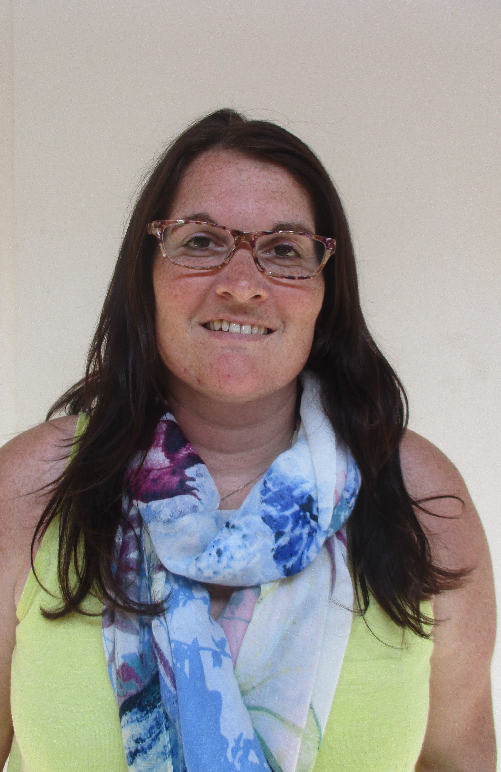
Senior Designated Deputy Designated Officers Safeguarding Officer Governors
Mrs N Taylor-Bashford Mrs R Pattison Mrs J Clarke Mrs J Bowes Mr E Howard

- If you are concerned about a child’s welfare please record your concern and report to a Designated Officer immediately.
- If your concerns relate to the actions of a member of staff please report this to one to the Designated Officers who will report it to the Headteacher.
- If your concerns relate to the actions of the Headteacher please contact our Chair of Governors, Sandi Forte. Her contact details can be obtained from the Office.

