

St Joseph’s Catholic Primary School

Regents Gate

Long Causeway

Exmouth

Devon

EX8 1TA

Acting Head Teacher: Mrs N Taylor-Bashford

Tel: 01395 264875



***SEN Jan 2018 Newsletter***

Dear Parent,

Your child’s parent teacher meeting will be coming up very soon. At this meeting you will be able to find out more information about how your child is progressing.

At this meeting your child’s class teacher will share with you a review of the support plan from the Autumn Term and also the new support plan for the Spring Term 2018.

SEND at St Joseph’s continues to move forward. All children on the special needs register now have a support plan where individual targets are set and the steps of how to achieve these are shared with both children and parents. These targets and plans are updated regularly as part of an assess, plan, do, review cycle.

I have received such positive feedback about the different group interventions. ‘Time to talk’ and ‘Think Good Feel Good’ have had some very positive impacts on children’s social and emotional health and therefore on their learning. Fun fit and Sherborne have been increasing children’s confidence and relationships as well their physical ability. Next week 3 members of staff will attend training for a new intervention called ‘high five.’ This is an intervention that is specifically aimed at children in key stages 1 and 2 with underdeveloped fine motor skills.  High Five is about helping children to engage in learning, about raising their self-esteem and about making an impact on their academic achievement.

The auditory processing, memory magic and sounds write interventions have shown a positive impact on many children’s learning last term. Miss Fisher has been running these groups on a Monday and Tuesday afternoon. This term they will be run by Mrs Briggs. There has been a thorough hand over and Mrs Briggs will be running the groups throughout the Spring Term.

Our speech and language therapist, Rachel Williams, visits us regularly to meet with teaching assistants and myself to discuss the children that we have with speech programmes and to review their progress.

If you have any concerns with health issues for example sleep, fussy eating, toileting needs or weight issues then please come and see me as when I met with the School Nurse she was offering support in these areas to our children and families.

It has been great to see so many parents making use of the ‘Withycombe Friday afternoon sessions.’ I have attended a couple myself and have found them very useful. Several of our teaching assistants have also been released to attend particular sessions that will support them in their role with our special needs children.

Keep an eye out on your email for more specific details but here is an overview of this half term.

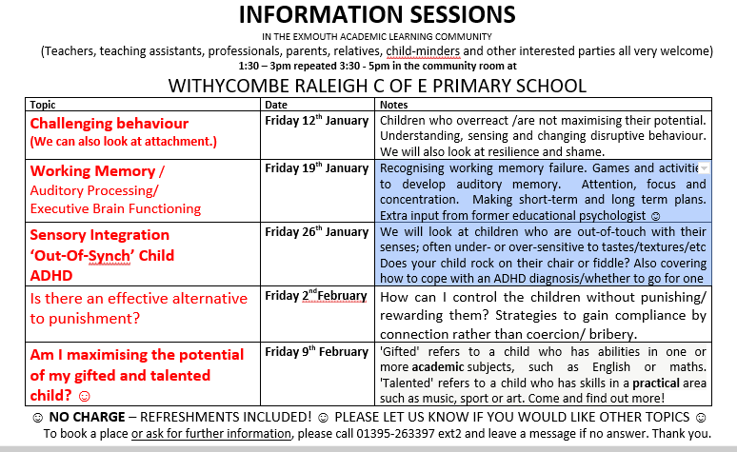

 I will meet with you again in the Summer Term to have a review meeting that will look at the support and plans so far as well as looking at transition into the next year group. If however you have any concerns or questions before then please do not hesitate to book an appointment via the school office or I can usually be found in Foundation after school on a Monday or Tuesday.

In the meantime, I would like to thank you for your help and support whilst I have been finding my feet and ensuring that we strive to do all we can for our children with SEND at St Joseph’s.

Many Thanks

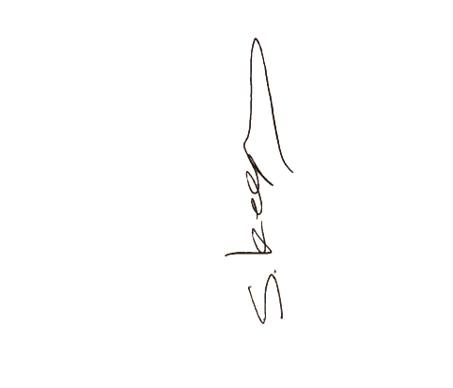

S.Keeping

SENCO