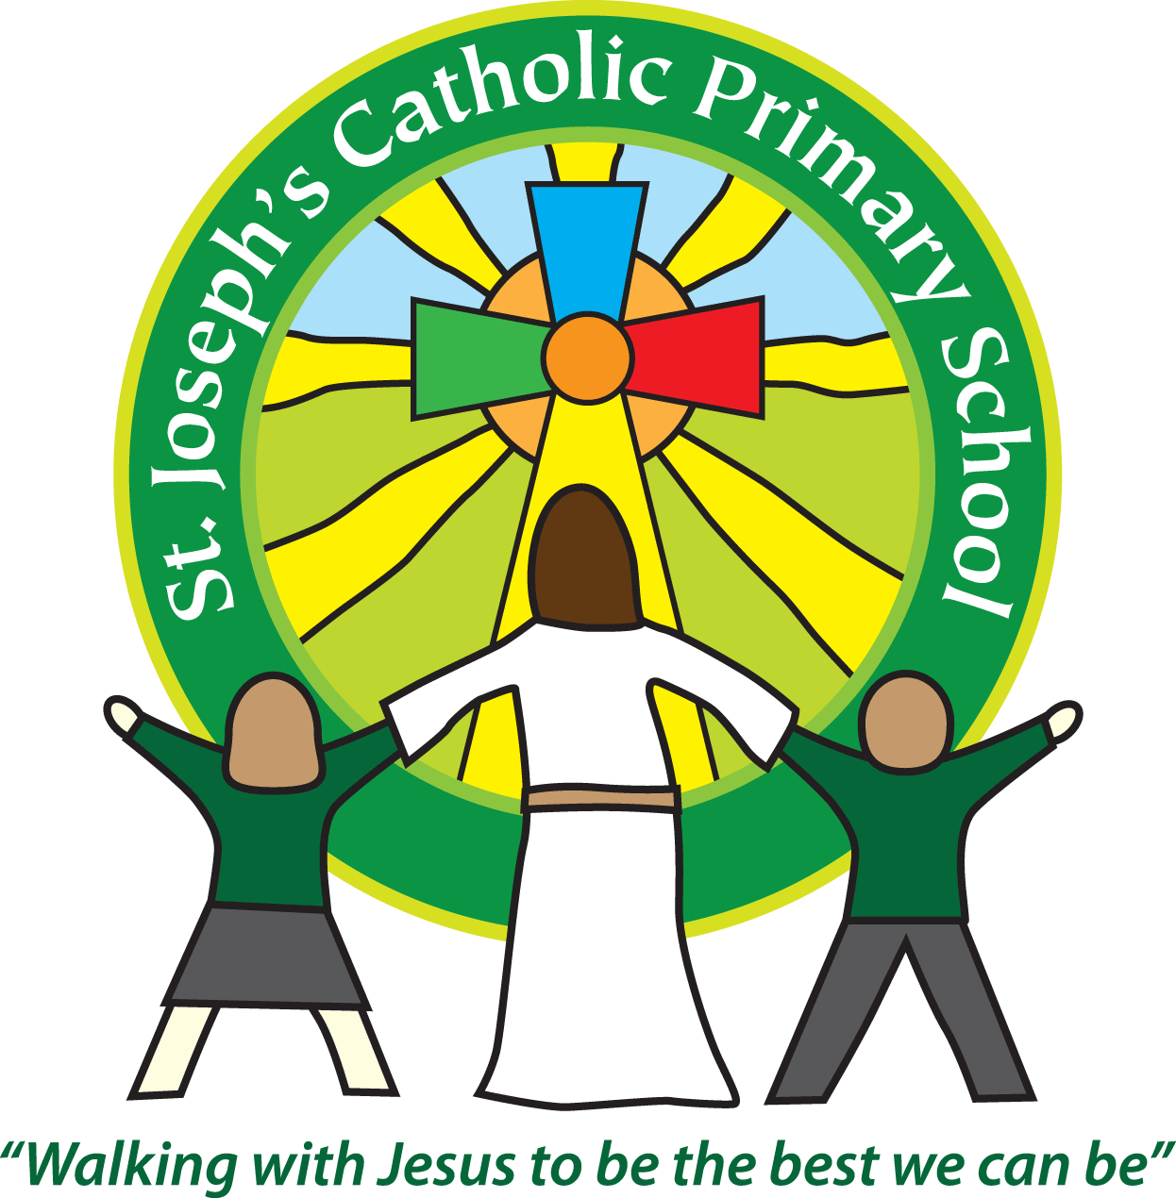Diary dates for parents/carers Spring/Summer 2017

|  |  |  |
| --- | --- | --- |
| Date | Time | Event |
| January | | |
| Wednesday 4th January | 8.55am | Children return to school after Christmas holidays |
| Friday 6th January | 9.30am | Mass in Church |
| Friday 13th January | 3.30pm | Class 4 Cake sale |
| Tuesday 17th January | All day | Class 5 & 6 WWII day - TBC |
| Tuesday 17th January | 3.30pm | Class 3 cake sale |
| Wednesday 18th January | 9.10am | Class 4 assembly |
| Friday 20th January | 3.00-3.20pm | Year 5 Prayers in Church |
| Tuesday 24th January | 2.45pm | Class 6 Mass in School |
| Friday 27th January | 3.30pm | FSU Cake sale |
| Tuesday 31st January | 2.15-3.15pm | Class 3 parent activity session |
| Tuesday 31st January | 2.45pm | Class 5 Mass in School |
| February | | |
| Wednesday 1st February | 9.10am | Class 3 assembly |
| Thursday 2nd February | 9.30am | KS2 only Candlemass in Church |
| Friday 3rd February | 6pm | Children’s Film night |
| Monday 6th February | 2.15-3.15pm | Class 1 & 2 parent activity session |
| Monday 6th February | 2.15-3.15pm | Class 1 & 2 cake sale |
| Tuesday 7th February | 1.30-3.30pm | Bishop Mark visiting the school |
| Thursday 9th February | 6pm | Spring disco |
| Friday 10th February | All day | Non Pupil day |
| 13th – 17th February | All week | Half term |
| Tuesday 21st February | 2.15-3.15 pm | Class 5 parent activity session |
| Wednesday 22nd February | 9.00-10.00am | FSU parent activity session |
| Wednesday 22nd February | 2.15-3.15pm | Class 4 parent activity session |
| Thursday 23rd February | 2.15-3.15pm | Class 6 parent activity session |
| Thursday 23rd/24th February | Over night | Class 4 to Eden project |
| Friday 24th February | Morning | Class 2 & 3 music sessions with Primary Music group |
| Tuesday 28th February | 9.10am | Class 1 assembly |
| Tuesday 28th February | 2.45pm | Class 4 Mass in School |
| March | | |
| Wednesday 1st March | 2.30pm | KS2 - Ash Wednesday assembly in School |
| Thursday 2nd March | All day | World book day – children to come to school dressed as their favourite character. Donations towards new reading books for classes. |
| Tuesday 14th March | 9.10am | Class 2 assembly |
| Thursday 16th March | All day | Class 1 Powderham trip |
| Monday 20th March | 9.15am | St Joseph’s Day – Mass in School |
| Wednesday 22nd March | 3.30pm | Class reports sent out – Yrs 1-6 |
| Thursday 23rd March | All day | Class 2 Powderham trip |
| Friday 24th March | All day | Comic relief day – wear red for the day. |
| Friday 24th March | Overnight | Class 4 to Buckfast Abbey |
| Sunday 26th March | 2-4pm | Easter Egg hunt and BBQ |
| Friday 31st March | 3.30pm | Children break up for Easter |
| April | | |
| 3rd – 17th April |  | Easter Holidays |
| Tuesday 18th April | 8.55am | Children return to school after Easter holidays |
| Tuesday 18th April | 10.00am | Class 6 science session at ECC |
| Monday 24th April | 9.15am | KS1 – Liturgy with Father Philip in School |
| Tuesday 25th April | 9.30am | KS2 – St Mark Mass in Church |
| Thursday 27th April | 9.30am | FSU assembly |
| May |  |  |
| Monday 1st May | All day | Bank holiday |
| 3rd – 5th May | 3 days | Year 5 Magdalen residential |
| Monday 8th May | Morning | Yr 6 Reading SATS |
| Tuesday 9th May | Morning | Yr 6 SpaG SATs |
| Wednesday 10th May | Morning | Yr 6 Maths SATS paper 1 & 2 |
| Thursday 11th May | Morning | Yr 6 Maths SATS paper 3 |
| Friday/Saturday 12th/13th May | Overnight | Year 6 sleepover in the Church |
| 29th May – 2nd June | All week | Half term |
| June |  |  |
| Monday 5th June | 9.15am | Father Philip Pentecost liturgy in School |
| Friday 9th June | 3.30pm | Summer fair |
| 12th – 16th June | All week | Year 1 phonics screening tests |
| Tuesday 13th June | 2.45pm | Class 5/6 Mass in Outdoor Classroom |
| Friday 16th June | 6pm | Public Speaking competition |
| Saturday 17th June | 6pm TBC | Church Service celebrating Children receiving first Holy Communion |
| Sunday 18th June | Time TBC | Church Service celebrating Children receiving first Holy Communion |
| Tuesday 20th June | 2.45pm | Class 3/4 Mass in School |
| Thursday 29th June | Over night | Class 3 sleepover |
| Friday 30th June | All day | Action Against Hunger - activities throughout day |
| July |  |  |
| Friday 7th July | All day | Sports Day |
| Wednesday 12th July | 3.30pm TBC | Parents in for meet new class teachers |
| Friday 14th July | 2.30pm | End of term awards |
| Thursday 20th July | 2.30pm | Yr 6 leavers assembly |
| Friday 21st July | 9.30am | Leavers Mass in School |
| Friday 21st July | 3.30pm | Children break up for Summer holidays |