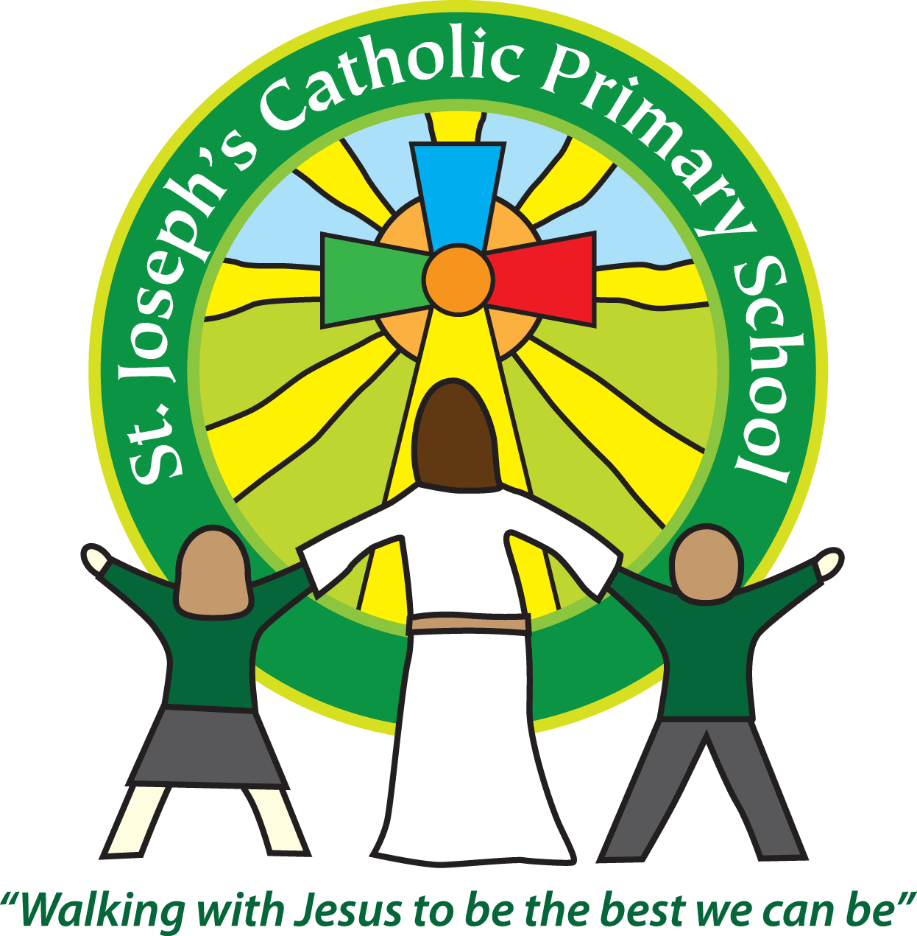
St Joseph’s News
Christmas 2015
stjosephsprimaryschool.com

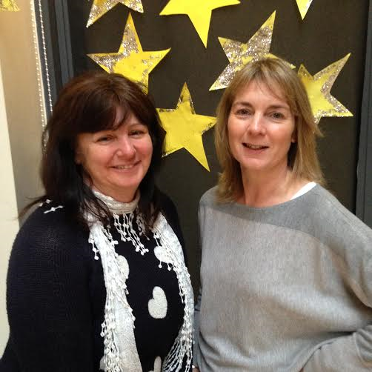

Sadly we have to say goodbye and good luck to two much loved members of staff who will be leaving us tomorrow.
Jan Birrell has been associated with St Joseph’s in a number of roles since April 1993. She came to us as a young teacher before her children were born, moved away for a while and then re-joined us in 2003. Since then she has taught every class in the school either as a class teacher, art specialist or, most recently, as SENCo. In all this time she has willingly shared her experience and wisdom and brought her down to earth northern sense of humour into all her wonderful teaching.
The whirlwind that is Sarah Cuthbert bounced into St Joseph’s in 2007 and has kept us all laughing and groaning in equal measure ever since! Her work ethic is remarkable, her love of life infectious and her sense of humour out of this world. She is an outstanding teacher who has always gone the extra mile for the children. They will both be greatly missed and will be incredibly hard acts to follow. We wish them well in the next, exciting phases of their careers.

As we come to the end of another busy term it is a great time to say a big thank you to everyone associated with our school, pupils, parents, staff, governors and parishioners, for all your help, support and prayers.
On behalf of all the staff I would like to wish you all a happy and peaceful Christmas. We hope to see many of you at the children’s service at Holy Ghost Church at 3.00 on Christmas Eve and don’t forget that the new term begins on Tuesday 5 January, 2016.

Merry Christmas

