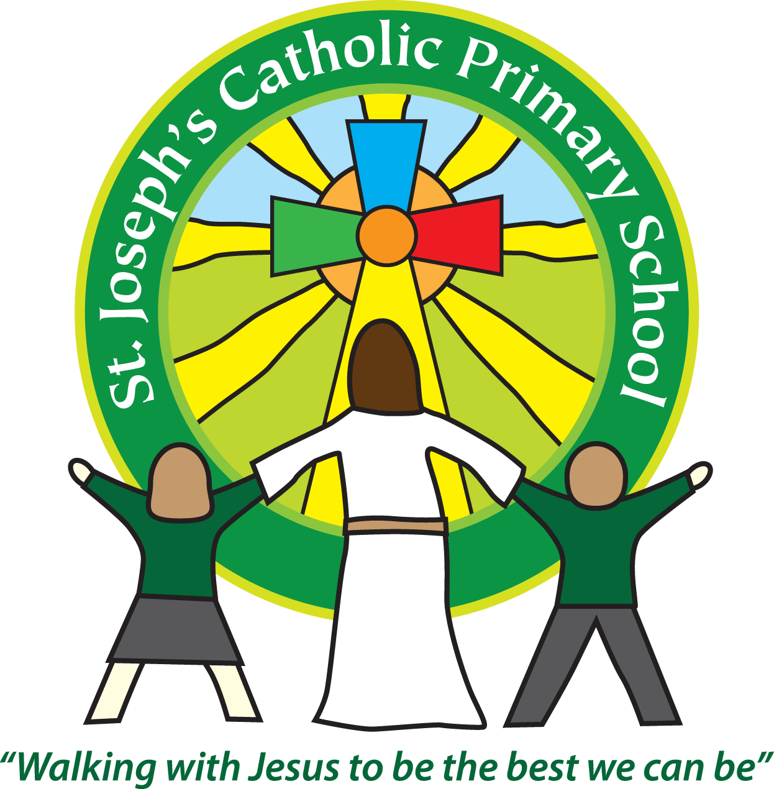

St Joseph’s Catholic Primary School

Newsletter

January 27th 2017

**Dear all,**

We have had a lovely week.

The Birdwatching week has been great fun with lots of children running up to me exclaiming that they have spotted collared doves, robins etc. It has been good to see them all wrapped up outdoors with the binoculars, identifying and tallying the birds they can see around school. I will gather in the findings and send them in to the RSPB next week.

Classes 5 and 6 thoroughly enjoyed their WWII day. They spent the morning trying morse code, looking at rations and clothing from that era. In the afternoon they had a realistic demonstration of an air raid siren, the airplanes flying overhead and the bombs dropping and then hearing that they had got the all clear. This was a really powerful exercise for the children and they have talked eloquently about the feelings that evoked and how it must have been to be alive during the war.

**Sporting news:**

Last Friday a group of 15 Key Stage 1 children took part in an Invasion Games Festival at the Tennis Centre. They played lots of mini games with children from other schools and even learnt some new skills. Well done to all that took part.

Yesterday 8 boys from classes 5 & 6 took part in a football tournament at Exeter University organised by Exeter City Football Club. 22 teams took part from schools in the Exeter and Mid & East Devon areas. We were drawn in a tough group with 5 teams we hadn't played against before. The boys played really well, winning our first 2 games 1-0 and 2-0 respectively. Our third match was against Stoke Hill who proved tough opposition and despite our best efforts we conceded a goal to lose 1-0. By the time we played our fourth game, the cold was really starting to bite, but we kept St Leonards to a 0-0 draw. Our final game started strongly and we scored the first goal but Willand came back to score 3 against us before the final whistle. Our boys were a credit to the school showing great sportsmanship and putting in their best efforts. They should be really proud of themselves.

**Next week:**

Monday: Class 5 swimming

Tuesday: Class 3 parent activity session – 2.15pm-3.15pm.

Tuesday: Class 5 mass – 2.45pm-3.15pm

Wednesday: Class 3 assembly – 9.10am-9.30am

Thursday: KS2 Mass in Church

**Best wishes and thank you for your continued support**

**Mrs Taylor-Bashford**

**Headteacher’s Awards:**

**Well done to:** FSU –Rose, Annie, Owen, Max, Nicholas, Yr 2 – Irys, Vince, George, Max, Lewis, Max,Nicole,Yr 5 – Sheril, Sophia, Poppy, Ellie & Tabitha

**Bronze certificates:** Yr 2 – Patrycja, Yr 5 – Alex, Yr 6- Loui-Jay, Lillie Saunders, Robert Golonko, Bethany Spencer

**Silver certificates**: Yr 5 – Maisie-Rae, Poppy Jones

**Stars of the Week:** FSU – Owen, Yr 1 – Holly, Yr 2 – Shanel, Yr 3 – Mara, Yr 4 – Charlotte, Yr 5 – Evelyn, Yr 6 – Shannon

