Is meal time like this? this? 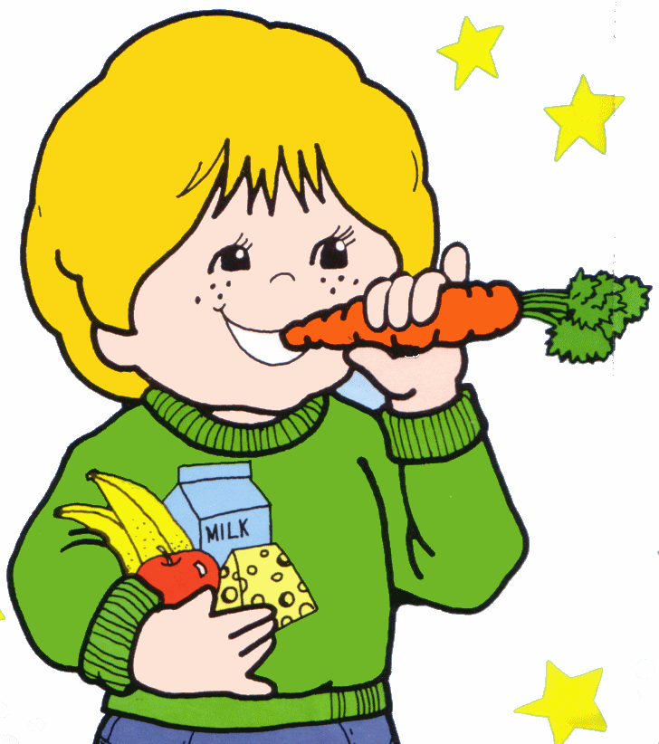or this? 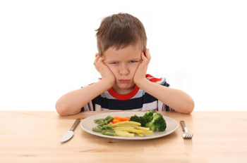
Is bed time like this?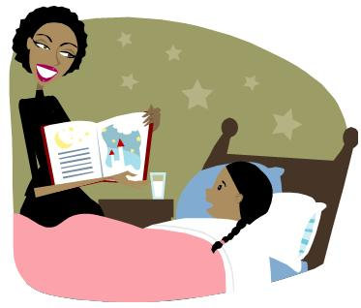this? 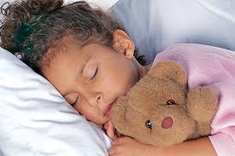 or this? 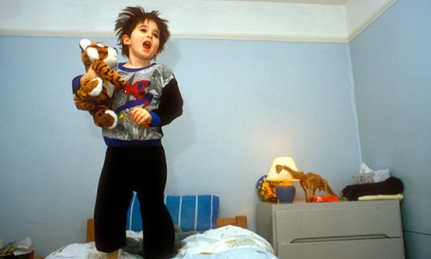
Is toileting like this? 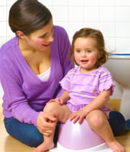 this? 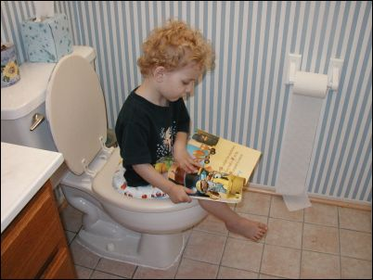 or this?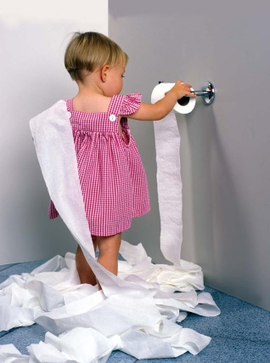
For a free pack of suggestions from the school nurse team and a chance to chat through possible ideas with other parents, come along to our information session this Friday, 23rd September 2016. Or just pick up the pack and go if you prefer!
We have two identical sessions to pop into; 1:30-3pm or 3:30-5pm, whichever is best for you!
You can book if you like, or just turn up!
NO CHARGE – REFRESHMENTS INCLUDED! PLEASE LET US KNOW IF YOU WOULD LIKE OTHER TOPICS
To book a place or ask for further information, please call 01395-263397 ext3 and leave a message if no answer. Thank you.

