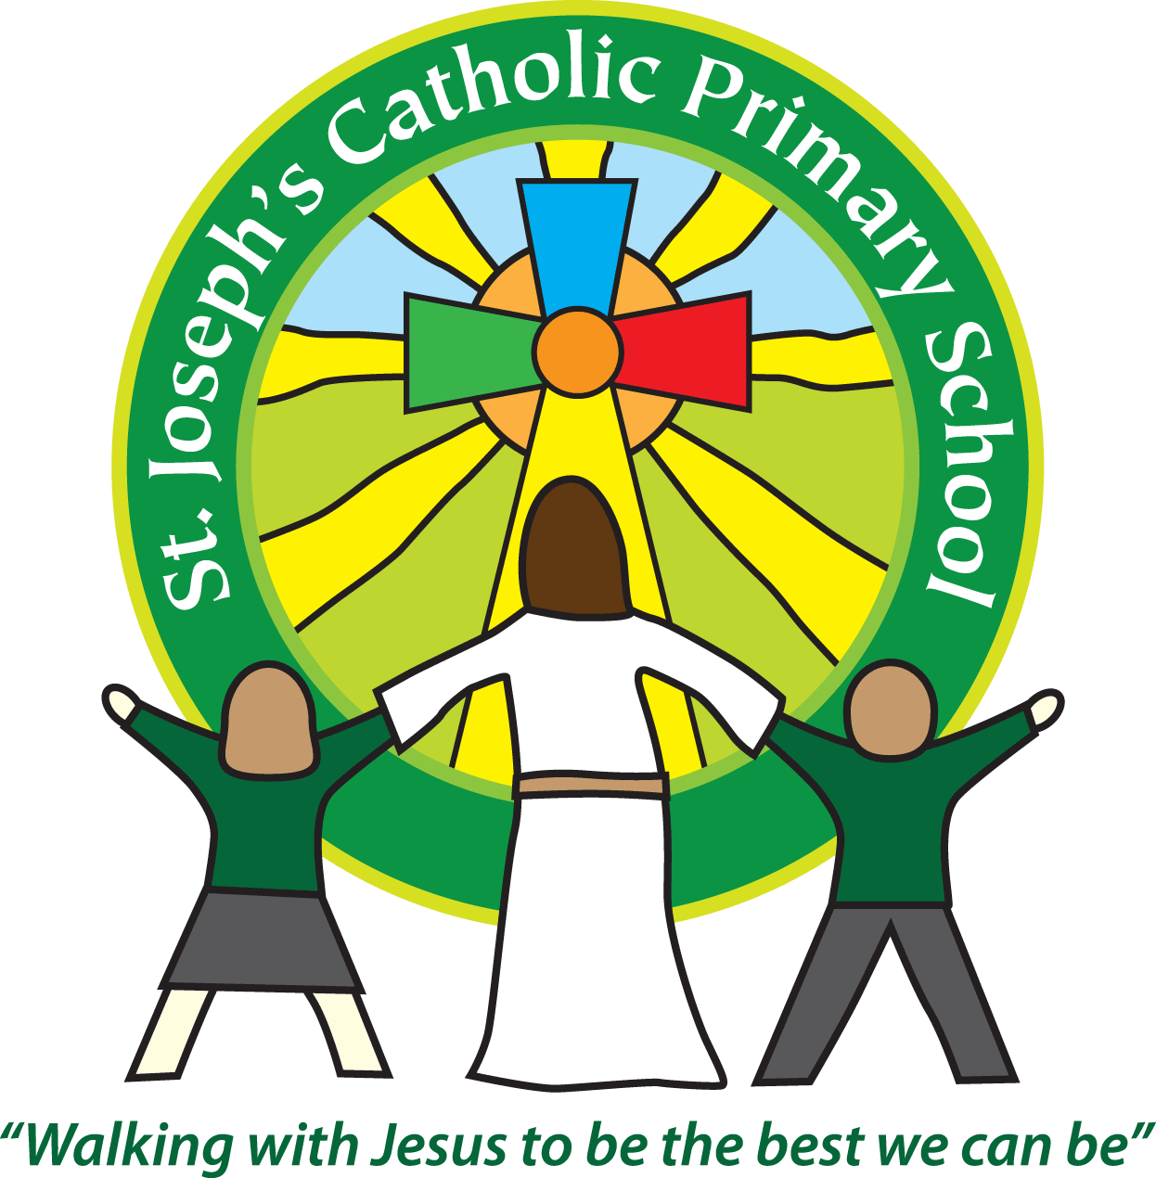

St Joseph’s Catholic Primary School

Newsletter

March 31st 2017

**Dear all,**

The holidays are finally here and the children and staff deserve a well earned break after a busy term full of learning and fun. Just a few of the highlights of the term have been: visits to Powderham castle, parent activity sessions, a visit from the 3 Kings (with a guest appearance by Angel Gabriel!), World Book day, sports festivals, bowling trips, WWII day, Buckfast Abbey, new wall bars and many more. I am looking forward to next term with many more new learning opportunities and hopefully more sunshine!

**Road safety**

It has been brought to my attention that some children are risking their own safety when walking to and from school – particularly on Albion hill. It is not that the children have been behaving badly but that they are too busy chatting and not looking where they are going. I have spoken to the children but would be grateful that if you have children who walk on their own or with friends to school that you also remind them of finding a safe place to cross and paying attention when crossing the roads and staying on the pavement at all times.

With that in mind we have also had incidents of parents driving up on kerbs along Boarden Barn close to children and parents parking in front of the school gates when dropping off. The children’s safety is paramount, please drive and park responsibly.

**Punctuality**

We have been noticing that some children have started to arrive just after 9am. If you are late to school please bring your child to the Office where you will be asked to sign a sheet with the time of arrival on.

**Red Nose day**

Many thanks for all your donations for Red Nose Day, we raised £302 which will all go to the charity.

**Church dates - Holy Week and Easter**

Palm Sunday April 9th. Mass Times - Budleigh Salterton 9.00.a.m. Exmouth 10.30a.m., beginning with a procession (+ donkey)  from the Convent garden in Long  Causeway

Good Friday - April 14th. The Stations of the Cross Budleigh 10.30.a.m, The Way of the Cross for Children Exmouth 11.00.a.m, The Sacred Liturgy of Good Friday Exmouth 3.00.p.m.

The Easter Vigil Saturday April 15th.  9.00p.m. Followed by a celebration in the hall afterwards – we invite you to *bake a cake to celebrate* and bring it to the hall before mass.

Easter SundaySt Peter, Prince of Apostles 9.00.a.m. & Holy Ghost Church 11.00.a.m.

**Parent activity sessions:**

Next half term our parent activity sessions will focus on Maths. I have added the times to the diary dates as well as the dates for parent’s evenings that have also been sent out today.

**First week back:**

Tuesday 18th April: Children return to school

Tuesday 18th April: Class 6 to ECC for Science session

Wednesday 19th April: FSU and Year 1 parents in for Easter celebration 9.10am

Thursday 20th April: Class 4 to Eden project and return Friday 21st April.

Thursday 20th April: Class 5 parents meeting about Magdalen 5.30pm

**Best wishes and thank you for your continued support**

**Mrs Taylor-Bashford**

**Well done to:**

**Headteacher’s Awards:** Yr2 – Orla, Nicole, Irys, Jasmine, Oscar, Halley, Silva, Patrycja, Ben, George, Emmie Yr 3 – Lola, Yr 5 Sophia, Jack S, Finn

**Bronze certificates**: FSU – Nicholas, Amelia, Queenie, Yr 1- Lewis, Theo, Brooke, Charlie, Holly, Yr 2 – Imogen, Halley, Silva, Joseph, Yr 3 - Morgan, Bart, Beau, Archie, Nathan, Izzy, Emma, Dillon, Ralph, Ryan, Yr 4 –Laura, Erin, Yr 5 - Anthony

**Silver certificates:** Yr 2 – Jack, Yr 3 – Thomas, Jasmyne, Yr 4 - Jeff

**Gold certificates**: Yr 3 - Laila, Lola N.

**Stars of the Term:** F1 – Emma, F2 – Annie, Yr 1 – Freddie, Yr 2 – Patrycja, Yr 3 – Morgan, Yr 4 – Evan, Yr 5 – Oliver, Yr 6 – Lillie



If you know anyone looking for school places, please let them know as we still have spaces available in some classes. They can contact the Office for more information or to book a tour.

Tel: 01395 264875 email: admin@stjo.uk