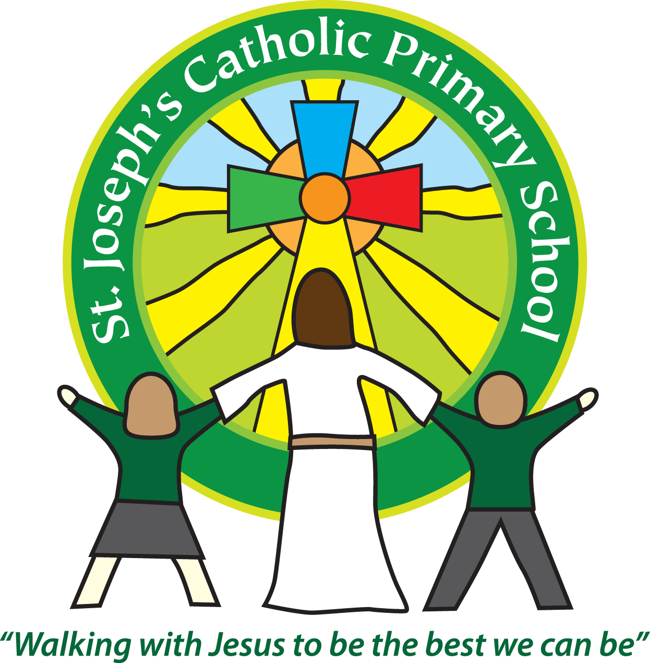

Equality Objectives

2017-2018

* Children of all groups to make at least good progress
* To develop support for children in school with emotional and mental health concerns
* To develop support for children in school with visual impairments