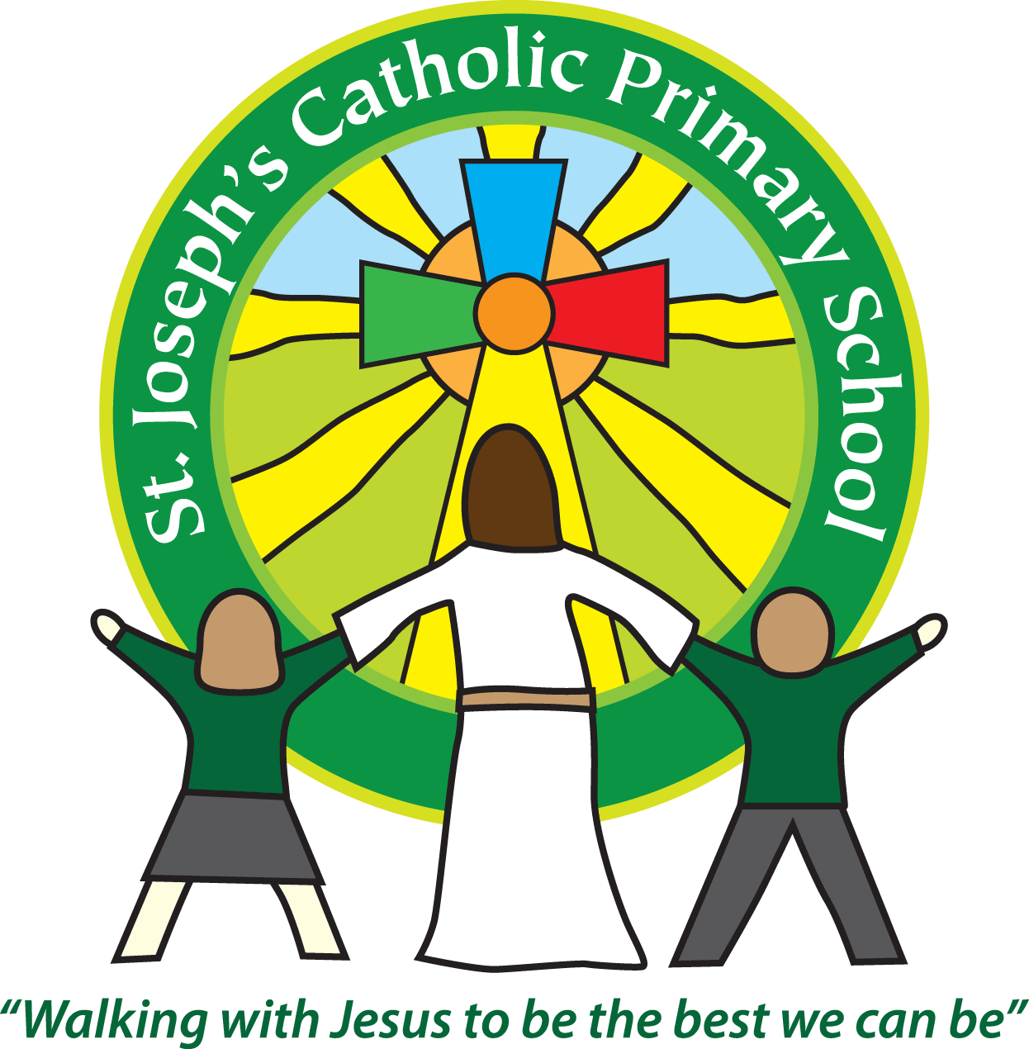St Joseph’s Catholic Primary School

26.1.18

Dear Parents/Carers

On Thursday 2nd February we will be holding an information session for parents about the arrangements for the Year 2 Sats. It will be taking place in Rowan class at 2.45pm. All are welcome to attend. We will talk through the tests the children will be sitting in May and how the judgements are made. We will aim to answer any questions parents may have about this.

Anyone who is unable to attend, please let us know and we can pass on any relevant information through book bags.

Mrs Handley and Mrs Edwards will be in school on Tuesday 6th February. They will be taking over Sycamore class when I begin my maternity leave. If you would like to meet them then please pop along to Sycamore class at 3pm on this date.

If you have any further questions, please let me know.

Many thanks,

Mrs Robertson

KS1 Leader