**St Joseph’s Catholic Primary School**

**Exmouth**



**More Able Policy**

April **2017**

This policy reflects our ethos and duty to eliminate discrimination, advance equality of opportunity and foster good relations with regard to our duties under the Equality Act 2010.

From September 2014, a New National Curriculum has been in place. The staff at St Joseph’s School reviewed and adapted the curriculum in light of these changes.

This policy is to be read in line with any relevant DFE Publications, e.g:

<https://www.gov.uk/government/uploads/system/uploads/attachment_data/file/183935/developing_quality_tuition_-_academically_more_able.pdf>

**Introduction**

The DFE definition of “More Able students” are pupils who achieve or have the ability to achieve at a level significantly in advance of the average for their year group in their school.

Nationally this is expected to be between 5 – 10 % of each group.

At St Joseph’s we will be identifying our most able pupils within each year group in order to provide a curriculum that is appropriate to the needs and abilities of all our children.

**Aims and Objectives**

Our school aims to:

* Provide all children with a challenging, extended and enriched curriculum.
* Encourage all children to develop higher order thinking skills and at the same time opportunities for able children to work at their own level and pace, thus realising their potential.
* Offer children opportunities to generate their own learning.

According to our school ethos, we support the development of the whole child. We believe that some children have special abilities and talents and that the nurturing of these is our responsibility.

**Definitions**

The following areas have been identified as being the main areas of ability. We also seek to identify pupils who are not fulfilling their potential. Pupils may also be recognised as ‘Good all Rounders’.

A. Intellectual – English, Mathematics, Science

B. Artistic and creative – Art and Design, Music, Drama

C. Practical - Art and Design, Mechanical Ingenuity

D. Physical – Sport, P.E., Dance

E. Social – Personal and Interpersonal, Leadership Qualities

F. A pupil who could be recognised as more able but who is presently not reaching his or her full potential.

**Identification Strategies**

Identification strategies for More Able Pupils are part of day-to-day classroom provision ensuring suitable and effective provision for all pupils to access the whole curriculum. There are many ways in which teachers can identify children’s special abilities and talents, these include:

* Teacher observation and assessment
* Test and assessment results (e.g. Foundation Profile, KS1 and KS2 SATs, End of year Tests and assessments, end of unit assessments)
* Discussion with pupils/ self and peer group identification
* Discussion with other staff
* Information received from previous class / school
* Information from parents and carers

We need to remember that the More Able pupil’s children may:

* Be high achievers in one area but unexceptional (or below average) in others
* Exhibit poor social skills
* Show poor motivation
* Disguise their ability
* Have poor coordination or motor skills (e.g. handwriting)
* Have English as an additional language
* Have been identified as SEN

**Disadvantaged most able pupils**

As with all pupils, the school is committed to ensuring that most able children are fully challenged and achieve their potential through quality first teaching. Due to the allocation of additional funding and the accountability this brings, the school will ensure that disadvantaged most able pupils are provided with opportunities to not only access and embrace the curriculum but to experience learning and life skills that will develop their whole being as a child. Experiences can include additional sports, music, Arts or simply new experiences that may not be available to help them because of financial constraints or difficulty. Our aim is to help our children grow existing talents and help them identify new ones. These opportunities can be provided in and/or outside of school hours.

**Provision and Planning**

We offer an enriched and differentiated curriculum for all children. This is achieved in the following ways:

* Regular use of enquiry based / problem solving activities that are as open ended as possible to allow for maximum differentiation by outcome and a variety of extension and enrichment activities.
* The use of The National Curriculum, including investigations which encourage higher order thinking skills of analysis, synthesis and evaluation where appropriate.
* Extra provision outside the classroom where possible, such as a variety of clubs and activities. Also, opportunities are provided for the children to take part in interschool competitions and events.
* Staff are encouraged to participate in relevant courses and events, school INSET is provided (where appropriate) to raise the profile and move the school forward in its provision for more able pupils.
* Classroom provision is monitored through planning, samples of work, subject leader reports and observations where appropriate.
* Guided Group Maths and English sessions as well as supporting learning also extend the more able pupils.
* We promote celebration of achievements by asking parents to inform the school if their child has an out‐of‐school award etc.
* The children will also have the opportunity to experience a range of educational visits that further enrich and develop learning.
* Our teachers plan carefully to meet the learning needs of all our children. We give all children the opportunity to show what they know, understand and can do, and we achieve this in a variety of ways when planning for children’s learning.

**Assessment**

Ongoing Teacher assessment and tests are two of the main ways in which we assess children’s ability.

We use a mastery curriculum. Mastery is how a child can apply much of the curriculum as a whole in more in‐depth and complex, cross‐objective, multi‐modal methods. Please see below for the system we use to track pupil’s mastery within the curriculum for Reading, Writing and Mathematics.

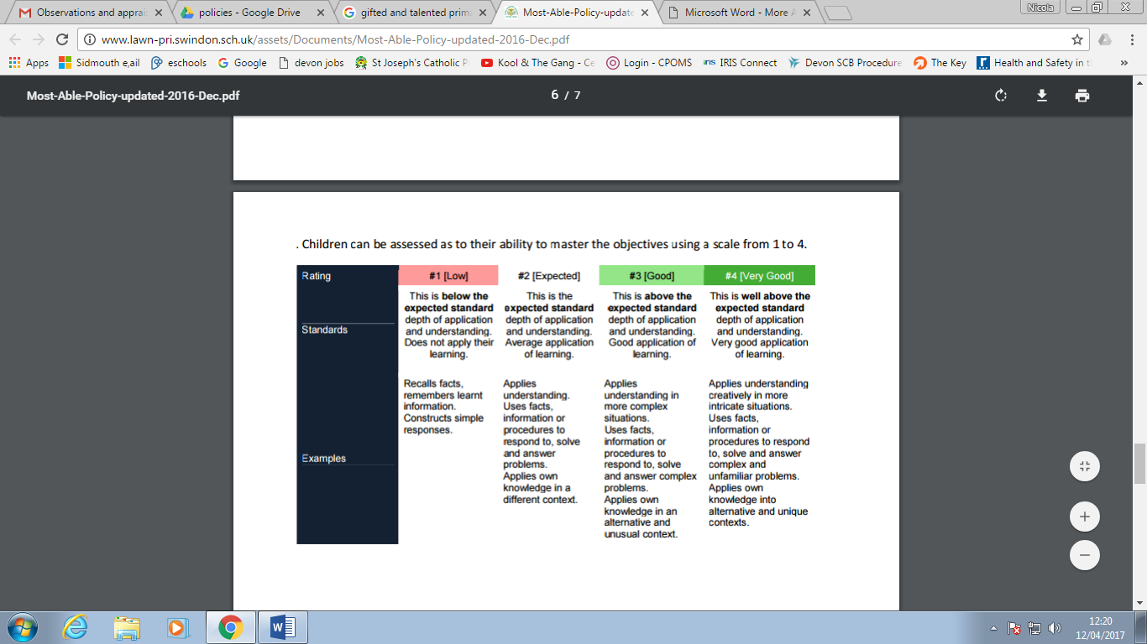

**Monitoring of this Policy**

This policy is monitored, reviewed and updated regularly and its effectiveness evaluated.

April 2017