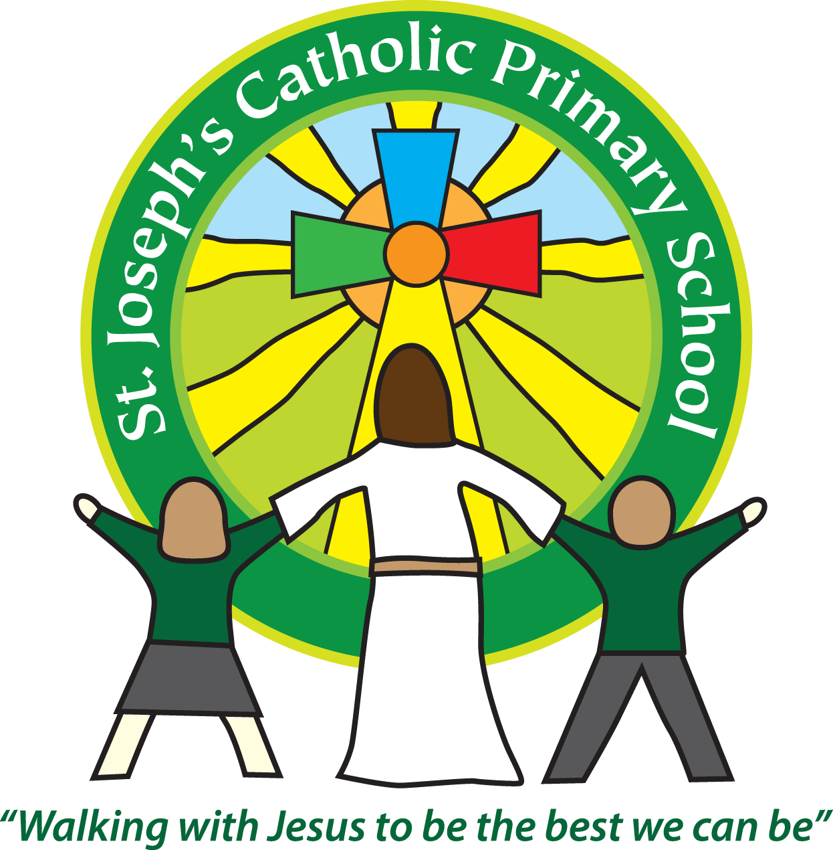Diary dates for parents/carers Spring/Summer 2017

|  |  |  |
| --- | --- | --- |
| Date | Time | Event |
| April |  |  |
| 3rd – 17th April |  | Easter Holidays |
| Tuesday 18th April | 8.55am | Children return to school after Easter holidays |
| Tuesday 18th April | 10.00am | Class 6 science session at ECC |
| Wednesday 19th April | 9.10am | Easter celebration FSU and Class 1 parents invited |
| Thursday 20th April | Overnight | Class 4 trip to Eden project |
| Thursday 20th April | 5.30pm | Class 5 parents meeting about Magdalen |
| Monday 24th April | 9.15am | KS1 – Liturgy with Father Philip in School |
| Tuesday 25th April | 9.30am | KS2 – St Mark Mass in Church |
| Wednesday 26th April | 4pm | Girls Tag rugby at Rugby club |
| Thursday 27th April | 9.30am | FSU assembly |
| Friday 28th April | All day | Class 3 & 4 at Lyme Regis fossil festival |
| May |  |  |
| Monday 1st May | All day | Bank holiday |
| 3rd – 5th May | 3 days | Year 5 Magdalen residential |
| Thursday 4th May | 9.10am | Class 3 parent activity session |
| Monday 8th May | Morning | Yr 6 Reading SATS |
| Tuesday 9th May | Morning | Yr 6 SpaG SATs |
| Wednesday 10th May | Morning | Yr 6 Maths SATS paper 1 & 2 |
| Thursday 11th May | Morning | Yr 6 Maths SATS paper 3 |
| Friday/Saturday 12th/13th May | Overnight | Year 6 sleepover in the Church |
| Monday 15th May | 9.10am | PTA meeting in the staffroom |
| Tuesday 16th May | 9.10am | Class 4 parent activity session |
| Wednesday 17th May | 9.10am | NSPCC assembly |
| Thursday 18th May | 9.10am | Class 2 parent activity session |
| Friday 19th May | 9.10am | Class 5 parent activity session |
| Monday 22nd May | 11.00am | Class 1 parent activity session |
| Tuesday 23rd May | 9.10am | FSU parent activity session |
| Tuesday 23rd May | 3.30pm | Class 1-6 parent evenings. Times will be issued. |
| Wednesday 24th May | Across the day | NSPCC workouts |
| Wednesday 24th May | 3.30pm | Class 1-6 parent evenings. Times will be issued. |
| Thursday 25th May | 9.10am | Class 6 parent activity session |
| Thursday 25th May | 3.30pm | Class 1-6 parent evenings. Times will be issued. |
| Friday 26th May | All day | Sponsored bounce & mufti day |
| 29th May – 2nd June | All week | Half term |
| June |  |  |
| Monday 5th June | 9.15am | Father Philip Pentecost liturgy in School |
| Wednesday 7th June | Across the day | NSPCC workouts |
| Thursday 8th June | All day | Class 2 & 3 Roman Roadshow from Exeter Museum |
| Friday 9th June | 3.30pm | PTA Summer fair |
| 12th – 16th June | All week | Year 1 phonics screening tests |
| Tuesday 13th June | 2.45pm | Class 5/6 Mass in Outdoor Classroom |
| Friday 16th June | 6pm | Public Speaking competition |
| Saturday 17th June | 6pm TBC | Church Service celebrating Children receiving first Holy Communion |
| Sunday 18th June | Time TBC | Church Service celebrating Children receiving first Holy Communion |
| Tuesday 20th June | 2.45pm | Class 3 &4 Mass in School |
| Thursday 29th June | Over night | Class 3 sleepover |
| Friday 30th June | All day | Action Against Hunger - activities throughout day |
| July |  |  |
| Friday 7th July | All day | Sports Day |
| Wednesday 12th July | 3.30pm TBC | Parents in for meet new class teachers |
| Friday 14th July | 2.30pm | End of year awards |
| Wednesday 19th July | TBC | Dance Show in the hall |
| Thursday 20th July | 2.30pm | Yr 6 leavers assembly |
| Friday 21st July | 9.15am | Leavers Mass in School |
| Friday 21st July | 3.30pm | Children break up for Summer holidays |
| September |  |  |
| Monday & Tuesday 4th/5th September | All day | School closed for Non-Pupil days |
| Wednesday 6th September | 8.55am | Children return to school after summer holidays |
| October |  |  |
| Friday 13th October | 1.15-3.15pm | Donkey Sanctuary visiting school |
| Friday 20th October | 3.30pm | Children break-up for half-term |
| Monday 23rd – Friday 27th October | All week | Half term |
| Monday 30th October | All day | School closed for Non-pupil day |
| Tuesday 31st October | 8.55am | Children return to school |
| December |  |  |
| Friday 15th December | 3.30pm | Children break-up for Christmas |