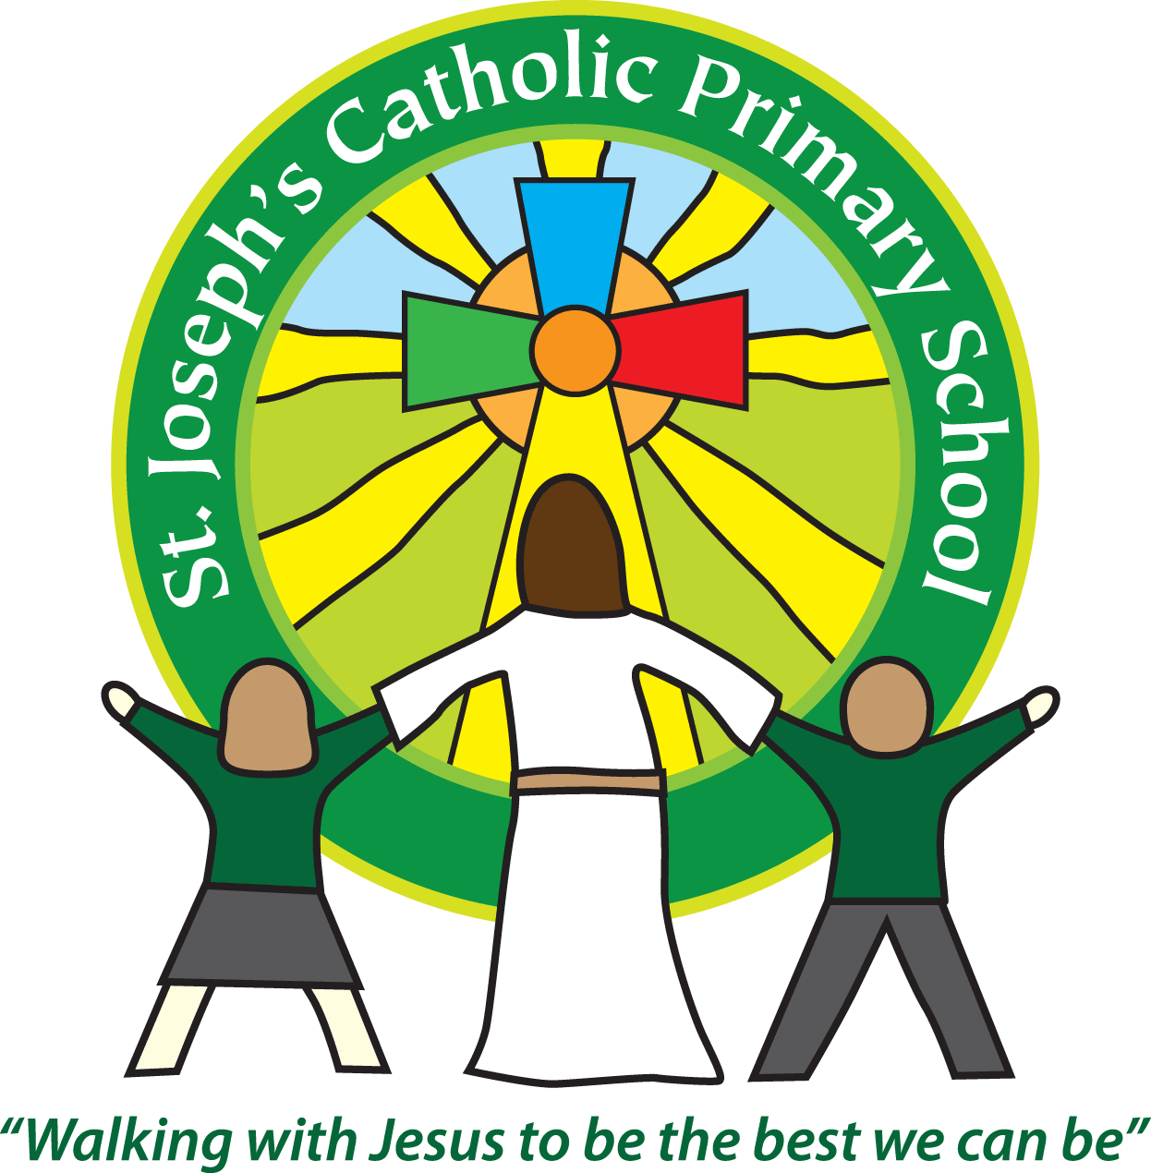

St Joseph’s Catholic Primary School

Newsletter

January 20th 2017

**Dear all,**

As usual we have had a busy week at St Joseph’s, although unfortunately the sore throat and temperature bug hit the Year 6s hard. It meant that we cancelled the WWII day and have rearranged it for next week when hopefully they are all feeling better!

Well done to Class 4 for their super assembly on Wednesday about the journey to find the source of the River Nile. The children spoke very clearly and knowledgably about the topic.

**Bird watching week**

We have signed up to take part in the RSPB Big Schools’ Birdwatch and next week is the week when every class will be outdoors counting and identifying the different birds we can see.

If your child has any binoculars they could bring in for next week that would be really helpful. Please ensure they are clearly named and give them to the class teacher.

**Co-op support**

As I mentioned last term we are one of the three lucky groups that the Co-op has chosen to support. Every time Co-op brand items are bought in one of the Exmouth stores we receive a % of the profit. Currently we have the lowest amount of the 3. If you have a Co-op card and wish to, you can go to the link below and register that all the profits from your purchases go to St Joseph’s. (Otherwise it is automatically split between the 3 groups) Every card registered will help our children to gain as much as possible from this opportunity. If you are not already a member you can also register to join easily on the site or pick up information at in the Co-op.

<https://membership.coop.co.uk/sign-in>

**Next week:**

Monday 23rd: Class 5 swimming.

Tuesday 24th: Class 5 and 6 WWII day. Children are welcome to come in dressed in costume appropriate to that time but it is not compulsory.

Friday 27th at 3.30pm is the FSU cake sale. Please bring in your pennies after school to buy a tasty treat.

**Best wishes and thank you for your continued support**

**Mrs Taylor-Bashford**

**Headteacher’s Awards:**

**Well done to:** FSU –Alfie & Rian, Yr 2 – Alfie,Yr 3 – Emma, Yr 4 – Oliver, Alfie & Scarlett, Yr 5 – Thomas, Connor.

**Bronze certificates:** Yr 1 – Declan and Freddie, Yr 2 – Lewis, Vince, Patrycja, Yr 5 – Jack S, Evelyn, Alex, Harry, Yr 6 – Oakley, Aidinn

**Silver certificates**: Yr 5 – Maisie-Rae

**Stars of the Week:** FSU – Lexi, Yr 1 – Annie, Yr 2 – Piran, Yr 3 – Edan, Yr 4 – Katy, Yr 5 – Thomas, Yr 6 – Will

